

Phresco Framework

**Newest version of the Social Media Framework**

Version 3.0

August 2013

*This document applies to Phresco Framework v3.0 and to all subsequent releases.*

*Specifications contained herein are subject to change and these changes will be reported in subsequent release notes or new editions.*

*© Copyright Photon Infotech Pvt Ltd 2013. All rights reserved.*

*The name Phresco and/or all Photon product names are either trademarks or registered trademarks of Photon. Other company and product names mentioned herein may be trademarks of their respective owners.*

**TABLE OF CONTENTS**

1 About This Guide 5

1.1 Document Conventions 5

2 Introduction 6

2.1 What Is Phresco Framework? 6

3 Phresco – Powered With Facets 7

3.1 Lifecycle Management 7

3.2 Pre - Built Architecture 7

3.3 Quality Assurance 7

3.4 Web Development 7

3.5 Mobile/Web Application Development 8

3.5.1 iPhone Features 8

3.5.2 Android Features 9

3.6 Standalone Application Development 9

3.7 Multichannel Presence 10

3.8 Responsive Web Design 10

3.9 Reuse and Continuous Improvement 11

3.10 Continuous Integration 11

4 Getting Started With Phresco Framework 12

4.1 Supported Platform 12

4.2 Supported Browsers 12

4.3 Steps To Extract and Execute Phresco Framework 12

4.4 Logging On To Phresco Framework 12

4.5 Using the Dashboard 12

5 Phresco Project Life Cycle 14

5.1 Projects 14

5.1.1 Creating a Project 14

5.1.2 Editing a Project 17

5.1.3 Import Application 17

5.1.4 Add to Repo & Commit to Repo 20

5.1.5 Update Application in SVN and GIT 20

5.2 Edit Project 23

5.2.1 Integration Test 23

5.2.2 Continuous Integration 23

5.2.3 API Status 23

5.3 Edit Application 23

5.3.1 App Info 23

5.3.2 Features 27

5.3.3 Code Quality 27

5.3.4 Environment Configuration 31

5.3.5 Build Generation 42

5.4 Project Deployment 43

5.4.1 Remote Deployment 44

5.5 Enabling https in Phresco 45

5.6 Project Testing 46

5.6.1 Unit Testing 47

5.6.2 Functional Testing 48

5.6.3 Performance Testing 58

5.6.4 Load Testing 61

5.7 Continuous Integration 63

5.8 Report 63

5.9 Global Settings 65

5.10 Knowledge Repository 66

5.11 Download 66

5.12 iPhone Prerequisites 67

5.13 Android Prerequisites 69

5.14 Blackberry Prerequisites 70

5.14.1 Software Installations: 71

5.14.2 Code signing key registration and installation: 73

5.15 Prerequisites for Windows Phone 79

5.16 Prerequisites for Windows Metro 80

5.17 Prerequisites for NodeJS 80

6 Archetypes 81

6.1 List of Available Archetypes 81

7 Reusable Components 83

7.1 What happens when you select a feature in your project? 84

8 Testing 86

8.1 Test Cases for Java Technology 86

8.1.1 Unit Test 86

8.1.2 Functional Test cases – Selenium Grid 91

8.2 Functional Test cases for Selenium Webdriver 98

8.3 Test Cases for Php Technology 107

8.3.1 Unit Test Cases 107

8.3.2 Functional Test Case for Webdriver 112

8.4 Test Cases for SharePoint Technology 119

8.4.1 Unit Test Case 119

8.5 Java Standalone Application 123

8.5.1 Unit Test Case 123

8.5.2 Functional Test Case 124

8.6 Android application 130

8.6.1 Unit Test Case 130

8.6.2 Functional Test Case for Android Native - Robotium 138

8.7 Functional Test cases for Android Hybrid – Monkey Talk 147

8.7.1 Structure of Functional Test for Android Hybrid 147

8.7.2 Performance Test for Android 152

8.8 iPhone Applications 155

8.8.1 Unit Test Case 155

8.8.2 Functional Test Case 165

8.9 Node js Test Cases 172

8.9.1 Unit Test Case 172

8.10 JQuery Test Cases 177

8.10.1 Unit Test Cases 177

8.10.2 Functional Test Cases 182

8.11 Performance Testing 189

8.12 Load test 193

8.12.1 Report Generated After Load Testing 194

9 Continuous Integration 195

# About This Guide

The purpose of this guide is to assist developers, testers, release engineers, managers and others aiming to use Phresco Framework user interface for maintaining and controlling the critical phases in the project lifecycle.

## Document Conventions

Table 1: Conventions

|  |  |
| --- | --- |
| Convention | Description |
| **Orange** | Identifies elements on a screen |
| **note.png** | Note |
| **Blue** | Phresco UI Navigation (Breadcrumbs) |
| **Brown** | Identifies tabs on a screen |
| *Italic* | Code structure |
| * | This is mandatory symbol |

# Introduction

Phresco, a product of Photon InfoTech Pvt Ltd, is designed to work seamlessly with the powerful and more popular technologies; Phresco assists users in creating projects that boast persistent uniformity in quality across platforms throughout the lifecycle of a project. Aiming to be thego-to tool for next generation multichannel development, Phresco allows the user to develop projects simultaneously with faster cycles across multiple channels. Phresco is endowed with latest tools and capabilities along with expanding libraries of pre-built templates, standardized codes and manifold archetypes which aid the development team to increase their capability by limiting the occurrences of errors and reducing the development time. Projects created using Phresco Framework adheres to the best practices in the industry making them resourceful, effective and reusable.

## What Is Phresco Framework?

Phresco is a next-generation development framework of frameworks. It is a platform for creating next generation web, mobile and Multichannel presences leveraging existing investments combined with accepted industry best practices. Phresco publishes new artifacts (components) in the centralized maven repository or Customer specific repository under appropriate technologies. Once published in the centralized repository, subscribed users can view and deploy those artifacts in their projects.

Phresco encapsulates the best practices of a project structure, re-usable components, standards, documentation, quality assurance and release process. This ensures the quality of a project deliverables, which in turn will increase the productivity of a project. Though Phresco guarantees projects adhering to best practices, it permits every organization to follow their respective quality measures and standards.

# Phresco – Powered With Facets

## Lifecycle Management

Maintaining end to end lifecycle of a project has never been easier.

From providing a stepwise method in creating a template project to integrating tools for code validation, build and deployment and continuous improvement, Phresco makes sure that every aspect of a project lifecycle is taken care of. The integration of Phresco with multiple open source projects allows the user community to reap the full benefits of the Framework.

## Pre - Built Architecture

Phresco provides a pre-built architecture model with certified template architectures such as Multichannel widget, SharePoint web parts and NodeJS Service gateway. It contains standard build structures with supported versions.

## Quality Assurance

Phresco contains powerful automated testing instruments designed to analyze and test the project at the code level. The testing methods deployed in Phresco include:

* Unit Testing
* Functional Testing
* Performance Testing
* Load Testing
* Manual Testing
* Component Testing

By using static code analysis tools to pick up and compare the metrics of different technologies with the source codes, Phresco makes sure that the project is of quality standards. Phresco Archetypes, created by following the best practices in the respective domains, help the developers in creating model projects by providing basic templates for any desired technology.

## Web Development

Phresco offers support for web development tools such as ASP.NET, SharePoint, SiteCore (an additional plugin for creating SharePoint projects), PHP (raw), PHP (Drupal), WordPress, HTML5 YUI Mobile Widget, HTML5 JQuery Mobile Widget, Html5 Multichannel YUI Widget, HTML5 Multichannel JQuery Widget, HTML5 and Java standalone. It also supports web applications using Responsive web design and Java / NodeJS based web services.

## Mobile/Web Application Development

Phresco patronage of the Responsive web design concept makes the mobile/web application development for iPhone, Android, Blackberry and Windows 8 unproblematic and resourceful.

### iPhone Features

* **iOS Platforms**

To test IOS applications, Phresco framework allows testers to select the required devices and its versions. Phresco finds out the installed versions of the devices available in the system and only those versions are shortlisted.

* **iOS Devices**

While deploying and testing the IOS application, Phresco Framework provides the option of selecting iPhone simulator or iPad simulator from the dropdown box listed under family. This is done by integrating waxsim plugin in the Framework

|  |
| --- |
| * **Note:**   + Waxsim tool should be installed manually from the directory path phresco-framework/workspace/tools/waxsim.   + The command xcodebuild install DSTROOT= from the command prompt will install the tool to the local machine.   + Prerequisites For Executing Application Test w.r.t Iphone through Phresco;     - IOS-Sim tool should be installed manually.     - For this go to the path Phresco-framework/workspace/tools/ios-sim then execute the below command to install ios-sim in the local machine.  rake install prefix=/usr/local/ |

* **iPhone Workspace**

The iPhone Workspace is an Xcode project for integrating multiple iPhone Native and iPhone library apps. Phresco offers support throughout the development cycle of a Native application culminating with the generation of .app file.

* **iPhone Library**

Phresco allows for the creation of a static library and offers code validation and build generation support for the same. The newly created iPhone library can be used in any application and cannot be deployed separately.

### Android Features

* **Proguard Enablement**

The source code can be decompiled and viewed from the installed application. To keep it in encrypted format, Proguard enablement shuffles the java classes and gives an ID to each class. The Class and its ID will be unrelated; i.e., the class will be shuffled and will be renamed as a, b, c, d.

* **Application Signing**

Android system requires that all installed applications be digitally signed with a certificate whose private key is held by the application's developer. In order to make application available in Android store (Market), the application has to be certified. Phresco allows user to select certificate through the Phresco UI while build the app for final release.

* **ZipAlign**

Zipalign is an archive alignment tool introduced first time with 1.6 Android SDK (software development kit). It optimizes the way an Android application package (APK) is packaged. Doing so enables the Android operating system to interact with the application more efficiently, and hence has the potential to make the application and overall the whole system much faster. Execution time is minimized for zipaligned an application, resulting is lesser amount of RAM consumption when running the APK.

* **NDK Support**

Native codes can also be used as an android application when the compiled native code is copied in the path <PHRESCO_HOME>/workspace/projects /PHR_Android/source/libs>. Phresco does not directly support NDK.

* **Android Library**

Phresco offers support to create an Android Library project. An Android Library is a development project that holds shared Android source code and resources. Any Android application project can reference the Library and, at build time, include its compiled sources in their .apk files.

Multiple application projects can reference the same Library and any single application project can reference multiple Libraries.

## Standalone Application Development

Standalone application does not require any software other than the operating system to run. This support is provided in the latest version of Phresco, where java standalone applications can be created.

## Multichannel Presence

The Burgeoning user base of Internet has forced organizations to provide customers a seamless environment for buying or utilizing their services in a manner that the channels complement each other.

Having this in mind, Phresco has enabled Widgetized Responsive web design to be accessed across various channels.

## Responsive Web Design

When creating a web page, it’s been a common tactic to serve up two different sets of pages - one for desktop browsers, another for mobile devices. With a wide variety of mobile devices, screen sizes and hardware features, designing a separate version for each quickly becomes impractical.

Phresco deploys the Responsive Web Design (RWD) concept to adjust the layout and features of a website based on how it’s being viewed. Phresco with the aid of RWD helps developers in exposing the myriad functionalities developed using Phresco across multiple channels i.e., web, mobile, tablet and kiosk with minimum resizing, panning and scrolling efforts.

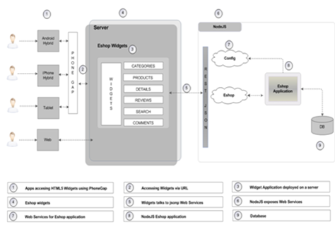 ***Figure 3-1: Multichannel Architecture in Phresco***

## Reuse and Continuous Improvement

For any organization, promoting reusability of the components is important. The components (artifacts) such as libraries, features, Web parts, archetypes, pilot projects and other artifacts can be reused in numerous projects with minimal changes.

## Continuous Integration

One of the cherished aspects of Phresco is the Continuous Integration feature made available as part of the Framework which generates the build automatically deploys it and tests the build in periodic manner. With this feature, it is trouble-free to keep track of the latest build updates and make sure that the builds adapt seamlessly to the existing project which is otherwise a tedious process. Added advantage in the Phresco is multiple job creation. Multiple jobs can be created to a single project and it can be rearranged to maintain the order of the automation.

# Getting Started With Phresco Framework

Once JAVA_HOME path is set and jdk 1.6.0_18 version is installed, it’s time to extract, install and start creating projects using Phresco.

## Supported Platform

* Windows: xp, 2003, 2008, windows 7 ( 32 and 64 bits are supported), Windows 8 ( 32 and 64 bits are supported)
* Mac: Mac OS X Lion, OS X Mountain Lion
* Linux: RedHat, SUSE Linux, Ubuntu

## Supported Browsers

* Firefox: Version 6 and above
* Google Chrome: Version 11 and above
* Internet Explorer: Version 9 and above
* Opera: Version 1o and above
* Safari: Version 5 and above

## Steps To Extract and Execute Phresco Framework

* Download and unzip the Phresco build <version>.zip file containing Service war, Mongo DB dump and Phresco Framework
* Unzip the Phresco Framework <version>.zip available inside the Phresco Framework
* For Windows, Run <phresco-framework>/bin>start-framework-server.bat from the command prompt. This will automatically open Phresco Framework in the browser. (User’s System Default Browser)
* For Mac/Linux, Run <phresco-framework>/bin>sh start-framework-server.sh from the command prompt. This will automatically open Phresco Framework in the browser. (User’s System Default Browser)

## Logging On To Phresco Framework

* In the Web Browser, enter the URL where Phresco Framework is hosted
* At the log in screen, enter organization’s LDAP credentials
* Now click **Login**

## Using the Dashboard

Phresco’s interactive dashboard aid users in moving seamlessly through the Framework.

The dashboard briefly highlights the essential aspects of a project which can be viewed in detail with a single click. Among those highlighted include,

* Project Tracker
* Code Validation
* Test results
* Continuous Integration
* Phresco updates
* Technology related documents and videos

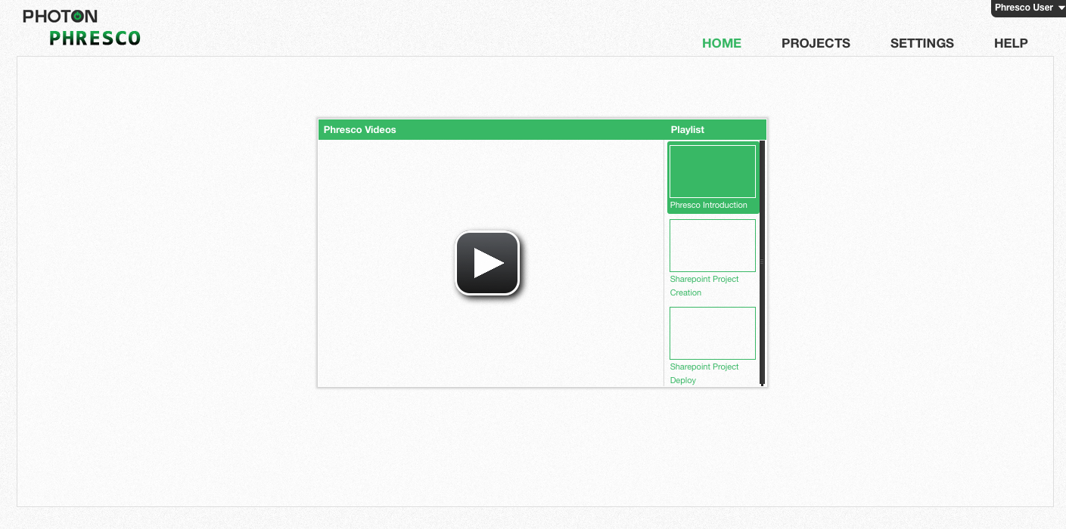

*Figure 4‑1: Dashboard*

# Phresco Project Life Cycle

## Projects

Phresco aids in developing web, mobile and web service applications based on any given project requirement. The Phresco created project contains a well defined archetype (Project structure), features, a testing structure and help documents. Out of the box features can be adapted to the project based on the requirements. On specific requests, additional features can be added to the framework by Photon on validation of the license.

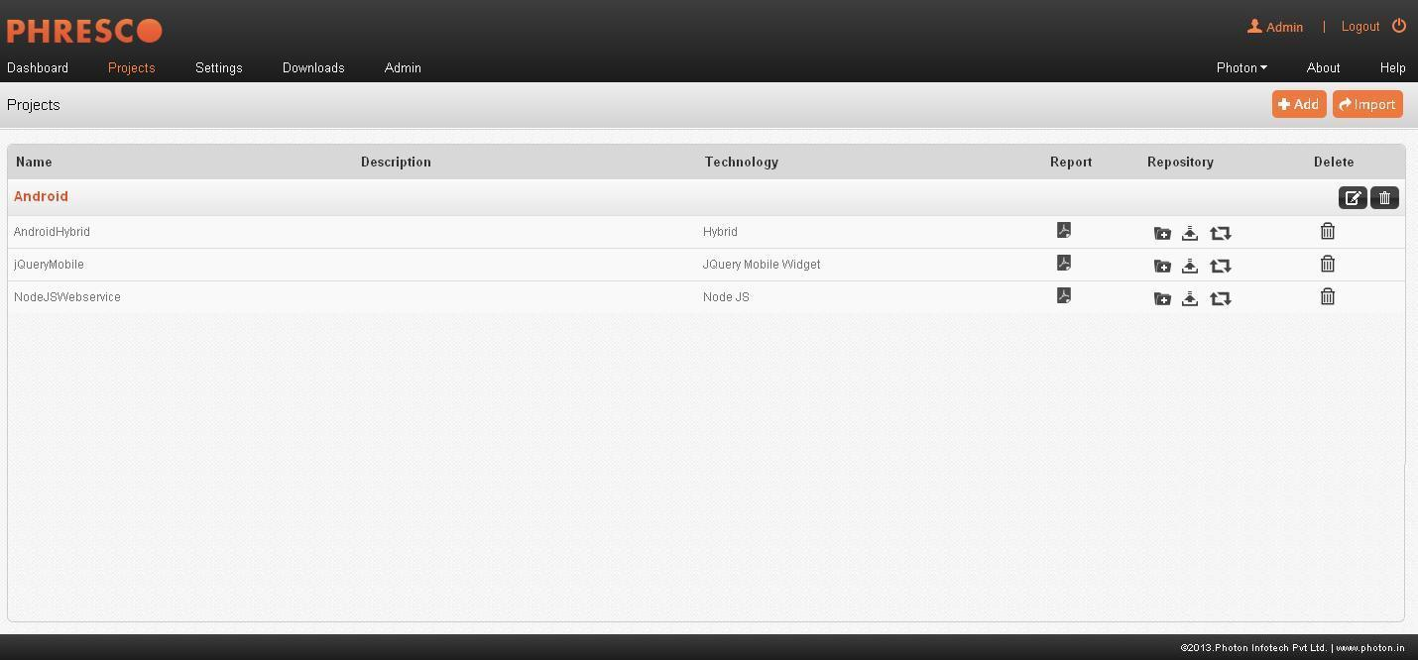

*Figure 5‑2: Projects*

### Creating a Project

Phresco offers support in creating projects for multiple technologies. A new project can be created from the **Projects🡪Add**. Depending upon the requirements, projects can be created simultaneously in the application, mobile and web layers and they will be grouped under one umbrella.

**Fields in the Add Project are as follows**

**Name**

It denotes the Name of the project created. Maximum text input of the field is restricted to 30 alphanumeric characters and is a mandatory field.

**Code**

It denotes the code of the project created. Maximum text input of the field is restricted to 30 alphanumeric characters and is a mandatory field.

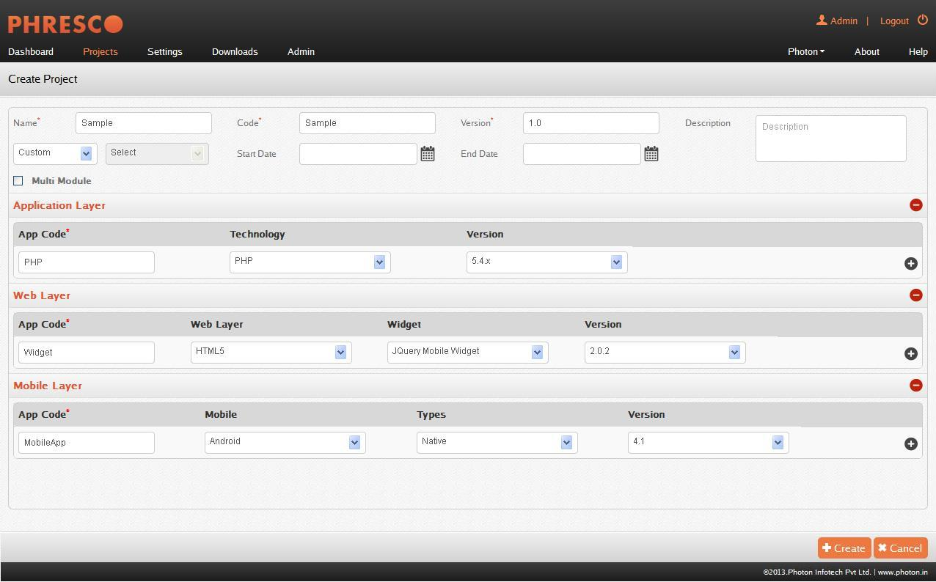

*Figure 5‑2: Creating a Project*

**Version**

It denotes the version of the project created. Maximum text input of the field is restricted to 20 alphanumeric characters with a special character “.”. It is a mandatory field.

**Description**

It denotes the description of project created. Maximum text input of the field is restricted to 150 alphanumeric, special characters and is not a mandatory field.

**Custom / Pre Built**

The Custom option allows the developer to build the project progressively in tune with his requirements. To circumvent the troubles normally involved in developing the project from scratch, The Pre Built option contains pilot projects developed using best practices that the developer can effortlessly edit to suit his needs.

The pilot project possesses libraries, components and validated code structures that can be modified based on the requirement. It,

* Allows components/libraries deployed to be re-used in multiple other projects.
* Authorizes re-branding of the pilot projects.

**Advantages**

* Less effort needed in creating new projects
* Ease in adopting the validated code structures and verified test cases ensure quality and saves time
* Improves application performance

**Application Layer**

This layer contains the list of Phresco supported application technologies and their versions. The technologies supported include,

|  |  |  |
| --- | --- | --- |
| S.No | Technology | Version |
| 1 | ASP.NET | 3.5, 3.0, 2.0 |
|  |  |  |
| 2 | WordPress | 3.4.2, 3.3.1 |
|  |  |  |
| 3 | PHP | 5.4X, 5.3X, 5.2X, 5.1X, 5.0X |
|  |  |  |
| 4 | Drupal 7 | 7.8 |
|  |  |  |
| 5 | Drupal 6 | 6.3, 6.25, 6.19 |
|  |  |  |
| 6 | Java WebService | 1.6, 1.5 |
|  |  |  |
| 7 | Java Standalone | 1.6, 1.5 |
|  |  |  |
| 8 | SharePoint | 3.5, 3.0, 2.0 |
|  |  |  |
| 9 | Site Core | 3.5, 3.0, 2.0 |
|  |  |  |
| 10 | NodeJs WebService | 6.14, 6.11, 6.8, 6.7, 6.1 |

**Web Layer**

This layer contains the list of Phresco supported Web technologies and their versions. The Web technologies supported include,

|  |  |  |  |
| --- | --- | --- | --- |
| S.No | Web Layer | Widget | Version |
| 1. | HTML5 | HTML5 JQuery mobile widget | 1.6, 1.5 |
| HTML5 Multichannel YUI Widget | 1.6, 1.5 |
| HTML5 Multichannel JQuery Widget | 1.6,1.5 |
| HTML5 YUI Mobile Widget | 1.6, 1.5 |

**Mobile Layer**

This layer contains the list of Phresco supported Mobile technologies and their versions. The Mobile technologies supported include,

|  |  |  |  |  |
| --- | --- | --- | --- | --- |
| S.No | Technology | Type | Version | Device |
| 1 | Android | Android Native | 4.2, 4.1.2, 4.1, 4.0.3, 2.3.3, 2.2, 2.1_r1, 1.6 | Phone, Tablet |
| Android Hybrid | 4.2, 4.1.2, 4.1, 4.0.3, 2.3.3, 2.2, 2.1_r1, 1.6 |
| Android Library | 4.2, 4.1.2, 4.1, 4.0.3, 2.3.3, 2.2, 2.1_r1, 1.6 |
|  |  |  |  |  |
| 2 | Blackberry | Hybrid | 7.X | Phone, tablet |
|  |  |  |  |  |
| 3 | iPhone | iPhone native |  | Phone, Tablet |
| iPhone hybrid |  |
|  |  | iPhone Library |  |  |
|  |  | iPhone Workspace |  |  |
|  |  |  |  |  |
| 4 | Windows | Windows Metro |  | Phone, Tablet |
|  |  | Windows Phone | 7.X, 8 |  |

### Editing a Project

Phresco permits editing certain aspects of existing project. This includes

* The general description of the project
* Adding new applications to the existing project

### Import Application

Apart from creating projects using Phresco, developers can also create their project with Phresco standards and import them into Phresco Framework.

Import Application will automatically check out a project in the desired path of the folder (*Phresco-framework-1.0\Phresco-framework\workspace\projects*)

**SVN**

Import from SVN is used for importing a replica of a project. Developers can check in and make changes to a project which will be reflected in the main project. Conflictions may occur if two developers check in at the same time. Only those projects developed using the Phresco standards can be imported from the SVN.

**Fields in import application are as follows**

**Application Repo URL**

URL of the SVN project to be imported into Phresco framework.

**Other credential**

Enter the SVN credentials if it is different from the one used to sign in to Phresco.

**Username**

The username used to login to the framework will be the default value in this field. This can be changed using the Other Credential option.

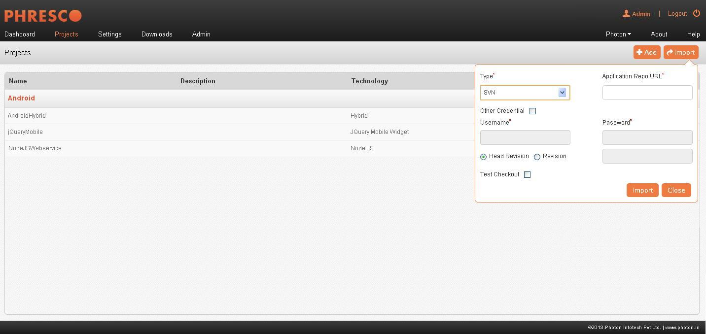

***Figure* 5-2: *Import Project from SVN***

**Password**

The password used to login to the framework will be the default value in this field. This can be changed using the Other Credential option.

**Head Revision**

It imports the latest revision of a project from the version controlling system.

**Revision**

Revision is to import a project by providing the revision number. Previously checked in projects can be imported using revision number

**GIT**

Like SVN, GIT is a [distributed revision control](http://en.wikipedia.org/wiki/Distributed_revision_control) and [source code management](http://en.wikipedia.org/wiki/Source_code_management) (SCM) system. Every GIT [working directory](http://en.wikipedia.org/wiki/Working_directory) is a full-fledged [repository](http://en.wikipedia.org/wiki/Repository_(version_control)) with complete history and full revision tracking capabilities. Import from GIT is used to import a replica of a project and make changes to it. Projects can be cloned from the repository by giving the repository URL.

|  |
| --- |
| * **Note**   GIT_HOME environment variable should be set  E.g., GIT_HOME = C:\Program Files\Git;  path = %GIT_HOME %\bin; |
|  |

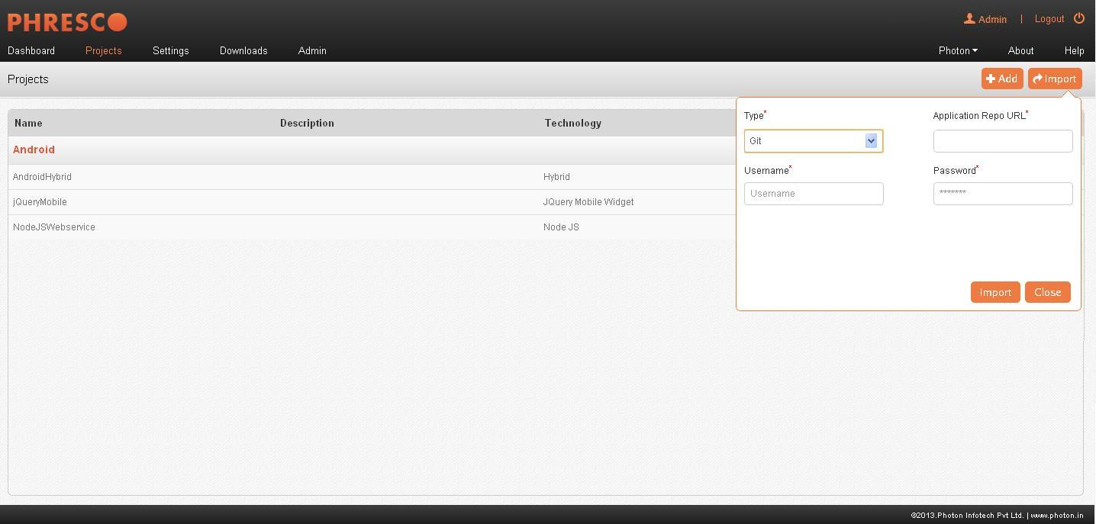

***Figure* 5-3: *Import Project from GIT***

**Fields in import application are as follows**

**Application Repo URL**

URL of the GIT repository to be imported into Phresco framework.

**Username**

Username of the private repository for the private customers. This field is not mandatory and the public repository can be used by the customers.

**Password**

Password of the private repository for the private customers. This field is not mandatory and the public repository can be used by the customers.

### Add to Repo & Commit to Repo

Using Phresco, users can add their files to SVN repo and can also commit and update them. A detailed procedure for updating the applications is given in the next section. Unlike SVN, Git repo can only be updated.

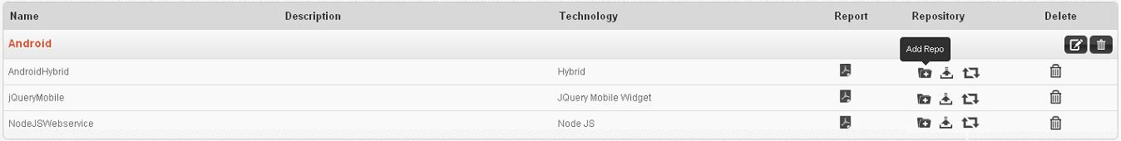

***Figure* 5-4: *Add, Update and Commit to Repo***

### Update Application in SVN and GIT

The applications imported using SVN and GIT can be updated by clicking the update icon available next to the application name in the Projects page. On clicking the update icon a pop up appears with two options.

**SVN**

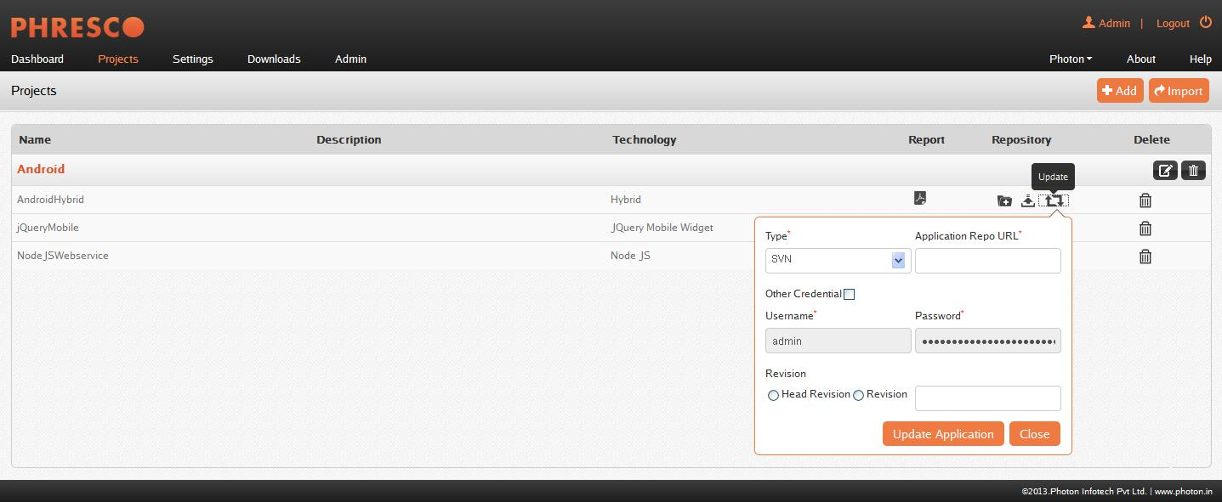

***Figure* 5-5: *Update Application - SVN***

**Fields in the update application are as follows**

**Application Repo URL**

URL of the SVN project to be imported into Phresco framework.

**Other credential**

Enter the SVN credentials if it is different from the one used to sign in to Phresco.

**Username**

The username used to login to the framework will be the default value in this field. This can be changed using the Other Credential option.

**Password**

The password used to login to the framework will be the default value in this field. This can be changed using the Other Credential option.

**Head Revision**

Head revision imports the latest revision of a project from the version controlling system.

**Revision**

Revision is to import a project by providing the revision number. Previously checked in projects can be imported using revision number

**GIT**

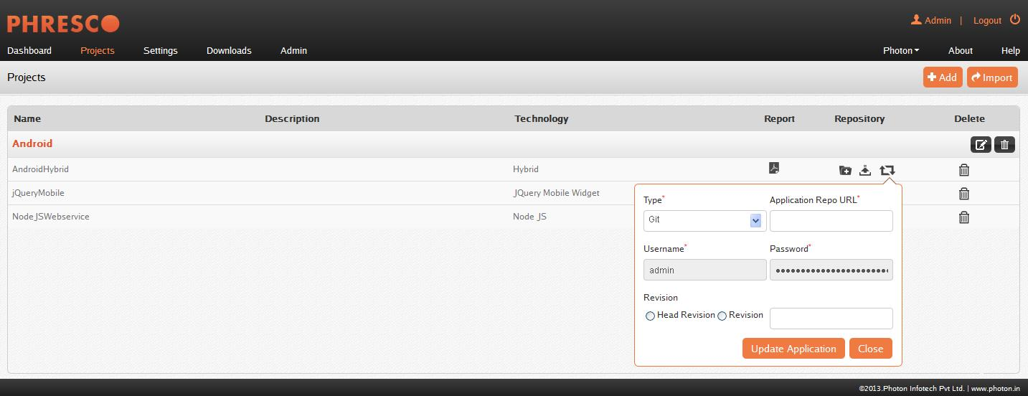

***Figure* 5-6: *Update Application - GIT***

**Fields in the update application are as follows**

**Repository URL**

URL of the GIT repository to be imported into Phresco framework.

**Username**

Username of the private repository for the private customers. This field is not mandatory and the public repository can be used by the customers.

**Password**

Password of the private repository for the private customers. This field is not mandatory and the public repository can be used by the customers.

**5.1.6 PDF Report**

The PDF Reports for the Code Validation, Unit Test, Functional Test, Performance Test and Load Test can be viewed by clicking the PDF Report icon available next to the application name in the Projects page. On clicking the PDF Report icon a pop up appears.

The popup has a Report type dropdown in which the Over All report and Detailed Report values are available. The user can select either the Over All report and Detailed Report and click generate button, the PDF Report will be available.

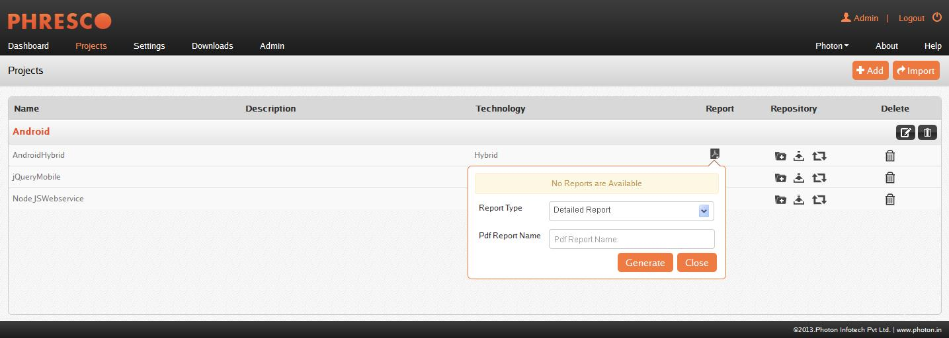

***Figure 5.7: PDF Report Generation***

|  |
| --- |
| * **Note**   For viewing the PDF Reports any one of the below has to be executed   * Code Validation * Unit Test * Functional Test * Performance Test * Load Test |
|  |

## Edit Project

The project created has configurations that make the project easier to develop & maintain.

### Integration Test

Integration test helps developers in combining individual software modules and testing them as a group.

### Continuous Integration

Phresco offers Continuous Integration support to generate builds automatically and deploy them by scheduling it to a particular time. Testing processes can also be automated. This process reduces the integration problems and help produce a full quality project. It deducts errors that may occur during build, deployment and testing. Detailed reports are automatically generated and are mailed to those in the mailing list specified during the CI configuration process.

*For a detailed explanation and walkthrough on CI, refer Section 9.*

### API Status

It shows the real time availability and performance status of Phresco service. It provides information on the uptime and performance history and any performance issues that may exist.

## Edit Application

The project will be created after selecting the different layers and its components. It is not necessary to select all the three layers for a project. The layers are listed as different applications under one project. Each layer has its own configuration and lifecycle.

### App Info

The App Info encompasses the information about an application. It holds the information about the Server, Database and the Web Service components utilized by a project.

**Fields present in the App info are as follows**

**Name**

It denotes the Name in which a project is created. Maximum text input of the field is restricted to 30 alphanumeric characters and is a mandatory field.

**Code**

It denotes the code in which a project is created. Maximum text input of the field is restricted to 12 alphanumeric characters and is not a mandatory field.

**App Directory**

This field is used to rename the application

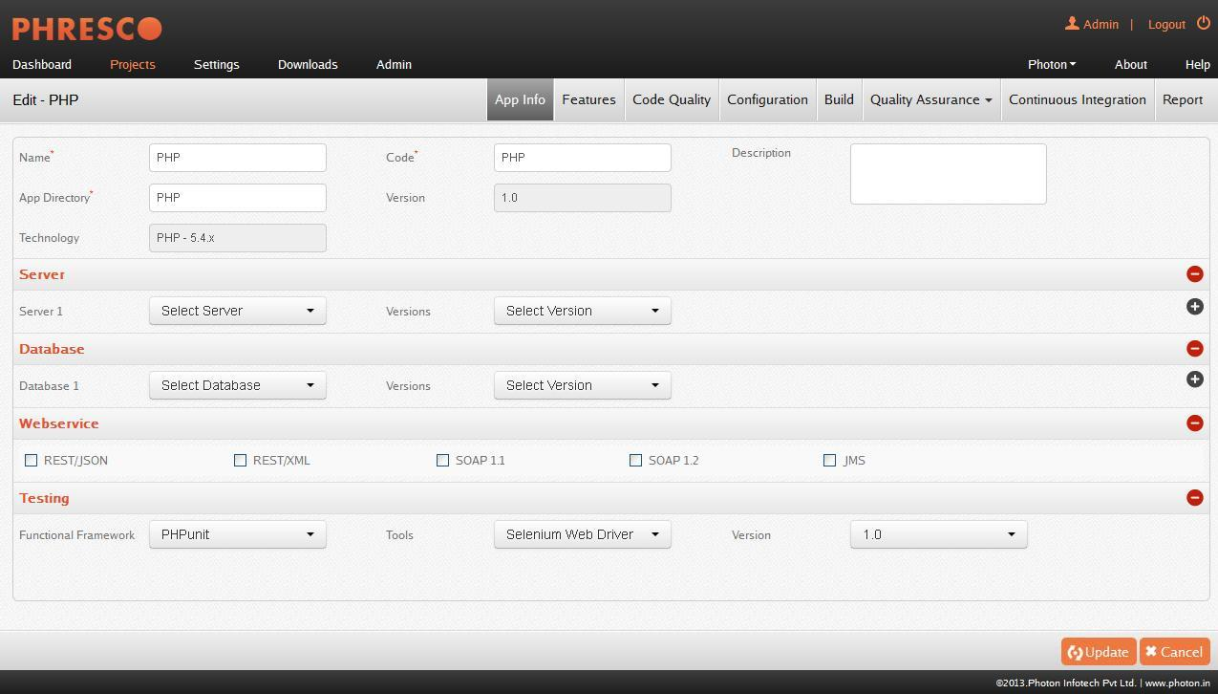

***Figure* 5-8: *Edit Application***

**Description**

It denotes the description of a project created. Up to 150 characters of the field can be entered and is not a mandatory field.

**Version**

It denotes the version of a project. 20 alphanumeric characters with a special character “.” can be entered and is a mandatory field.

**Technology (Archetype)**

This field highlights the technology selected at the time of project creation. This field cannot be altered.

**Servers**

Every organization has an affinity to adopt projects to their in-house servers, saving time and allaying adaptability concerns.

Understanding this need, Phresco has been configured in such a way that the project developed or adopted can run on a wide range of servers available in the market.

The desired server can be selected from the dropdown box in the accordion.

|  |  |
| --- | --- |
| Supported Servers | Versions |
| Apache Tomcat | 7.0.x, 6.0.x, 5.5.x |
| JBoss | 7.1.x, 7.0.x, 6.1.x, 6.0.x, 5.1.x, 5.0.x, 4.2.x, 4.0.x |
| IIS | 7.5, 7.0, 6.0, 5.1, 5.0 |
| Web Logic  Apache | 12c(12.1.1), 11gR(10.3.6), 11g(10.3.1), 10.3, 10.0, 9.2, 9.1  2.3, 2.2, 2.0, 1.3 |
| NodeJS | 0.6.x, 0.7.x, 0.8.x |
| Jetty | 8.x, 7.x, 6.x, 5.x, 4.x |
| SharePoint Server | 2007 |
| MAMP | 2.0.5 |
|  |  |
| LAMP | 0.0.9 |
|  |  |
| WAMP | 2.1e |
|  |  |
| XAMP | 1.7.7 |
|  |  |
| MicroApache | 2.0.64 |
|  |  |
| Apache Tomcat64 | 7.0.25 |

**Databases**

As with the servers, Phresco incorporates popular databases that are widely preferred by organizations. For the same project, Phresco allows more than one database to be shortlisted. In the App info page, the developers can choose their preferred database from the list.

|  |  |
| --- | --- |
| Supported Databases | Versions |
| MySQL | 5.5.1, 5.5, 5.1, 5.0, 4.1, 4.0 |
| Oracle | 11gR2, 11gR1, 10gR1, 10gR2 9iR2, 9iR1, 8iR3, 8iR2, 8iR1, 8i |
| MongoDB | 2.0.4, 1.8.5 |
| DB2 | 10, 9.7, 9.5, 9 |
| Microsoft SQL | 2012, 2008R2, 2008, 2005 |

|  |
| --- |
| * **Note**   Oracle database requires a dependency jar file. This jar should be used with a proper license and hence the users should manually add the dependency tag in the pom file which points the file path present in the local machine. Below is the example code snippet  <dependency>  <groupId>com.oracle</groupId>  <artifactId>ojdbc14</artifactId>  <version>10.2.0.</version>  <scope>system</scope>  <systemPath>DRIVER NAME:/oracle/webdriver/ojdbc14--10.2.0.jar</systemPath>  </dependency> |
|  |

**Web Service**

Some of the established Web Services are supported in Phresco Framework. Phresco allows more than one Web Service to be selected from the “App Info” page. From the shortlisted Web Services displayed in the App Info page, the desired option can be chosen.

The supported Web Services in Phresco Framework includes,

* REST/JSON 1.0
* REST/XML 1.0
* SOAP 1.1
* SOAP 1.2
* JMS

### Features

Phresco provides numerous Modules and JS libraries to enhance a project. Every feature contains a feature icon and a brief description.

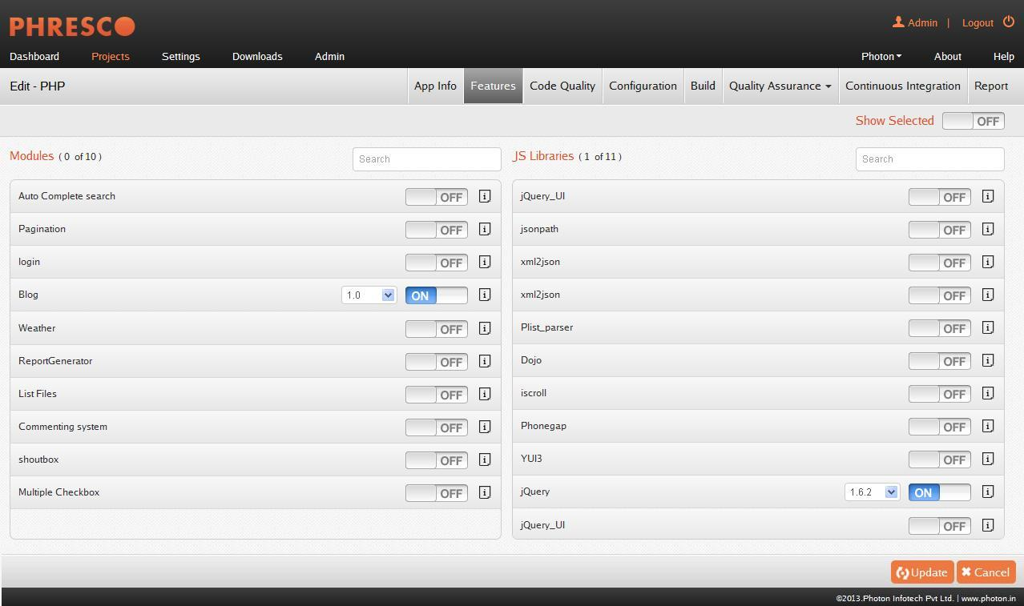

***Figure 5-12: Feature Selection page***

**Modules**

Modules include external features and custom features. External features are out of the box features offered by Phresco to enhance a project. Custom features are customer specific features incorporated in Phresco based on a request from the user.

**JS Libraries**

Phresco offers JS Libraries as out of the box features to alleviate some of the difficulties faced in the development of Java Script based applications.

### Code Quality

Code Validation is a method wherein the source code of a project is tested in compliance with the prescribed standards. Phresco renders code validation by picking up standards for distinct technologies and examining the disparity with codes of a project. The errors are extricated depending on how the errors affect a project. Result is furnished in the form of graph.

Phresco also supports code validation of test cases. Code validation can be done against source code and functional test cases for different technologies available in the validation pop up box. The technologies supported by Phresco for code validation of source are Java, Java Script, HTML and JSP/JSF. This is available only for the widget projects.

For iPhone hybrid, blackberry hybrid and android hybrid technologies, code validation is executed against the targets or static HTML codes. Targets can be selected from the validation report drop down list available next to the Validate tab.

The code validation tool should have been started in order to perform Code validation. When Phresco starts, the code validation tool also starts automatically.

The **Validate** button will be enabled once the code validation tool is started. Otherwise a warning message “Sonar not yet started” will be displayed. Once the code is validated, validation reports for **Source** and **Functional test** are made available in the validation report dropdown box. Use **Skip Unit test** to skip the unit test when performing code validation against source.

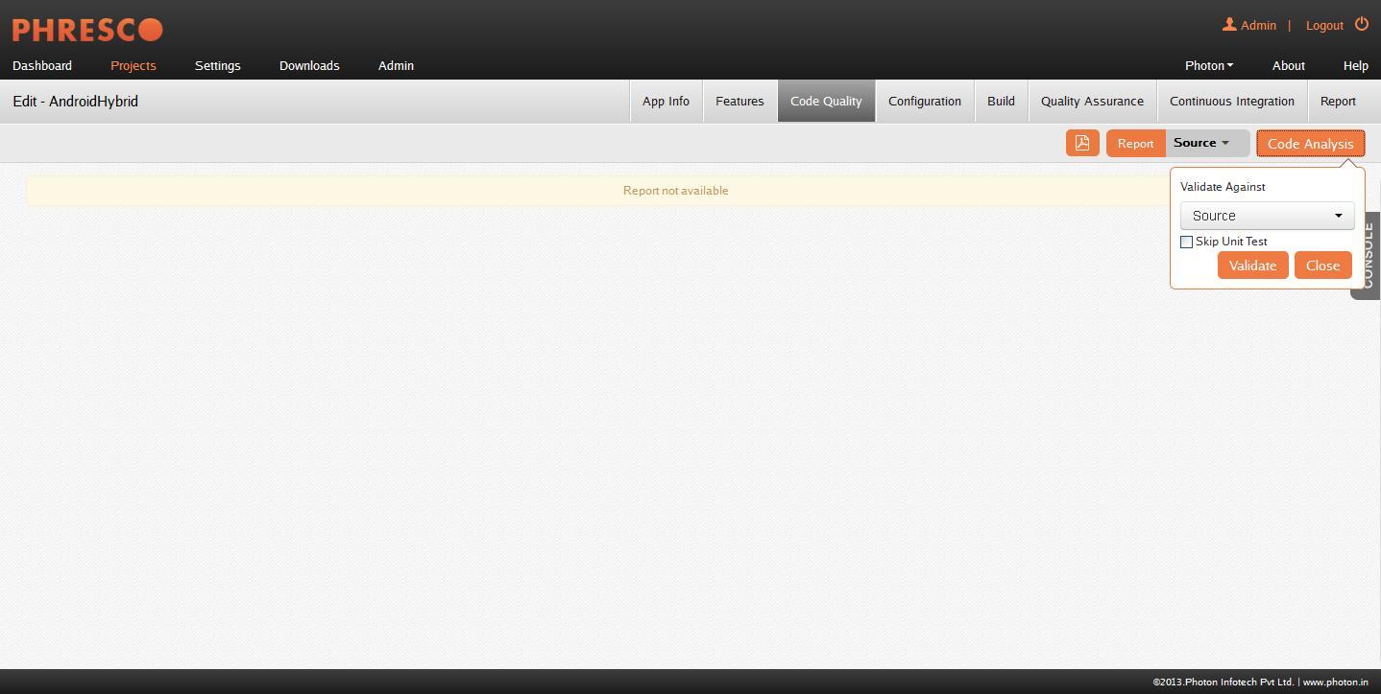

*Figure 5‑14: Code Validation*

**Prerequisites for code validation**

A prior installation of PEAR software is essential to run code validation for PHP, Drupal and WordPress projects.

* PHP Path should be set in environment variable
* Maven path should be set before the installation of Pear
* Pear has to be installed

**To install PEAR in Phresco**

1. Set pear path- {pear installation path}/<APACHE>/bin/php in the environment variables for users

2. Set PHP path- {PHP installation path}/<APACHE>/bin/php/php 5.3.5 in the environment variables for system.

3. To set Maven path in the environment:

* Open a command prompt
* Navigate to Phresco Framework-> bin
* Run the env.bat (windows)/env.sh (Mac and LINUX) for this will set Maven temporarily in the command prompt

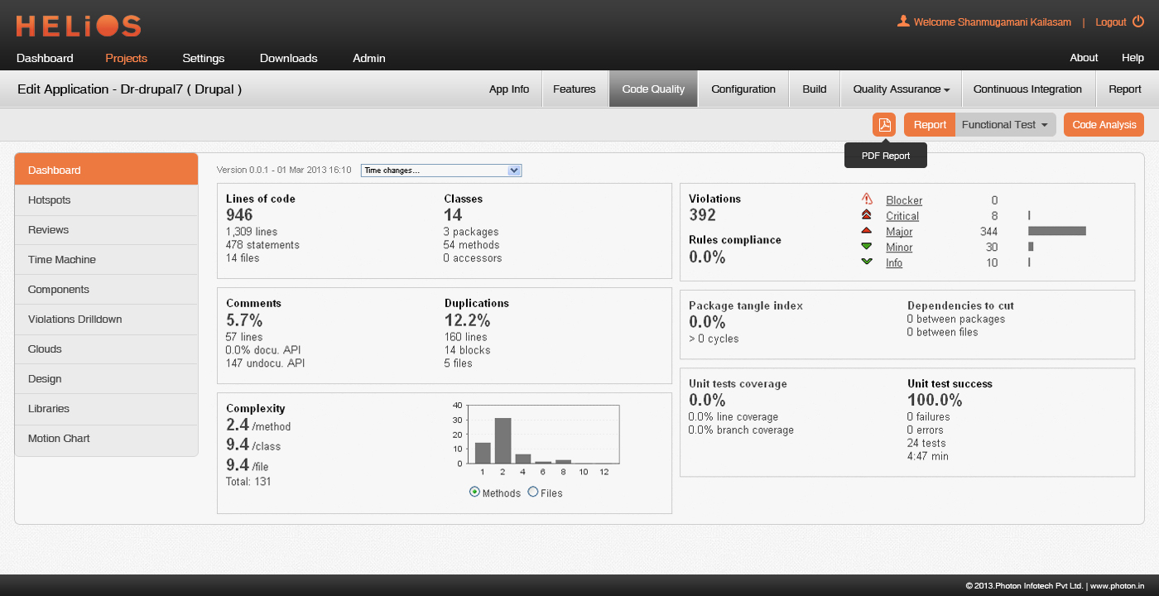

*Figure 5‑15: Code validation report*

* Following this the steps for Pear installation should be carried over in the same command prompt

|  |
| --- |
| * **Note:** * This is carried over only when maven is not available. * Setup for wamp and xamp is available in downloads tab of Phresco. |

4. Download <Php_Drupal_code_validation_setup> from Phresco

5. Extract the zip file.

6. Edit Php_Drupal_code_validation_setup-> PearInstall-> setup.bat.

7. Configure

8. Php path should be set in setup.bat by opening it with edit tool. Below mentioned is the syntax to set the php path.

9. Call pear.bat <php path>

10. E.g.: call pear.bat <driver_name>:\<APACHE>\bin\php\php5.3.5

11. Execute setup.bat in Command Prompt / Terminal

12. On the execution of the command there are few steps which require User's input

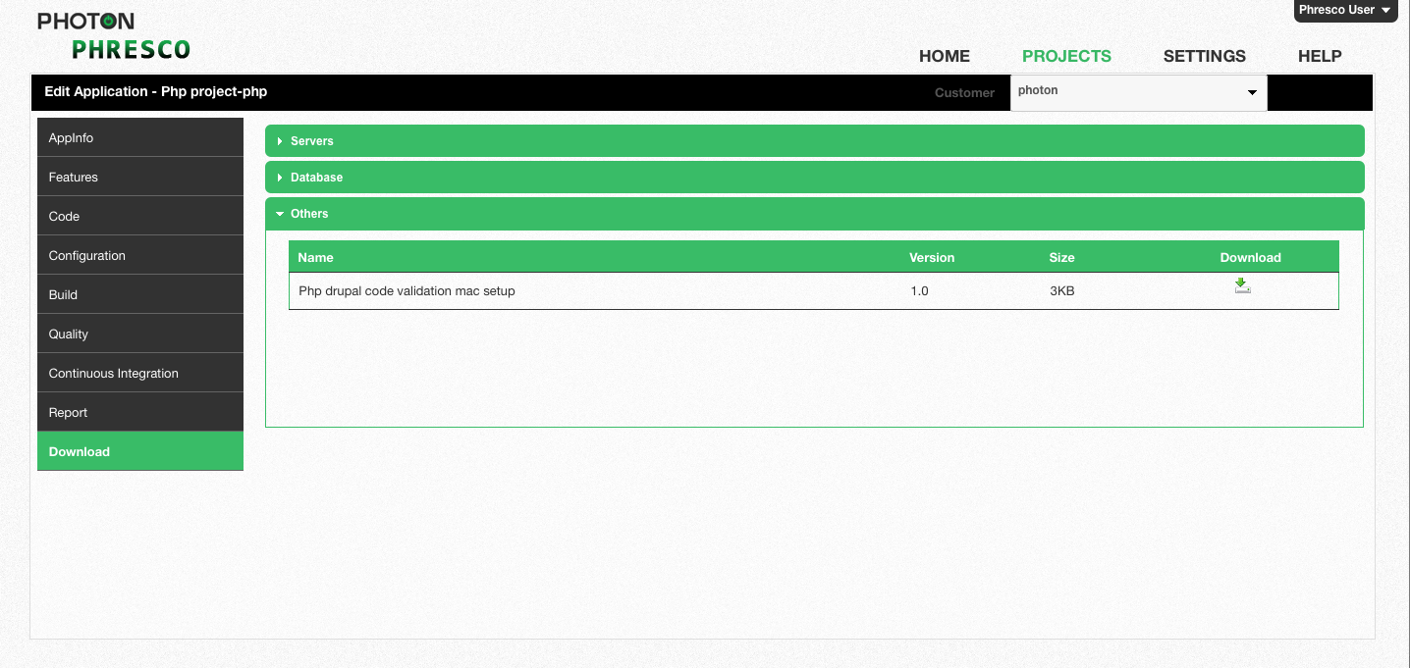

*Figure 5‑16: Downloading Php_Drupal_code_validation_setup for pear installation*

**Steps which requires user input**

1. *Are you installing a system-wide PEAR or local copy?*

Select an option or if it takes time to respond, a default value will be chosen by the system itself.

The default value would be <*system:local> [system] :*

Press Enter.

1. *1-12, 'all' or Enter to continue: _*

Press enter.

1. *Would you like to alter php.ini <driver_name>:\<APACHE> \bin\php\php5.3.5\php.ini>? [Y/n] :*

Type y and press enter.

1. *Press Enter to continue:*

Press enter.

1. *Press any key to continue*

Press enter.

1. *<driver_name>:\<APACHE>\bin\php\php 5.3.5>call pear upgrade pear*

Wait till the system downloads the file.

1. *After downloading system pops up with a message box.*

Are you sure you want to add the information in <driver_name>:\<APACHE> \bin\php\php5.3.5\PEAR_ENV.reg to the registry?

Click yes.

1. *Click ok in the message box stating “Information in <driver_name>:\<APACHE>\bin\php\php5.3.5\PEAR_ENV.reg has been successfully entered into the registry”*
2. *After the installation of PEAR and when the build is success*

*Press any key to continue*

Press any key.

|  |
| --- |
| * **Note:** * When Pear is installed for the first time, the standards need not be downloaded. * When Pear is already installed in the machine, Drupal standards should be downloaded for Drupal projects from download link and WordPress standards should be downloaded for WordPress projects (refer fig: 5.6) * The standards should be pasted in the path,   **For Windows,**  "<DRIVER_NAME>\Apache \bin\php\php5.3.5\PEAR\PHP\CodeSniffer\Standards"  **For Mac**  "/usr/local/pear/share/pear/PHP/CodeSniffer/Standards" |
|  |

### Environment Configuration

Environment Configuration is the powerful feature of Phresco for managing multiple environments in a project, where a single build can run on multiple environments without any configuration changes in build.

Environment set up in Phresco user interface is made very simple and the developers can create any number of environments to deploy a single build. The environment configurations with user credentials and other significant data are stored in Phresco-env-config.xml. Hence Phresco encrypts this xml file for the technologies like PHP, Drupal and WordPress to hold intact data.

When the environment to be deployed is not selected, the application selects the default environment for the applications. The default environment can be switched over between any environments that are created using Phresco Framework.

|  |
| --- |
| * **Note** * For the successful installation of Drupal the following changes has to be enabled. * Extension of php_mcrypt in php.ini should be added with php_mcrypt.dll. |

**Creating an Environment**

Multiple environments can be created from the Edit Application page by clicking the **Application created -> Configuration -> Add Environment**

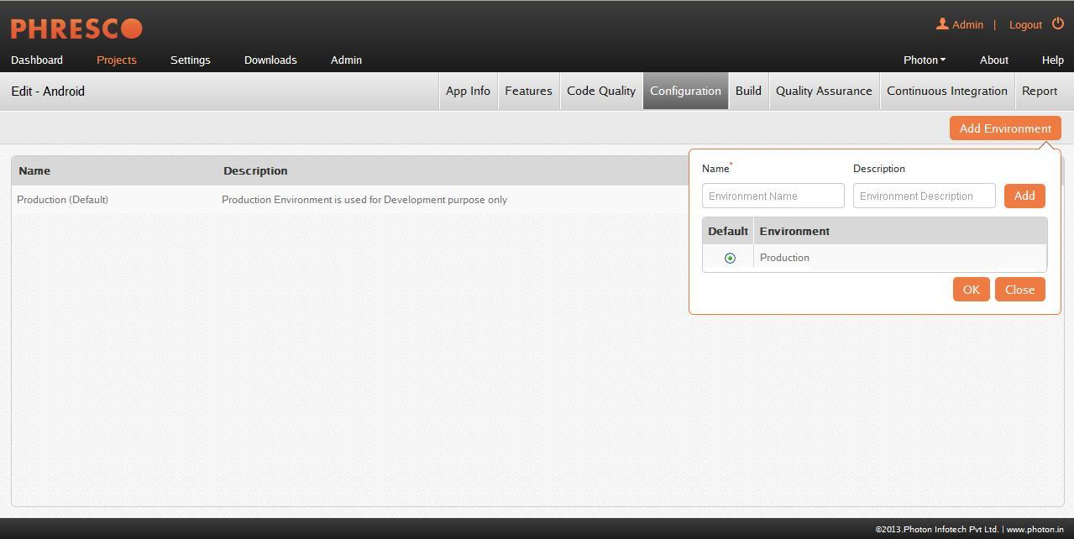

***Figure* 5-17: *Environment Creation***

Server, Database, Web Service, Email, SAP and LDAP can be configured in **Application created->Configuration->Add**.

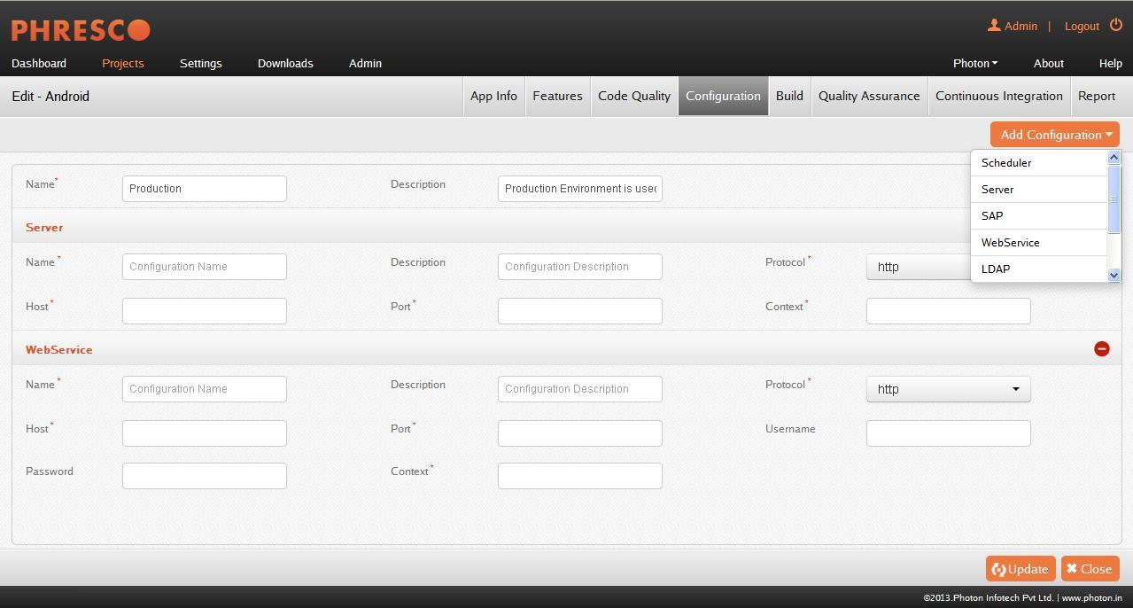

***Figure* 5-19: *Environment Configuration***

|  |
| --- |
| * **Note** * Multiple environments can be associated when building a project. * Projects can be deployed only in one environment at a time. * In web application only one environment can be selected at a time for functional, performance and load testing whereas for mobile application environments cannot be selected. |

**Advantages**

Phresco also allows user defined configuration template. New configuration templates can be published in Phresco server which would be immediately seen in the drop down list of configuration page. For example log4j template can be published in Phresco server which can be used across a project.

When the environment is created in the global settings, it can be used globally across projects using the show settings option.

#### Configuration Types

##### **Server Configuration**

The server configuration can be added using Configure option in the Environment list page.

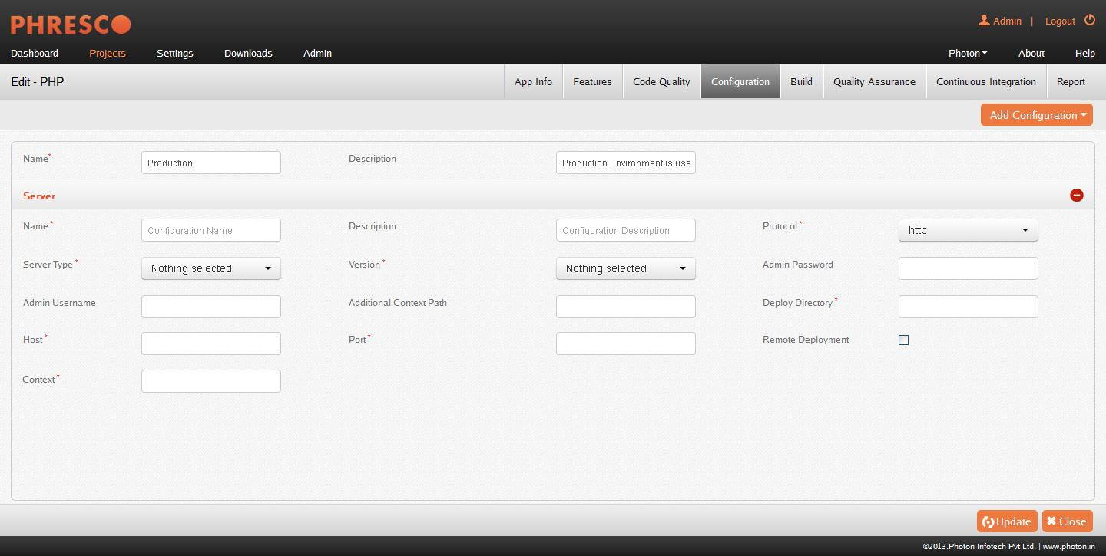

***Figure 5-20: Server Configuration for an environment***

Mentioned below are the details to be filled for server configuration:

**Name**

It denotes the Name in which a project is created. Maximum text input of the field is restricted to 30 alphanumeric characters and is a mandatory field.

**Description**

It denotes the Description of a project which is created. This field supports 150 alphanumeric, special characters and is not mandatory.

**Protocol**

Protocol should be selected to access the application from dropdown box. http and https are the two types of protocols available. This field is mandatory.

**Server Type**

This contains the list of servers that was already short listed in the app info page. Only one server can be selected from the list.

**Version**

Version of the selected server will be displayed here.

**Admin Username**

It denotes the Admin Username of the server in which a project is created. This field supports alphanumeric, special characters and is not mandatory.

**Admin Password**

It denotes the Admin Password of the server in which a project is created. This field supports alphanumeric, special characters and is not mandatory.

**Additional Context Path**

A project’s additional context path can be specified here which can also include special characters.

**Deploy Directory**

Deploy directory of the server on the instance should be filled in this field. It is not a mandatory field and supports alphanumeric and special characters.

**Host**

It denotes the Host in which a project is created and is mandatory.

**Port**

Port number of the server and it must be between 1 and 65535. This field is mandatory and only numeric characters are supported.

Port number should be selected such that the port does not run any other application which will not be known by the configuration.

**Remote Deployment**

The checkbox can be enabled to deploy a project in remote machine. Admin Username and Admin Password fields are mandatory for remote deployment.

**Context**

Root context of the server can be specified here. It does not allow special characters. This is a mandatory field.

**For example** http//localhost:2468/Phresco/login#. Here Phresco is the root context and login# is the additional context path.

|  |
| --- |
| * **Note** * By providing a port number for the server configuration and clicking on   RunAgainstSource button for java projects, the inbuilt tomcat will reserve the next immediate port number for tomcat shutdown service.   * For example: If “7070” is provided as port number in server configuration   and RunAgainstSource is clicked, “7071” port will be reserved.  So configuring the port number “7071” in any other server configuration in a different project and clicking on RunAgainstSource will result in bind exception. |

##### **Database Configuration**

**Name**

It denotes the Name in which a project is created. Maximum text input of the field is restricted to 30 alphanumeric characters and is a mandatory field.

**Description**

It denotes the Description in which a project is created. This field supports 150 alphanumeric, special characters and is not mandatory.

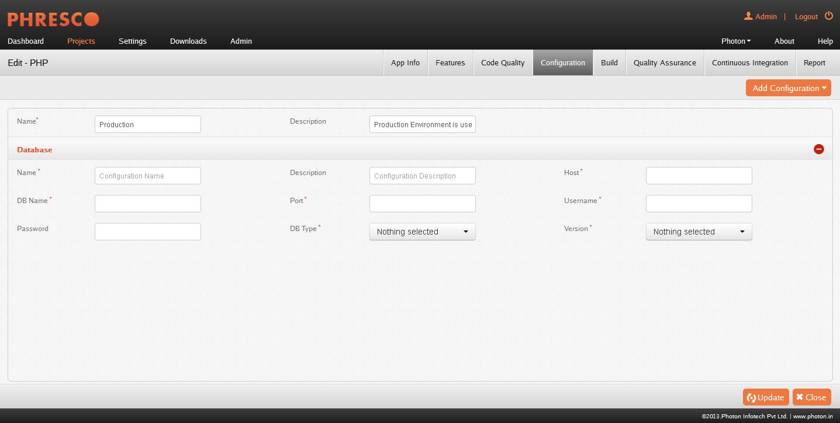

***Figure 5-21: Database Configuration for an environment***

**Host**

It denotes the Host in which a project is created and is mandatory.

**Port**

It denotes port number of the database. Port number must be between 1 and 65535. This field is mandatory and only numeric characters are supported. Port number should be selected such that the port does not run any other application which will not be known by the configuration.

**Username & Password**

It denotes Username and Password to access the database. Username is “root”.

**DB Name**

Database name should be entered and this field supports alphanumeric and special characters.

**DB Type**

This contains the list of database that is already short listed in the app info page.

**Version**

Version of the selected database will be displayed here.

##### **Web Service Configuration**

**Name**

It denotes the Name in which a project is created. Maximum text input of the field is restricted to 30 alphanumeric characters and is a mandatory field.

**Description**

It denotes the Description in which a project is created. This field supports 150 alphanumeric, special characters and is not mandatory.

**Protocol**

Protocol should be selected to access the application from dropdown box. http and https are the two types of protocols available. This field is mandatory.

**Host**

It denotes the Host name of the web service in which a project is created and is mandatory.

**Port**

This field is the port number of Web Service. Port number must be between 1 and 65535. This field is mandatory and only numeric characters are supported.

Port number should be selected such that the port does not run any other application which will not be known by the configuration.

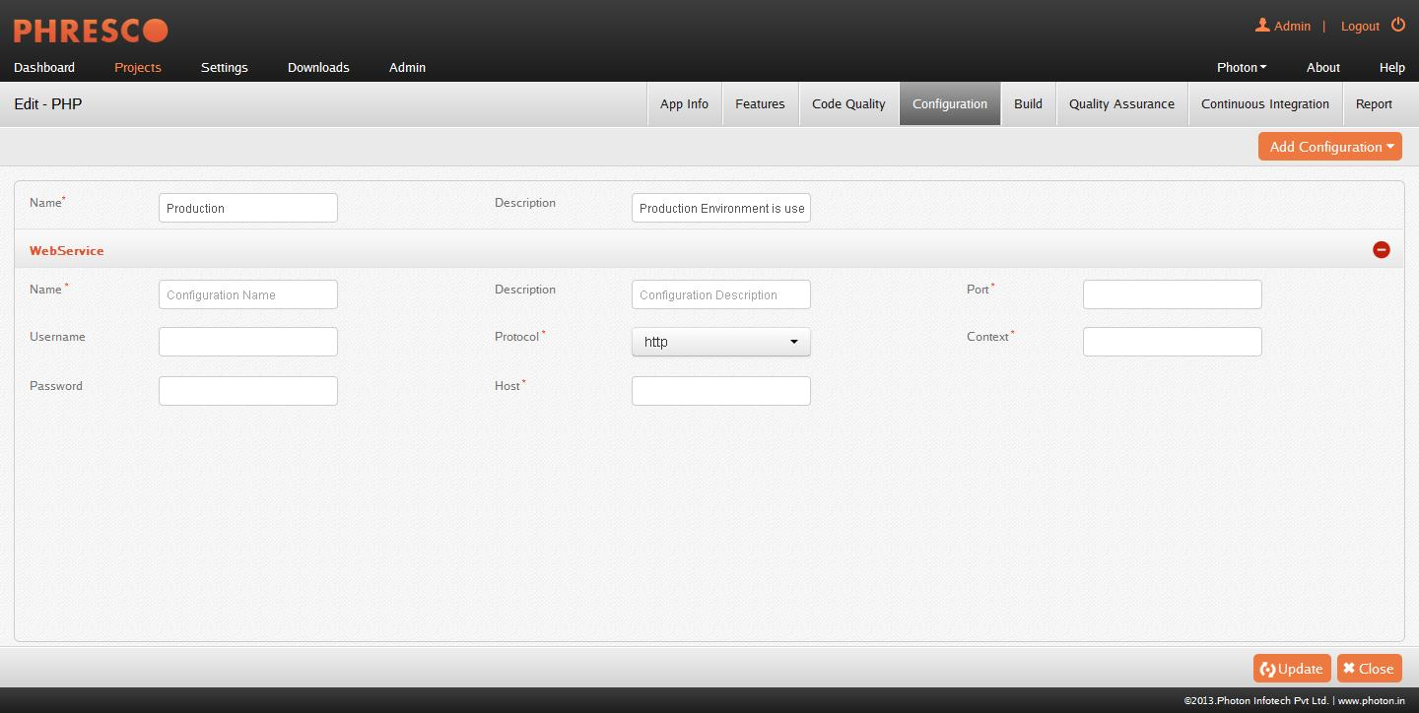

***Figure 5-22: Webservice Configuration for an environment***

**Username and Password**

It denotes Username and Password to access the webservice.

**Context**

Context of the web service can be entered in this field and is mandatory.

#### Email Configuration

**Name**

It denotes the Name in which a project is created. Maximum text input of the field is restricted to 30 alphanumeric characters and is a mandatory field.

**Description**

It denotes the Description in which a project is created. This field supports 150 alphanumeric, special characters and is not mandatory.

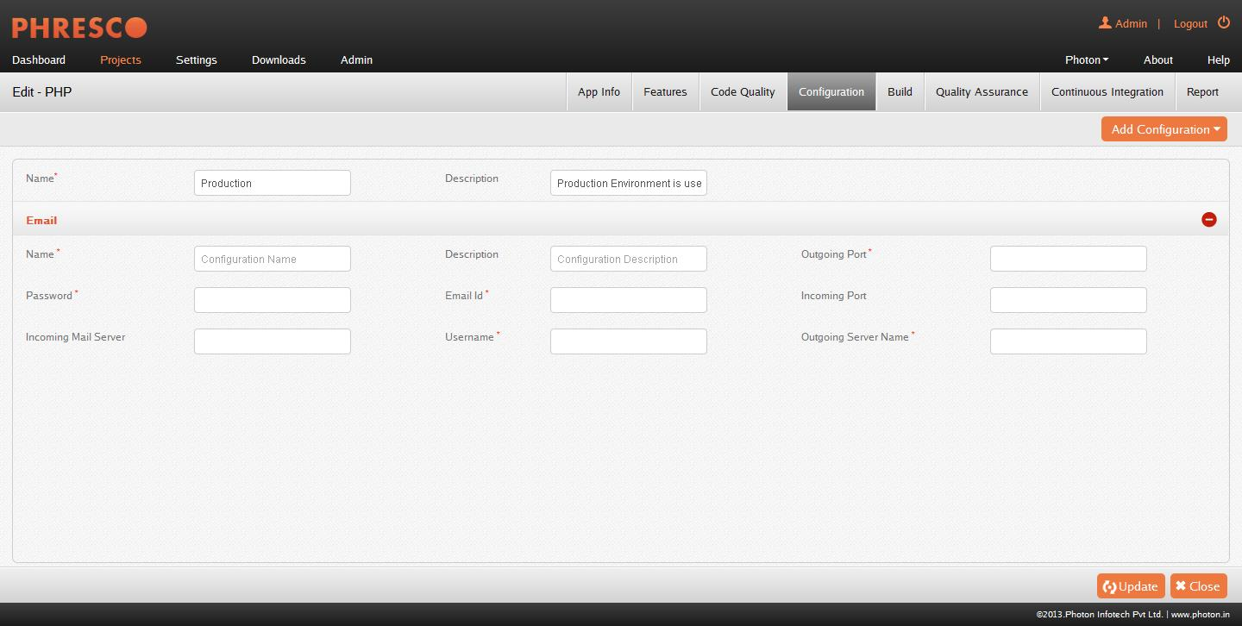

***Figure 5-23: Email Configuration for an environment***

**Incoming Mail Server**

The incoming mail server configuration can be entered and this field is not mandatory.

**Incoming Port**

Incoming mail server’s port can be entered and this field is not mandatory.

**Outgoing Server name**

The outgoing mail server configuration can be entered and this field is mandatory.

**Outgoing port**

The outgoing mail server’s port can be entered and this field is mandatory.

**Username & Password**

It denotes username& passwordcredentials to access the mail server.

**Email Id**

It denotes the email id in which the recipient receives the email notifications.

##### **SAP Configurations**

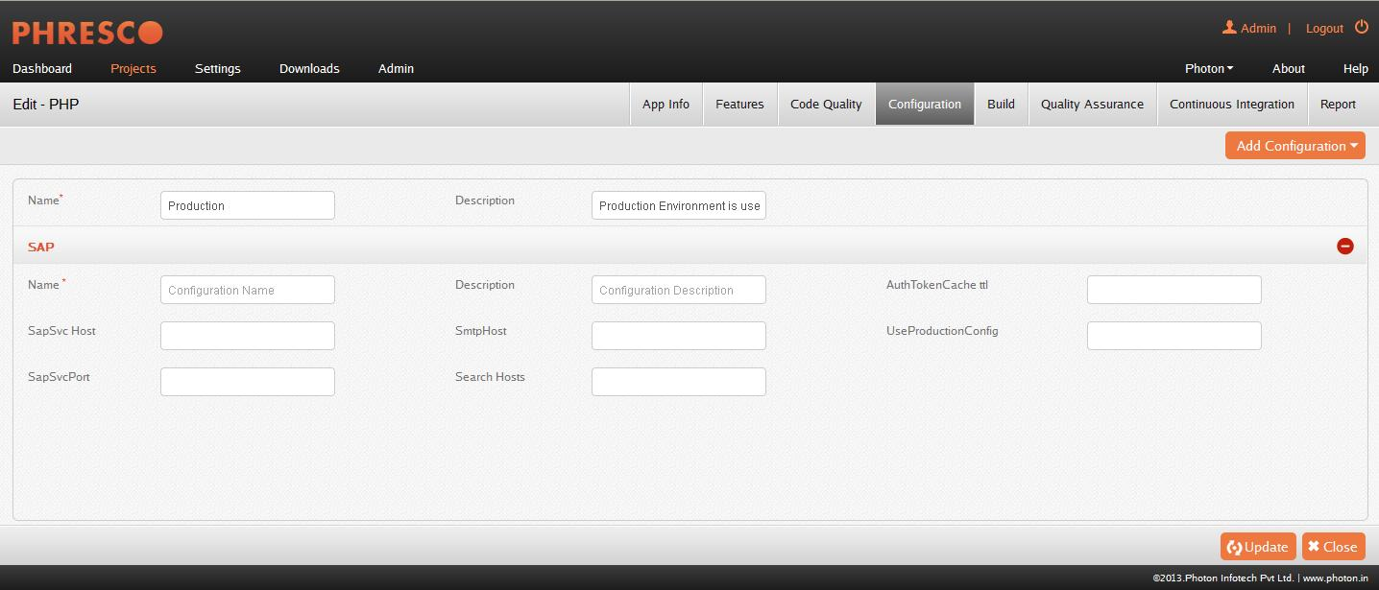

***Figure 5-24: SAP Configuration for an environment***

**Name**

It denotes the Name in which a project is created. Maximum text input of the field is restricted to 30 alphanumeric characters and is a mandatory field.

**Description**

It denotes the Description in which a project is created. This field supports 150 alphanumeric, special characters and is not mandatory.

**Search Hosts**

This field is to search the host of the SAP Server. It supports alphanumeric, special characters and is not a mandatory field.

**SapSvcHost**

It denotes the Host name of the SAP Server in which a project is created and is not a mandatory field.

**SapSvcPort**

This field is the port number of SAP Server. This field supports alphanumeric, special characters and is not mandatory. Port number should be selected such that the port does not run any other application which will not be known by the configuration.

##### **Cloning the Configurations**

Apart from the advantages and various configuration types in Phersco, users are also allowed to clone the configurations for different environments created. Instead of creating many server or database configurations for different environments, single server or database configuration can be cloned. This cloning of configurations is available for all the types of configuration including the dynamic configuration.

A configuration can be cloned from one environment to other by clicking the clone icon present next to the configuration that is created. A pop up appears to choose the environment for which the configuration is to be cloned.

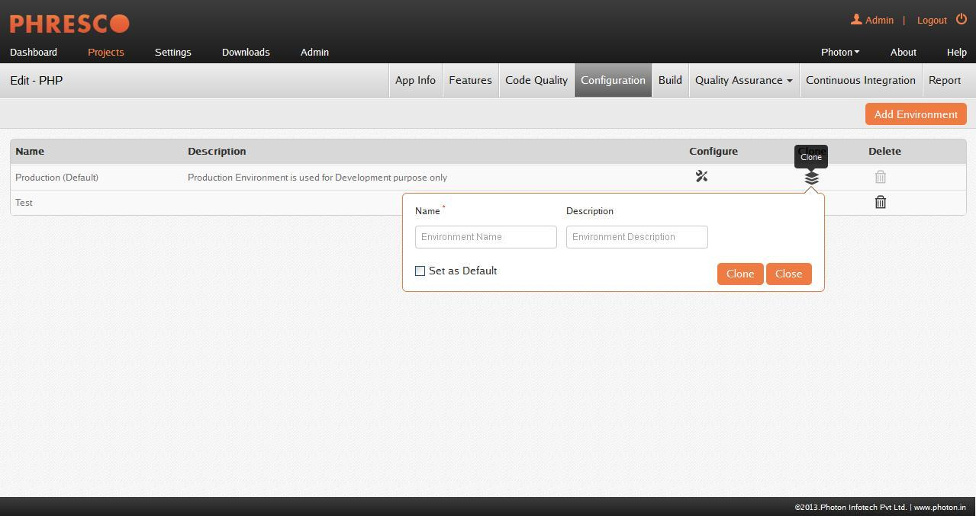

***Figure* 5-26: *Cloning configuration***

**Fields in cloning configuration are as follows**

**Name**

Name of the configuration to be cloned

**Description**

Description of the configuration to be cloned

### Build Generation

The process of converting source code files into standalone software artifacts to run on a computer. The important process of the build generation is converting a source code into executable codes.

Project build process can be selected from Project list ->Applications->Build->Generate Build**.**

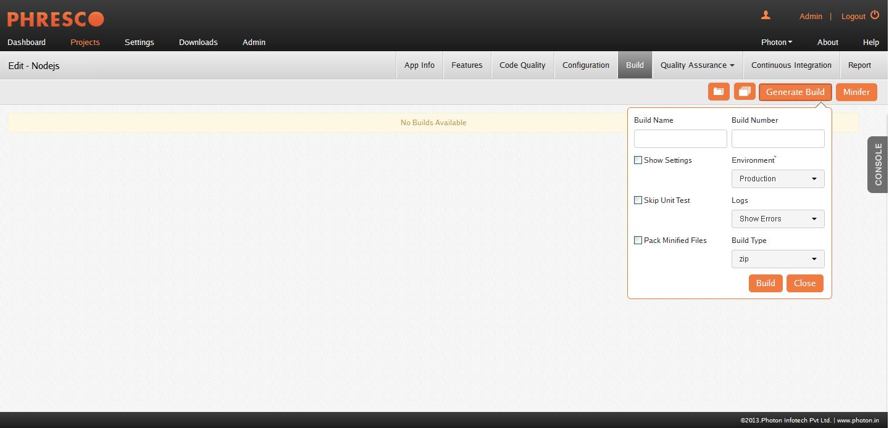

***Figure* 5-28: *Generating Build***

**Fields in the Generate Build are as follows**

**Build Name**

Name of the build to be generated

**Build Number**

Number of the build to be generated

**Show Settings**

The global configurations for server, database, web service and email can be selected using the show settings option.

**Environment Selection**

Multiple environments can be selected to build a project in the environment field and production environment will be already selected as default.

**Logs**

Selecting Show error in the logs will provide the error information along with the log for build generation.

Hide log hides the log console and provides only the error message while generating the build.

**Skip Unit Test**

Phresco enables skip unit tests where the unit tests will be skipped on building a project. This consumes less time on building a project.

**Build Type**

Use this option to download the build as a war file or zip file based on the need.

|  |
| --- |
| * **Note:**   Generate build pop-up varies according for different technologies |

## Project Deployment

Project deployment is interpreted as a general process that should be customized according to the requirement and characteristic of a particular project which makes a project available for use. After the build generation process, a deploy icon appears on the screen. On clicking the icon, deploy pop up box appears which has environment selection, show error and hide log check boxes which has the same functionality as in build generation.

**Deployment: Execute SQL**

Phresco provides an option to execute the SQL scripts to the configured database while deploying the application. To enable this feature, the Execute SQL checkbox should be selected in the deploy pop up.

* When the environment is selected in the environment field, the database chosen for that corresponding environment will be displayed in the database field.
* The site.sql files depending on the features selected in the features page will be displayed in the box on the left side as a list.
* Users can select the desired site.sql using the arrows present in the user interface and deploy the application.

|  |
| --- |
| * **Note** * The prerequisite for executing the SQL script is that, the configured database schema should be created in the database. * In MongoDB, execute SQL will export BSON files instead of SQL files. |
|  |

### Remote Deployment

The application package can be deployed to a local machine or remote machine. Phresco enables the remote deployment concept whenever there is a requirement to deploy to a remote staging or production machine.

**Enabling Remote Deployment**

Remote deployment in Phresco can be done by selecting the remote deployment in the server configuration screen and by entering the host (IP address of the remote system), port (server port of the remote system), admin username (admin username of the server) and password (admin password of the server).

**Application Servers supported in Phresco for Remote Deployment**

* Apache Tomcat – Above 6.x
* JBoss (Restricted to 4.x & 7.x)
* WebLogic (Restricted to 10.3.6, 12c)

**Web Logic Server**

For remote deployment using the Web Logic server, make the following changes in the Web Logic server configuration. Go to Domain Configurations in the Home page and select Domain -> Web Applications. Select the Archived Real Path Enabled check box and restart the server. This change is needed to launch pilot project in that server.

**Apache Tomcat**

Edit tomcat-users.xml in the path apache tomcat /conf/tomcat-users.xml and add the following

<role rolename="manager"/>

<role rolename="admin"/>

<role rolename="manager-gui"/>  
<role rolename="manager-script"/>  
<user username="admin" password="admin" roles="manager-gui, manager-script, admin, manager"/>

<plugin>

<groupId>org.codehaus.mojo</groupId>

<artifactId>tomcat-maven-plugin</artifactId>

<version>1.1</version>

<configuration>

<username>admin</username>

<password>admin</password>

<url> URL </url>

<path>/${project.build.finalName}</path>

</configuration>

</plugin>

|  |
| --- |
| * **Note:**   Server should be up and running during remote deployment. |

## Enabling https in Phresco

**http**  
  
Phresco supports http (Hypertext Transfer Protocol) which is used for accessing resources normally. Phresco runs in the port number “2468”.  
  
**https**  
  
Phresco additionally supports https ((Hypertext Transfer Protocol over Secure Socket Layer). This can be configured for the projects by using the following steps.

1. Edit server.xml in server/conf folder of tomcat installation.
2. Add the below details with preferred port, and keystore location

     
   <Connector port="<PORT NUMBER>" SSLEnabled="true"  
              maxThreads="150" scheme="https" secure="true"  
              keystoreFile="<KEYSTORE FILE" keystorePass="<PASSWORD>"  
              clientAuth="false" sslProtocol="TLS" />

1. Rerun the tomcat server and this will connect Phresco in secure connection

Remote deployment through https is also possible in Phresco only if valid certificate is selected from the User Interface. This is possible by clicking the Add certificate option after selecting the Remote deployment checkbox. The certificate from the local system can be browsed and attached.

## Project Testing

Testing can be stated as the process of validating and verifying that a project

* Meets the requirement that guides its design and development;
* Works as expected; and
* Can be implemented with the same characteristics.

Many type of testing process can be done for a single project and it consumes more time. Using Phresco framework circumvents the troubles associated with testing.

**Report generated in PDF**

Reports can be generated in the form of PDF which includes total report of all the test cases and also the code validation report when the report icon is clicked. The generated PDF can be sent to the stakeholders when there is a need.



***Figure* 5-29: *PDF Report Generation***

There are four types of testing process available and they are categorized into the following:

### Unit Testing

Unit testing ensures that the developers write proper project implementation. For Unit testing, coverage and reporting Phresco framework uses many tools like JUnit, NUnit, WSUnit, PHPUnit, NodeUnit, and OCUnit for different technologies. The results are provided both in a tabular and graphical output format indicating the ratio of success, failure or error among the test cases.

#### Unit testing for iPhone

In Phresco, execution of Unit Test differs for iPhone applications.On clicking **Test** button from **Unit** Tab, the below pop-up appears.

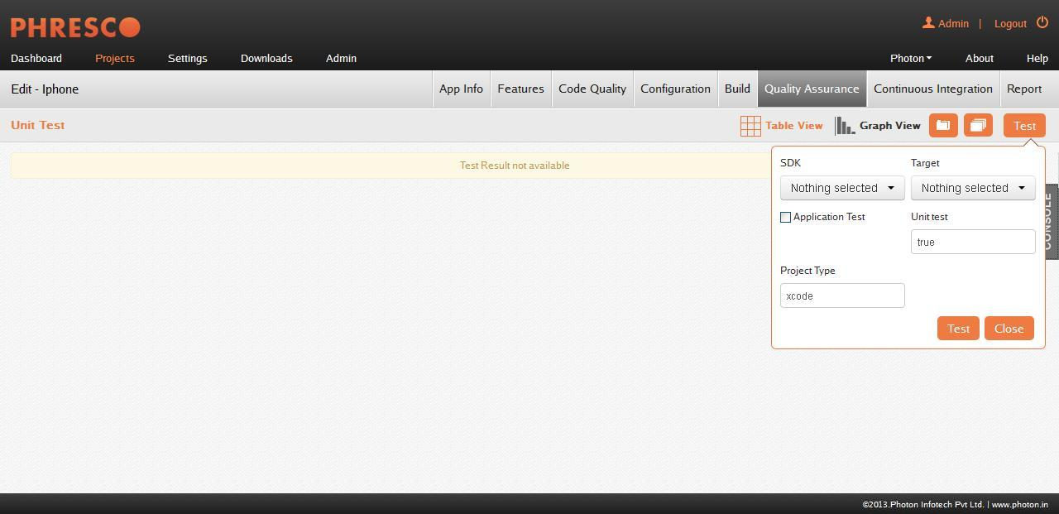

***Figure 5-30: Unit Test for iPhone Application***

**SDK**

SDK versions installed in the system will be displayed in this field and the SDK in which tests needs to be executed can be selected from this drop down box.

**Target**

Targets will be listed in this drop down user can select the target to be executed from this drop down box.

**Application Test**

Application Test can be performed by selecting the Application Test in the Target drop down and by checking the Application Test check box.

|  |
| --- |
| * **Note:** * Refer section 8.8.1 for detailed information on Logic and Application Tests for iPhone applications * A PDF report of the executed tests can also be generated using “Report” icon as shown |

### Functional Testing

Functional testing involves testing on the specifications of a project under test. Functions are tested by feeding them input and examining the output.

Functional testing involves

* Identifying functions the software is expected to perform.
* Creating input data based on the function’s specifications.
* Determining output based on the function’s specifications.
* Executing test cases.
* Comparing actual outputs and expected outputs.

Functional testing uses tools like selenium, Robotium, M0nkey Talk and Xcode. The result is given through static analysis and test cases.

#### Functional Test execution for Widgets, PHP, Nodejs & Java Webservices

The functional test cases can run in different browsers parallely in different machines that are supported by Phresco using the Selenium Grid.

Though Phresco supports Selenium Grid by default, Selenium Webdriver testcases can also be executed for the above mentioned technologies.

Changes that has to be made for Selenium Webdriver Support:

* Go to directory D:\Phresco-Build<version>\phresco-framework\ workspace\projects\Your_Project
* Open the pom.xml and replace the value grid to webdriver as shown:

*<phresco.functionalTest.selenium.tool>grid</phresco.functionalTest.selenium.tool>*

|  |
| --- |
| * **Note:**   Refer Section 5.8.4 for detailed explanation on the Functional test execution pop-up for Selenium Webdriver. |

#### Functional Test execution in Selenium Grid

#### Click on the created application in “Project” page and navigate to Quality tab by clicking the Application created 🡪Quality🡪Functional

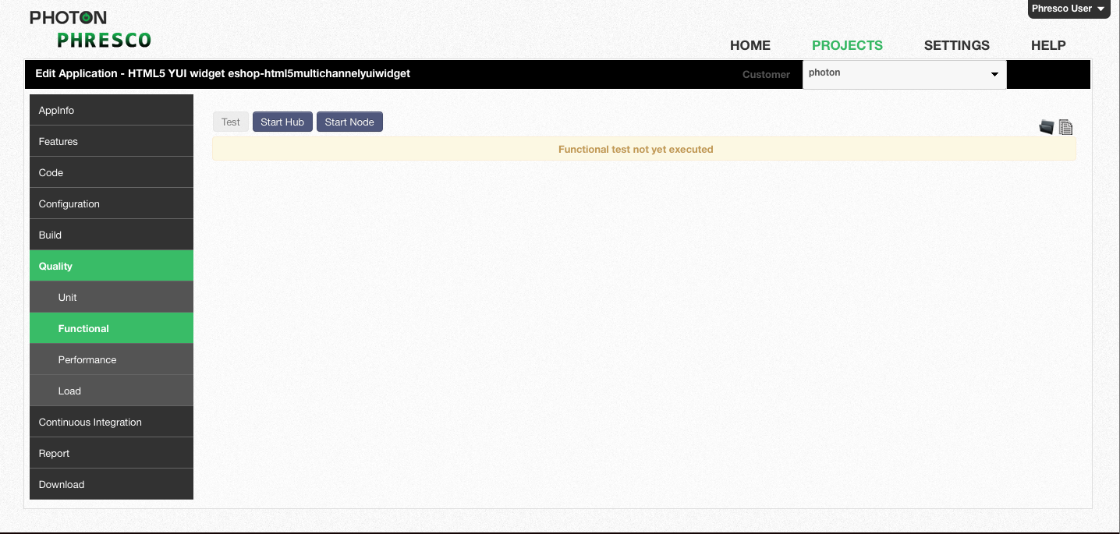

***Figure 5-31: Executing Functional Test***

**Start Hub**

On clicking the **Start Hub** button, the following popup appears:

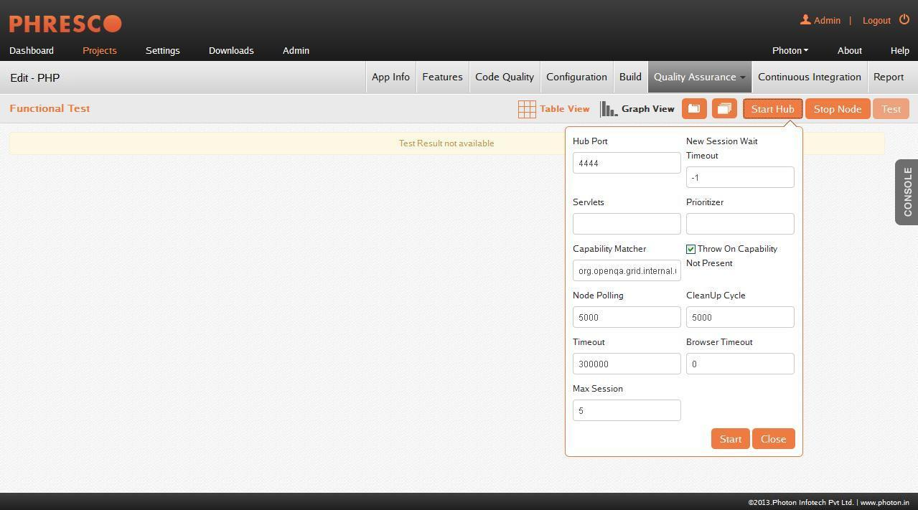

***Figure* 5-32: *Start Hub***

**Hub Port**

This field is to configure the listening port of the hub. Default port is 4444.

**New Session Wait Timeout**

Timeout value required for the test to be executed in node has to be mentioned here in milliseconds.This is not mandatory, however (-1 ms) is set as default in Phresco. When the timeout value for a specific test case exceeds the value as mentioned in “**New Session Wait Timeout**”, the test will throw an exception before starting a browser.

**Servlets**

This is to register a new servlet on the hub/node.

**Prioritizer**

This is a class implementing the Prioritizer interface. It is set to null by default (no priority = FIFO).For example, User needs to specify a custom prioritizer if they need the grid to process the tests from CI, or IE tests first.

**Capability Matcher**

This is a class implementing the CapabilityMatcher interface. Logic that the hub follows to assign requests to the node has to be specified here. This class can be changed if the user wants to have the matching process.For e.g Regular expression can be used instead of exact match for the version of the browser. By default, it is set to org.openqa.grid.internal.utils.DefaultCapabilityMatcher. All the nodes of a grid instance will use the same matcher, defined by the registry.

**Throw On Capability Not Present**

Can be set to either <true | false> and by default it is set to true. If true, the hub will reject the test requests right away when no proxy that can host that capability is currently registered. User can set it to false to have the request queued until a node supporting the capability is added to the grid.

**Node Polling**

It denotes how often the hub checks if the node is still alive.

**CleanUp Cycle**

It denotes how often a proxy will check for timed out thread in milliseconds.

**Timeout**

This refers to the timeout in seconds before the hub automatically ends a test that hasn't had any activity in the last X seconds.

After which the browser will be released for another test to use. This typically takes care of the client crashes.

**Browser Timeout**

Timeout value in seconds for which a browser will hang has to be mentioned here.

**Max Session**

This refers to the max number of tests that can run at the same time on the node, independently of the browser used. The Hub starts on clicking the “**Start**” button after filling all the required details in the Start Hub popup.

**Start Node**

On clicking the “**Start Node**” button the following popup appears

**Hub Host**

This denotes the <IP | hostname>, usually not needed since it is determined automatically. For exotic network configuration, network with VPN, specifying the host might be necessary.

**Hub Port**

This field is to configure the listening port of the hub. Default port is 4444.

**Node Port**

This field is to configure the listening port of the Node. Default port is 5555.

**Max Session**

This refers to the max number of tests that can run at the same time on the node, independently of the browser used.

**Selenium Protocol**

It refers to the selenium protocol that is used to run the Tests.

**Register**

Can be set to either <true | false> and by default it is set to “true” in Phresco. If configured to true, then the node will try to register itself again according to the register cycle set in milliseconds. It can also be set to false if not required.

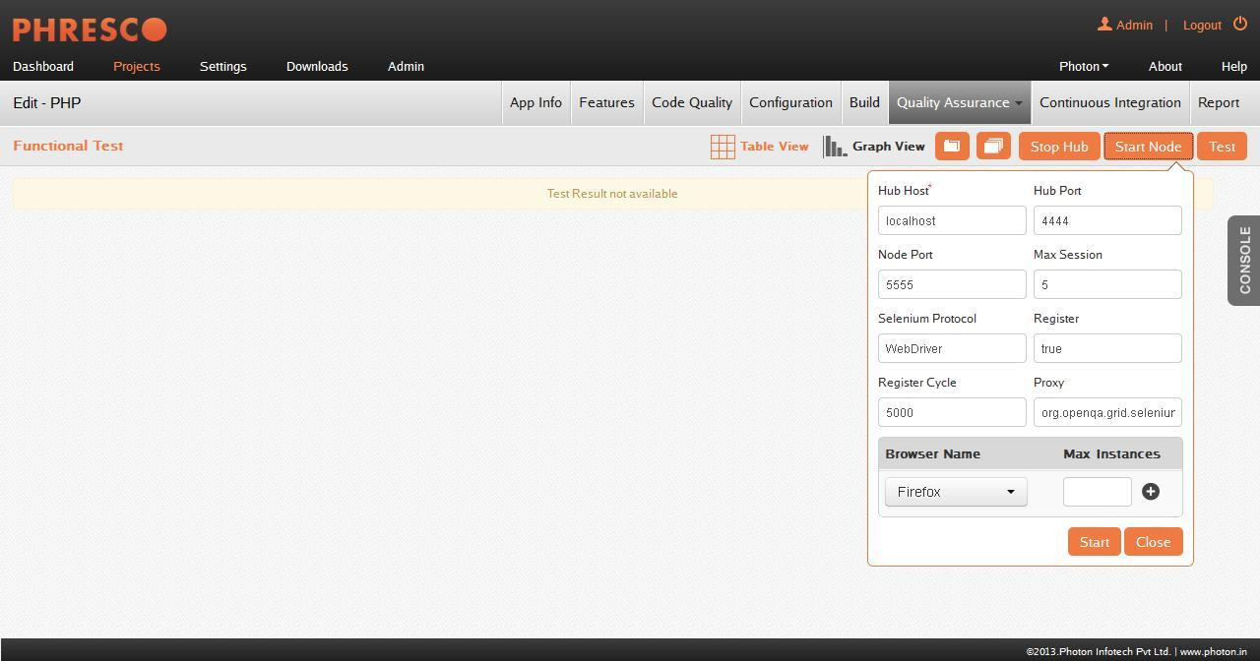

***Figure* 5.33: *Start Node***

**Register Cycle**

It refers to how often the node will try to register itself again (in milliseconds). It allows restarting the hub without restarting the nodes.

**Proxy**

It’s a class that will be used to represent the node. By Default, “org.openqa.grid.selenium.proxy.DefaultRemoteProxy” value is set.

**Browser Info**

This section is used to select the combination of browsers and their maximum instances. The Node starts on clicking the “**Start**” button after filling all the required details in the Start Node popup.

**Test**

On clicking the “**Test**” button, the below popup appears.

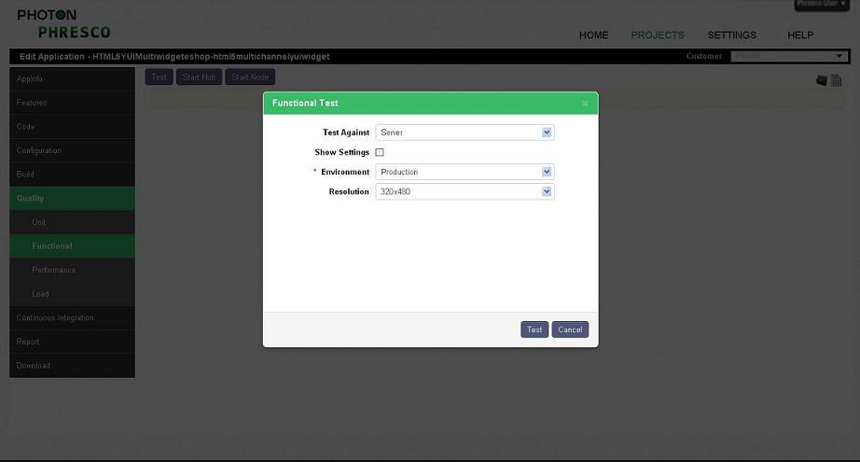

***Figure 5-34: Functional test pop-up***

**Fields in the functional test pop-up are as follows**

**Test Against**

This option can be selected to run functional test against the project that is deployed in the server.Makesure that the project deployed in the server before performing this test.

**Environment**

Created environments can be selected from the drop down box. If the environment is not created default environment will be selected.

**Resolution**

The resolution size of the browser can be selected from the dropdown available for the functional test to execute. The resolution size is the view port of the browser.

#### Functional Test execution for Java Standalone

The functional test cases can be run in different browsers that are supported by Phresco and the resolution for the browser window can also be selected by the users when the functional test tab is clicked.

**Fields in the functional test execution are as follows**

**Test Against**

This option can be selected to run functional test against the project that is deployed in the server.Makesure that the project deployed in the server before performing this test.

**JAR Location**

Use this option to upload the JAR file needed to perform the test.

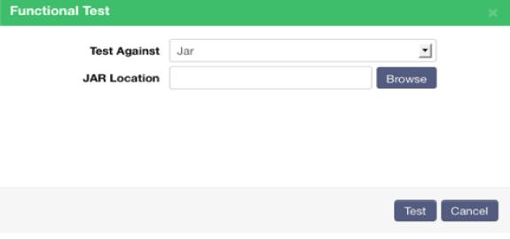 ***Figure* 5.35: *Functional Test execution for Java Standalone***

#### Functional Test execution for Share Point

The functional test cases can be run in different browsers that are supported by Phresco and the resolution for the browser window can also be selected by the users when the functional test tab is clicked.

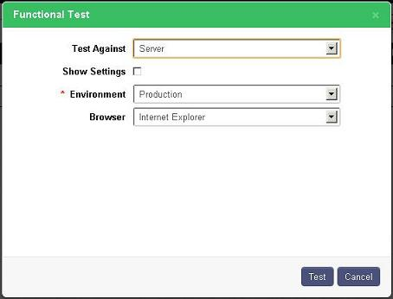

***Figure* 5.36: *Functional Test execution for Sharepoint***

**Test Against**

This option can be selected to run functional test against the project that is deployed in the server.Makesure that the project deployed in the server before performing this test.

**Show settings**

The global configurations for server, database, web service and email can be selected using the show settings option.

**Environment**

Created environments can be selected from the drop down box. If the environment is not created default environment will be selected.

**Browser**

The browser in which the functional test case has to be executed can be selected from the dropdown box. The supported browsers in Phresco will be listed in the dropdown list.

#### Functional Test execution for Android

Click on the application created in **Project** page.Execute the functional test as shown by navigating to Quality tab: **Application created -> Quality -> Functional -> Test**.

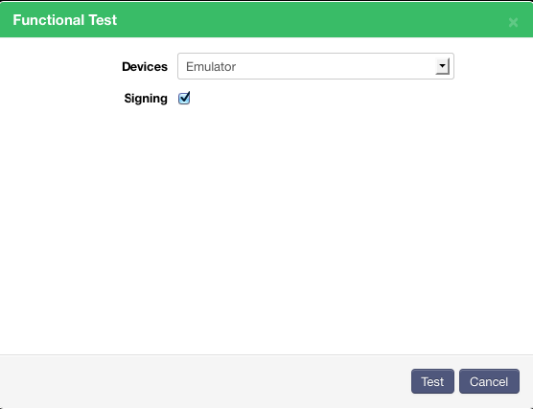

***Figure* 5-37: *Functional Test pop-up for Android application***

**Devices**

Devices in which tests needs to be executed can be selected from this drop down box.

**Signing**

Android system requires that all installed applications be digitally signed with a certificate whose private key is held by the application's developer. In order to make application available in Android store (Market), the application has to be certified. This can be selected if signing functionality is required.

#### Functional Test execution for iPhone

Click on the application created in **Project** page.Execute the functional test as shown by navigating to Quality tab: **Application created -> Quality -> Functional -> Test**.

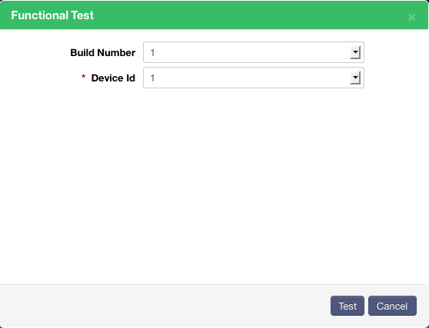

***Figure* 5-38: *Functional Test pop-up for iPhone application***

**Build Number**

Build Number against which the Test to be executed can be selected from this drop down box.

**Device Id**

If the Test is to be executed in device then the device Id should be mentioned in this field.

|  |
| --- |
| * **Note:**   A PDF report of the executed tests can also be generated using “Report” icon as shown |

### Performance Testing

Performance testing determines the performance of a system in terms of receptiveness and solidity under a particular workload. This testing also determines the speed or effectiveness and the response time or throughput of a project. In Phresco the result of the testing is given through static analysis and test cases.

#### Performance Test execution for Android

**Device List**

Devices in which tests needs to be executed can be selected from the drop down box.

**Signing**

Android system requires that all installed applications be digitally signed with a certificate whose private key is held by the application's developer. In order to make application available in Android store (Market), the application has to be certified. This can be selected if need signing functionality.

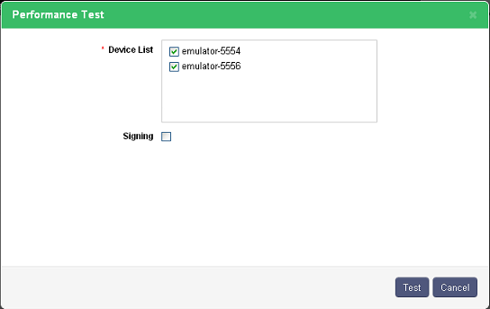

***Figure 5-39: Performance test execution for Android***

#### Performance Test execution for other Technologies

On clicking the **Test** button in the Performance tab, the following popup appears

**Test Against**

This option is used to run Performance test against the project that is deployed in the server.It can also be used to run the test againt the database 0r the web services used in the project. These values are available in the drop down and the user can select the required one.

**Show Settings**

The global configurations for server, database, web service and email can be selected using the show settings option.

**Environment**

Created environments can be selected from the drop down box. If the environment is not created, default environment will be selected.

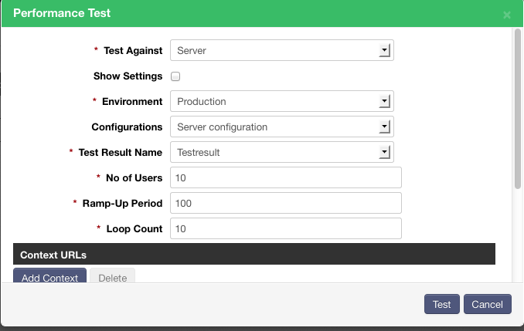

***Figure* 5.40: *Performance Testing for other technologies***

**Configurations**

The name of the configuration created in configuration page will be dispalyed in this field.

**Test Result Name**

The name of the Test can be entered in this field.

**No of Users**

This field defines the number of users to access the application at the same time.

**Ramp-Up Period**

This field defines the time period in milliseconds within which the performance test has to be carried out.

**Loop Count**

Loop count determines the number of times each user needs to access the Application.

**Context URLs**

Context URLs specify the name and context of the Application to be tested together with its type & encoding values. Headers contain the key and the value details. An instance is given below.

*Key- Content-Type*

*Value - application/json*

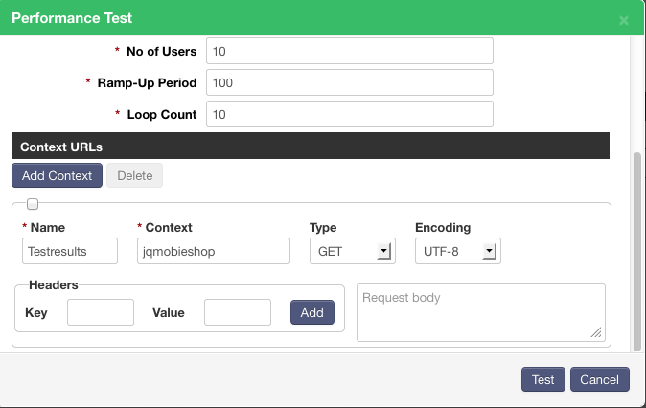

***Figure* 5-41: *Adding Context URL’s in Performance Testing***

|  |
| --- |
| * **Note:**   A PDF report of the executed tests can also be generated using “Report” icon as shown |

### Load Testing

Load testing refers to modeling the expected usage of a project by simulating the access of multiple users to the same project concurrently. Load and performance testing is usually conducted in a test environment identical to the production environment before a project is permitted for real time usage.

Load testing also uses jMeter. The result is given through static analysis and test cases. The test cases will point out the error and this will be very useful for the testing team.

On clicking the **Test** button in the Load tab the following popup appears

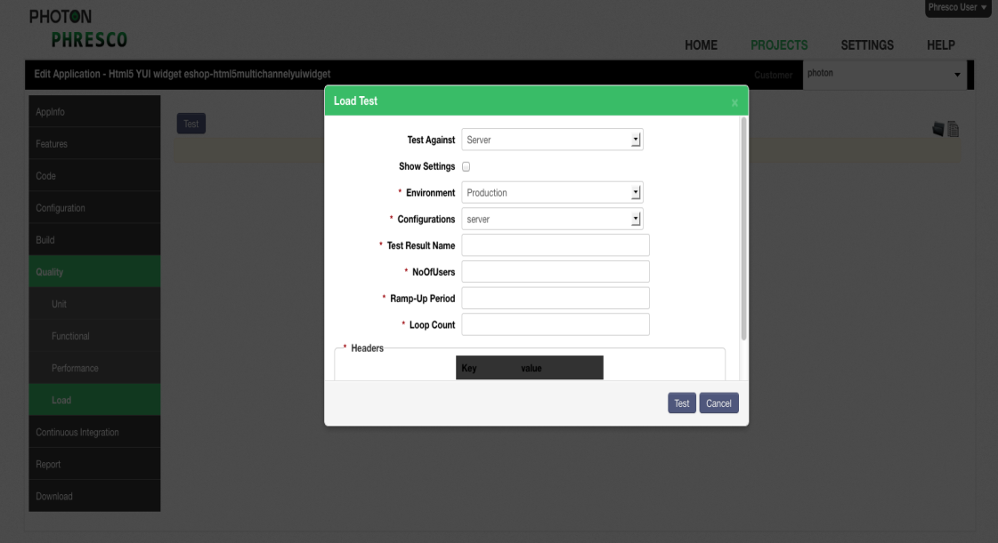

***Figure 5-42: Load Testing***

**Test Against**

To run Load test against the project that is deployed in the server or the test can to run againt the database 0r the web service used in the project. These values are available in the drop down and the user can select the one required.

**Show Settings**

The global configurations for server, database, web service and email can be selected using the show settings option.

**Environment**

Created environments can be selected from the drop down box. If the environment is not created default environment will be selected.

**Configurations**

The name of the configuration created in configuration page will be dispalyed in this field.

**Test Result Name**

The name of the Test can be entered in this field.

**No Of Users**

This field defines the Number of users to access the application at the same time.

**Ramp-Up Period**

This field defines the time period in ms within which the performance test has to be carried out.

**Loop Count**

Loop count determines the number of times each user needs to access the Application.

**Headers**

|  |
| --- |

The key and the value details can be entered in Headers section.

Eg., Key- Content-Type

value - application/json

|  |
| --- |
| * **Note:**   A PDF report of the executed tests can also be generated using “Report” icon as shown |

## Continuous Integration

Continuous Integration process is used for generating the builds, deploying the generated build and testing the deployed project. The build, deploy and test process that are generated manually using build, deploy and test option respectively can be made automatic by scheduling the time. This automation process is done using Jenkins.

Phresco Framework also has the option of sending the build result directly to the developers’ inbox.

## Report

Report tab in Phresco is used to generate a site for the project. The generated project site includes the project's reports that were configured in the POM.

Below are the lists of reports that can be configured using Phresco:

* Project-Info-Report

Enabling this gives a report of all the information about the project. This report is common across all the technologies. Options listed under “Project-Info Report” are explained below:

* + index: index of the project. This is a default enabled option.
  + modules: list of description of each module used in the project.
  + dependencies: list of dependencies collected from POM.
  + cim: continuous integration management report.
  + scm: source configuration management report.
  + summary: summary of the project.
  + licence: licence that is used in the project.
* JavaDoc Report

Enabling this option gives a report of Java source files and produces a JavaDoc which has browsable source code containing hyperlinked cross-references within and across that set of files. This is applicable only for the java technology projects.

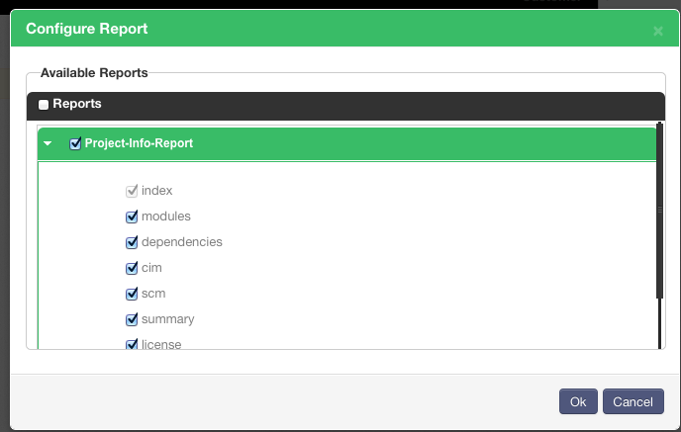

*Figure 5‑43: lists in Project-Info-Report*

* jDepend Report

Enabling this option generates a report of quality metrics for each java package. Degree of dependencies, its extensibility and reusability is measured and a report is generated on it. This is applicable only for the java technology projects.

* JXR Report

Enabling this option generates a report of the source code in the html format which can be viewed in the browser. Cross-reference of the project’s source is generated which allows the users to find the specific lines of code. This is applicable only for the java technology projects.

* PMD Report

Enabling this option generates a report of the metrics using the PMD tool. This tool helps in sorting out the test case that are mostly used and the ones that are not important. The unimportant sets can be ruled out to suppress the code. This is applicable only for the java technology projects.

* Surefire Report

Enabling this option generates a report of the unit test results. This is applicable only for the java technology projects.

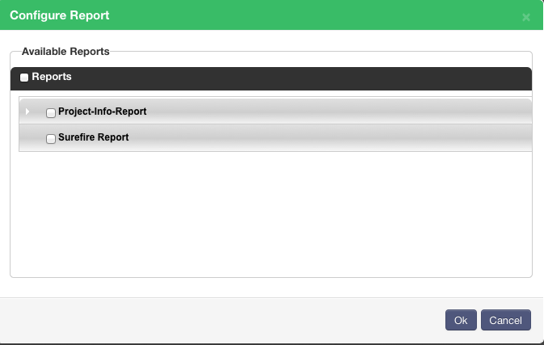

*Figure 5‑44: Configure Report tab*

## Global Settings

Global settings is the method of creating configurations for server, database, email and web service globally and use it for different projects which requires the same configurations. Phresco also allows creating an environment and its configurations globally and reuse it for the other projects to make the work easier. Global settings can be configured by clicking **Settings->Add** for Server, Web Service, email and Database while for environment click **Settings->Environment**.

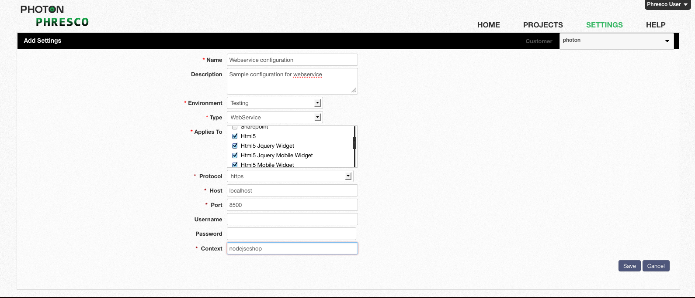

***Figure 5-27: Configuration in Global Settings***

## Knowledge Repository

A knowledge repository is a computerized system that systematically captures, organizes and categorizes an organization's knowledge.

Knowledge repository in Phresco is the central repository which contains the application types, archetypes and features. It is a common repository where the admin can perform changes or modifications that will impact the user interface.

A Common Knowledge repository exists where any changes made will be reflected across all the account holders. Each customer will have their own knowledge repository for their artifacts. Any changes in Customer Knowledge repository can be witnessed in the customer’s user interface.

## Download

Downloads in Phresco are the configurations that are provided to the developers out of the box. Developers can choose the servers or databases or even editors that are available in the download.

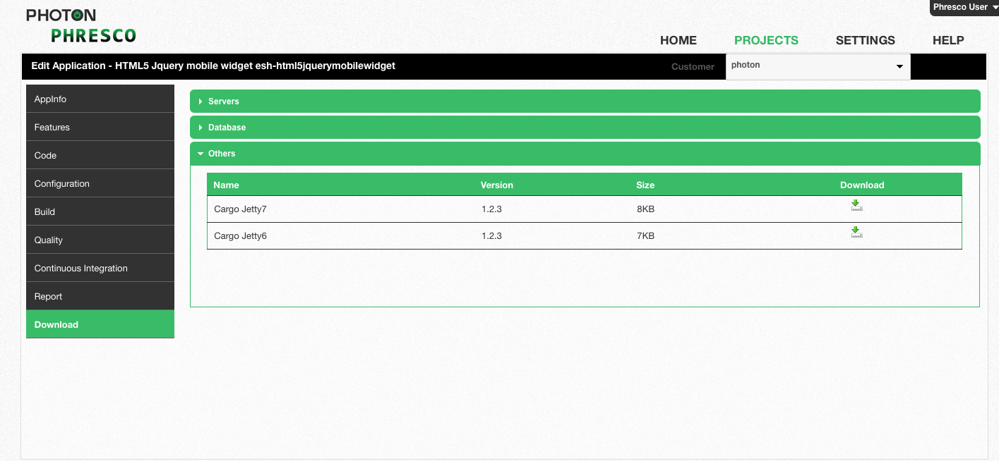

*Figure 5‑45: Third party downloads*

## iPhone Prerequisites

**iOS Sim**

To perform application test for iPhone, **iOS-Sim** tool needs to be added in the tools folder and path should be set.

*export IOS_SIM=****/Users/tools/ios-sim****/build/Release  
export PATH=$IOS_SIM:$PATH*

In the command prompt, go to ios-sim folder and execute the following command to install iOS-Sim. This is a onetime install.

*rake install prefix=/usr/local/*

**Wax Sim**

While deploying and testing the IOS application, Phresco Framework provides the option of selecting iPhone simulator or iPad simulator from the dropdown box listed under family. This is done by integrating waxsim plugin in the Framework.

Waxsim tool should be installed manually from the directory path *phresco-framework/workspace/tools/waxsim.*

Go to command prompt and execute the below command to install waxsim in the local machine.

*xcodebuild install DSTROOT=*

**For developers**

1. Mac machine
2. Mac OS 10.7 & above
3. Xcode tool 4.2 & above
4. iPhone Simulator version - 4.3, 5.0 and above
5. iPad simulator version - 4.3, 5.0 and above
6. iPad Devices - iPad 2 and iPad 3(Only for Native apps and support not given to iPad 3 to develop Phonegap applications)

**For testers**

* 1. Mac machine
  2. Mac OS 10.7 & above
  3. Xcode tool 4.2 & above
  4. iPhone Simulator version - 4.3, 5.0 and above
  5. iPad simulator version - 4.3, 5.0 and above
  6. iPad Devices - iPad 2 and iPad 3(Only for Native apps and support not given to iPad 3 to develop Phonegap applications)
  7. Instrumentation tool for automation test

**Deploying Devices**

1. iPhone 4, 4s, iPad 2

|  |
| --- |
| * **Note:** * Developers or testers should have registered in [develop.apple.com](http://develop.apple.com/) or should have an id for downloading the following software. * Development certificate is required for deploying a project in the device. |

## Android Prerequisites

**To build a project:**

Phresco supports versions like 2.2, 2.3.3 and 4.0.3 for building a project in ANDROID

**To deploy a project**

Project can be deployed depending on the <minSdkVersion> which is defined in the manifest.xml file.

* Manifest.xml code:

<?xml version="1.0" encoding="utf-8" ?>

[-](https://mail.google.com/mail/?ui=2&view=bsp&ver=ohhl4rw8mbn4#13725e382aede226_13718186ff516810_) <manifest xmlns:android="[**http://schemas.android.com/apk/res/android**](http://schemas.android.com/apk/res/android)" package="**com.photon.Phresco.nativeapp**" android:versionCode="**1**" android:versionName="**1.0**">

<uses-sdk android:minSdkVersion="7" />

<application android:icon="**@drawable/icon**" android:label="**@string/app_name**">

< activity android:name="**.activity.MainActivity**" android:label="**@string/app_name**">

<intent-filter>

<action android:name="**android.intent.action.MAIN**" />

<category android:name="**android.intent.category.LAUNCHER**" />

</intent-filter>

</activity>

</application>

</manifest>

Depending on the versions given in the manifest.xml project can be deployed. In the above example

“<uses-sdk android:minSdkVersion="7" /> “

7 is the version mentioned while a project can be deployed in the versions of 7 and above 7.

Table 2: Android API levels

|  |  |
| --- | --- |
| Platforms | API Level |
| Android 1.5  Android 1.6  Android 2.1  Android 2.2  Android 2.3- 2.3.2 | 3  4  7  8  9 |
| Android 2.3.3-2.3.7  Android 3.0  Android 3.1  Android 3.2  Android 4.0-4.0.2  Android 4.0.3-4.0.4 | 10  11  12  13  14  15 |
| Android 4.1 | 16 |
| Android 4.1.2 | 16 |
| Android 4.2 | 17 |

Prerequisites for android for developers and testers

1. User should install Eclipse 3.7[indigo] IDE or above.
2. Also Android SDK for 2.3.3 or higher platform (API level 10 or higher) should be installed
3. “ANDROID_HOME” environment variable should be set, and should point to android sdk folder /tools and /platform-tools should be system PATH variable.
4. For Android projects, avoid using Android versions 1.6 & 2.1_R1 for project creation and build generation

## Blackberry Prerequisites

**Prerequisites for running Blackberry application:**

In order to start with BB hybrid application development, two steps needs to be followed:

* Necessary software installations.
* Code Signing key registration and installation

### Software Installations:

Following software needs to be installed for BB hybrid development.

* BlackBerry WebWorks SDK for Smart Phones
* BlackBerry Desktop Software
* BlackBerry JDE Plugin

**BlackBerry WebWorks SDK for Smart Phones:**

BlackBerry WebWorks SDK for Smart Phones has to be installed on machine.

**Windows**

<https://developer.blackberry.com/html5/downloads/fetch/BlackBerryWebWorksSDK.exe>

**Mac**

<https://developer.blackberry.com/html5/downloads/fetch/BlackBerryWebWorksSDK.zip>

**Create Environment variable**

Name: BB_WEBWORK_SDK_HOME

Value: <PATH TO SDK INSTALLATION> [E.g: C:\Program Files\Research In Motion\BlackBerry WebWorks SDK 2.3.1.5]

**Add following 2 variables to Path**

%BB_WEBWORK_SDK_HOME%;

%BB_WEBWORK_SDK_HOME%\bin;

**Blackberry Desktop Software**

Install the BlackBerry Desktop Software to simulate the usb connection with simulator. Go through following links and install the software.

**Windows**

<https://www.blackberry.com/Downloads/contactFormPreload.do?code=A8BAA56554F96369AB93E4F3BB068C22&dl=A2C0D61EB187AB3AFD247A852FAD3647>

**Mac**

<https://www.blackberry.com/Downloads/contactFormPreload.do?code=CBC462E27100DAD71CDBF606D396DDAD&dl=3C4BB676CED2EDE17E0996B0A4A20B01>

**BlackBerry JDE Plugin Installation**

Get the BB JDE plugin from following links:

**Windows**

<https://developer.blackberry.com/java/downloads/fetch/BlackBerry_JDE_PluginFull_2.0.0_indigo.exe>.

**Mac**

<https://developer.blackberry.com/java/downloads/fetch/BlackBerry_JDE_PluginFull_2.0.0_indigo.zip>

**Download the BB plugin and install.**

Once installed, start the IDE and follow below mentioned steps: [Note: steps mentioned below are specific for windows installation. Kindly follow the appropriate steps for Mac as instructed on screen]

* Go to File -> New -> BlackBerry Project. The wizard will help developer to create new project.
* Enter Project name in next step.
* Under Template selection window, choose BlackBerry Application.
* Enter necessary information in Application Details step. Click Finish.
* New BlackBerry application will be available in list.
* Right click on project, select Run As -> BlackBerry Simulator. This will launch BB simulator.

**Note for simulator:** Once the simulator is launched, select "Simulate->USB Cable Connected" and then you can use javaloader as if it was an actual device connected via USB.

### Code signing key registration and installation:

Once the components are installed, Code Signing Keys need to be requested and installed on development machine. Code signing key installation process is one time process.

**Getting the Key Files:**

* Open

[https://www.blackberry.com/SignedKeys/codesigning.htmlhttps://www.blackberry.com/SignedKeys/codesigning.html](https://www.blackberry.com/SignedKeys/codesigning.html)

* Enter required details as described in image below, and click submit. [Note: Kindly note down the Registration PIN. It will be required in key installation process later on]

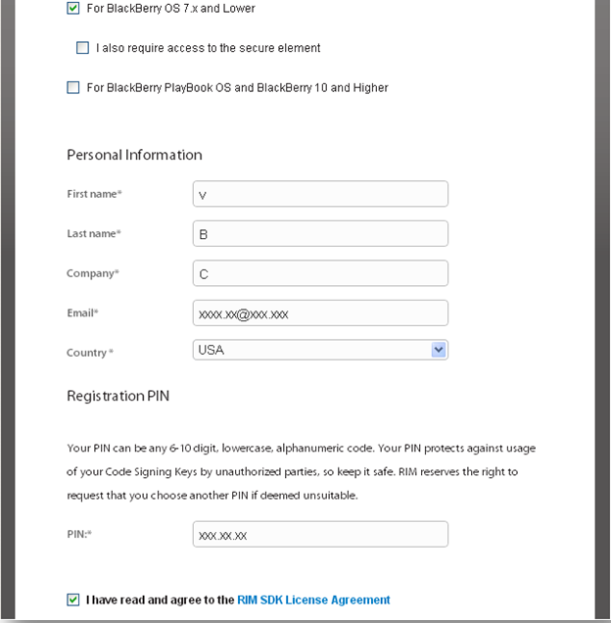

***Figure 5.46: Getting Key details***

* Once details are submitted, you will get confirmation page on screen, stating that .csi files will be sent within 2 hours. Probably the email will be sent within 15-20 mins.
* Once the email is delivered in your inbox with 3 .csi files, go to <https://developer.blackberry.com/CodeSigningHelp/codesignhelp.html> . Select the highlighted option as shown in image, and click Next

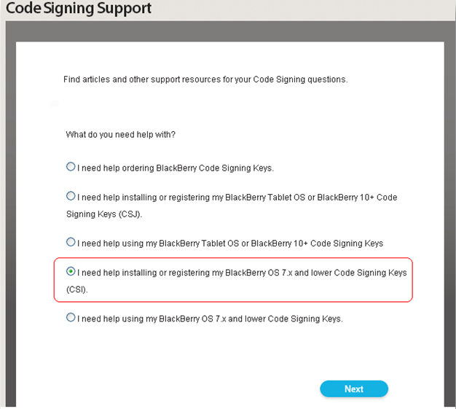

***Figure 5.47: Code Signing support***

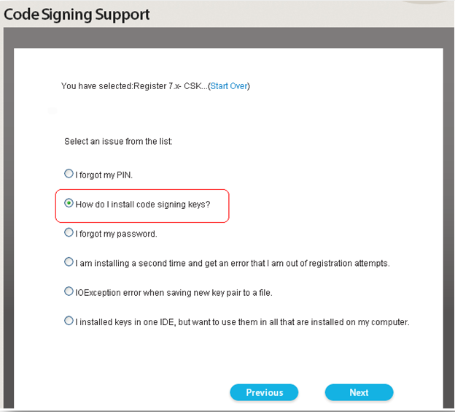

***Figure 5.48: Code Signing Support***

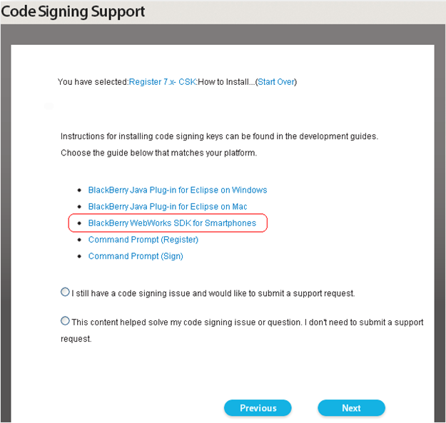

***Figure 5.49: Code signing support***

* Scroll down to the bottom of the opened page, and click on the highlighted option, as shown in image below.

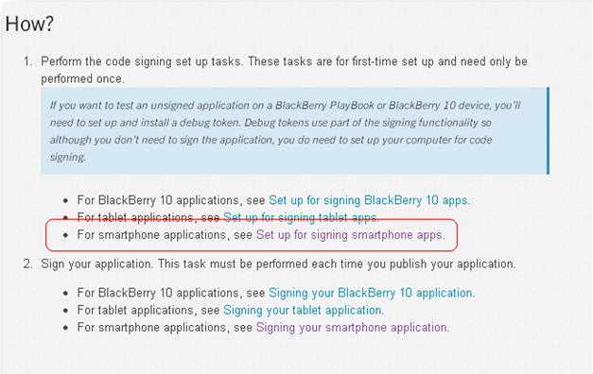

***Figure 5.50: Setup for signing smartphone apps***

* This will open “**Set up for signing smartphone apps**” page. Follow all the 10 steps mentioned in **Requesting and Registering your keys** section for all the 3 .csi files that you have received in emails earlier.

|  |
| --- |
| * **Note:**   This is required to get the keys in order to run the application on BB device. |

## Prerequisites for Windows Phone

* Visual Studio 2010 or higher should be installed
* Windows Phone SDK 7.0 or higher should be installed [Note: For Using Windows phone SDK 8.0, 64bit OS is required
* Create MSBUILD environment variable pointing to C:\Windows\Microsoft.NET\ Framework\<Framework_version> directory on your machine, containing the MSBuild.exe file

E.g., C:\Windows\Microsoft.NET\Framework\v3.5 (Or)

      C:\Windows\Microsoft.NET\Framework\v4.0.30319

* Add MSBUILD environment variable in your Path
  1. Edit your existing Path variable.
  2. If semi colon (;) is not present at the end, place one semi colon(;) at the end.
  3. Append %MSBUILD%; at the end.

For 32-bit,

* The console tools are available under the Downloads section in Phresco
* Download and extract it at desired location on your machine
* Create WPTOOLS_HOME environment pointing to extracted directory (containing wptools.exe)
* Add WPTOOLS_HOME environment variable in your Path
  1. Edit your existing Path variable.
  2. If semi colon (;) is not present at the end, place one semi colon(;) at the end.
  3. Append %WPTOOLS_HOME%; at the end.

For 64-bit,

* The console tools are available under the Downloads section in Phresco
* Download and extract it at desired location on your machine
* Extract it at desired location on your machine
* Create XAPDEPLOYCMD_HOME environment pointing to extracted directory (containing wptools.exe)
* Add XAPDEPLOYCMD_HOME environment variable in your Path
  1. Edit your existing Path variable.
  2. If semi colon (;) is not present at the end, place one semi colon(;) at the end.
  3. Append % XAPDEPLOYCMD_HOME_HOME%; at the end.

## Prerequisites for Windows Metro

* Windows 8 OS
* .Net Framework 4.0 or higher should be installed
* Visual Studio Express 2012 RC for Windows 8 should be installed (IDE
* Create MSBUILD environment variable pointing to C:\Windows\Microsoft.NET\Framework\<Framework_version> directory on your machine, containing the MSBuild.exe file.

E.g., C:\Windows\Microsoft.NET\Framework\v4.0.30319

* Add MSBUILD environment variable in your Path
  1. Edit your existing Path variable
  2. If semi colon (;) is not present at the end, place one
  3. Append %MSBUILD%; at the end.

## Prerequisites for NodeJS

* Download and install Node JS. ( NodeJS is available under Downloads tab in the Phresco Framework). The NodeJS version should be equal to or greater than node-v0.8.7-x86.msi
* Set the path of installed Node Js in the environment variables
* Mocha tool is essential for performing code validation, build and unit test. Open the command prompt and execute the following commands inside the installed Node Js

*npm install -g mocha  
 npm install -g mocha_lcov_reporter  
 npm install -g should*

* The code coverage tool, Jscoverage, will be available under the Others section of the Downloads tab in the Phresco Framework. After creating a Node Js project using Phresco, download and unzip it at any system location
* Set the path of this jscoverage folder in the environment variables.

|  |
| --- |
| * **Note:**   Installing NodeJS is a one time event |

# Archetypes

Archetype, provided in Phresco, is an ideal project from which similar projects can be created. Phresco Archetypes help the developers follow the best practices in creating projects by providing basic templates for any technology. Developers can create archetypes and deploy it in their organization’s repository which will be available for the use of all developers within their organization. Users can also upload archetypes required for their projects with the help of admin console.

## List of Available Archetypes

Archetypes are classified under three different applications - web, mobile and stand alone applications. Under each applications there are list of Archetypes available as given below.

**List of Archetypes for Web Applications**

* PHP
* Drupal6
* Drupal7
* SharePoint
* ASP.Net
* SiteCore
* WordPress
* Java Standalone
* HTML5 Multichannel YUI Widget
* HTML5 Multichannel jQuery Widget
* HTML5 YUI Mobile widget
* HTML5 jQueryMobile Widget

**List of Archetypes for Mobile Applications**

* iPhone Native
* iPhone Hybrid
* iPhone Library
* iPhone Workspace
* Android Native
* Android Hybrid
* Android Library
* Blackberry Hybrid
* Windows Metro
* Windows Phone

**List of Archetypes for Web Services Applications**

* Java Web service
* NodeJS

# Reusable Components

Phresco promotes reusability of components by providing a knowledge repository that systematically captures, organizes and categorizes an organization's knowledge.

**Archetype:**

Archetype, provided in Phresco, is an ideal project from which similar projects can be created. Phresco Archetypes help the developers follow the best practices in creating projects by providing basic templates for any technology. Users can also upload archetypes required for their projects with the help of admin console.

**Features:**

The below mentioned resources are represented in Phresco as features that can be selected when creating a project.

* Java libraries
* Android libraries
* iPhone libraries
* ASP.NET Libraries
* SharePoint Features
* PHP Modules
* Drupal Modules
* WordPress Modules
* NodeJS Modules
* JS Libraries

**Pilot Projects:**

Pilot project is an actual project built with the best practices of project development, libraries, components and validated code structures. Phresco has included Pilot projects for most of the technology it supports. The inclusion is intended to cut maintenance time by synchronizing application and design. Phresco also allows the pilot projects to be re-branded, reused and redelivered when published in the repository.

**Third Party Libraries:**

Phresco’s repository server is the main vital repository and any changes and modifications made by the administrators have a significant impact on the framework’s user interface.

It is a common knowledge repository that controls the content accessed by the entire team. Organizations can move the artifacts and features that they desire to reuse across platforms in to the repository.

**What happens when you select a pilot project?**

Once a pilot project for the desired technology is selected, it will be added into

Phresco Framework/workspace/projects. Projects a user may create using Phresco archetypes will be located in the above location.

**What happens when you select an Archetype?**

Archetypes provided by Phresco can be adapted to the user’s project and the completed project can be hosted in Phresco’s repository for access by other projects in the organization.

## What happens when you select a feature in your project?

Table 3: Features and Js Libraries for the Technologies

|  |  |  |
| --- | --- | --- |
| **Technology** | **Selecting a feature** | **Selecting a JS library** |
| Drupal | The modules will be added into <PROJECT_HOME>/source/sites/all/modules | N/A |
| SharePoint | The features will be added into <PROJECT_HOME>/source | N/A |
| NodeJS | The modules will be added into <PROJECT_HOME>/source/node_modules | The modules will be added into <PROJECT_HOME>/source/lib |
| iPhone  Native | The libraries will be added into <PROJECT_HOME>/source/Thirdparty | N/A |
| iPhone Hybrid | The libraries will be added into <PROJECT_HOME>/source/Thirdparty | N/A |
| PHP | The libraries will be added into <PROJECT_HOME>/source | The libraries will be added into <PROJECT_HOME>/source/public_html/js |
| WordPress | The modules will be added into <PROJECT_HOME>/source/wp-content | N/A |
| ASP.NET | The features will be added into <PROJECT_HOME>/source/src | N/A |

|  |
| --- |
| * **Note:**   For Java, Java WebService, HTML5 and Android the features are updated in the pom.xml as dependencies. |
|  |
|  |

# Testing

Phresco provides standardized structure for testing all the technologies.

## Test Cases for Java Technology

### Unit Test

#### Structure of AllTest and Test Cases

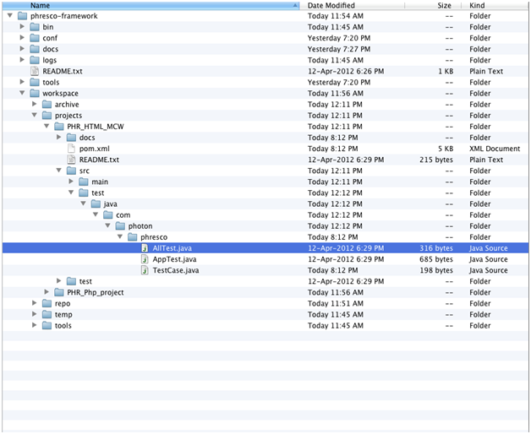

*Figure 8‑1: Java unit tests structure*

1. **AllTest :** AllTest is the root file that carries all the test cases to initiate the testing process. Each test case can be called separately to run the unit test.
2. **Test case:** In unit test, Test cases are written in order to test the source code.

#### Existing Test Cases Out Of the Box in Phresco

**AllTest for Java Technology**

AllTest contains a bunch of test cases, each of which performs a unique scenario on the application. Test developers can start writing new suite classes and test cases by following the syntax and structure of Phresco frameworks out of the box class structure. AllTest class calls all the suite classes and the test cases within it. Once suite classes and test cases are written developers can execute those from Phresco Framework and can see the report. Following is the AllTest file which shows up how to add / include the class inside it.

package com.photon.Phresco;

import junit.framework.Test;

import junit.framework.TestSuite;

public class AllTest {

public static Test suite() {

TestSuite suite = new TestSuite(AllTest.class.getName());

//$JUnit-BEGIN$

suite.addTestSuite(AppTest.class);

//$JUnit-END$

return suite;

}

}

**Test Case Example for AppTest**

Test cases examine all the aspects including inputs and outputs. It gives the detailed steps that should to be followed during the testing process. Testing process follows only the steps that have been written for each test case.

package com.photon.Phresco;

import junit.framework.Test;

import junit.framework.TestCase;

import junit.framework.TestSuite;

/**

* Unit test for simple App.

*/

public class AppTest

extends TestCase{

/**

* Create the test case

*

* @param testName name of the test case

*/

public AppTest( String testName ) {

super( testName );

System.out.println("Printed");

}

/**

* @return the suite of tests being tested

*/

public static Test suite() {

return new TestSuite( AppTest.class );

}

/**

* Rigourous Test :-)

*/

public void testApp() {

assertTrue( true );

}

}

#### Report generated after execution

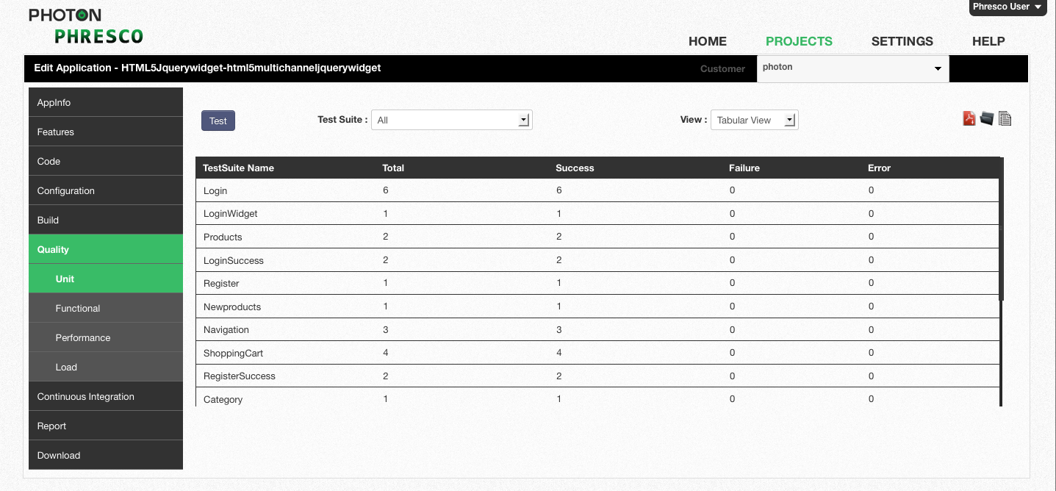

*Figure 8‑2: HTML5 widget* *unit test report for all test cases in tabular view*

### 

*Figure 8‑3: HTML5 widget unit test report for all test cases in graphical view*

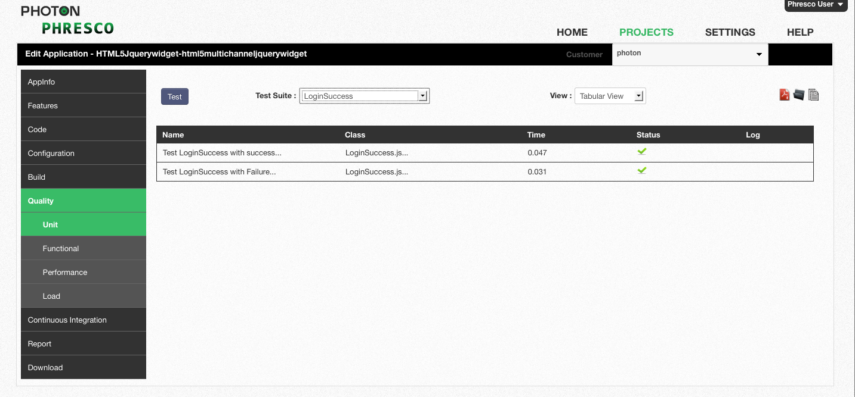

*Figure 8‑4: HTML5 widget unit test report for single test case in tabular view*

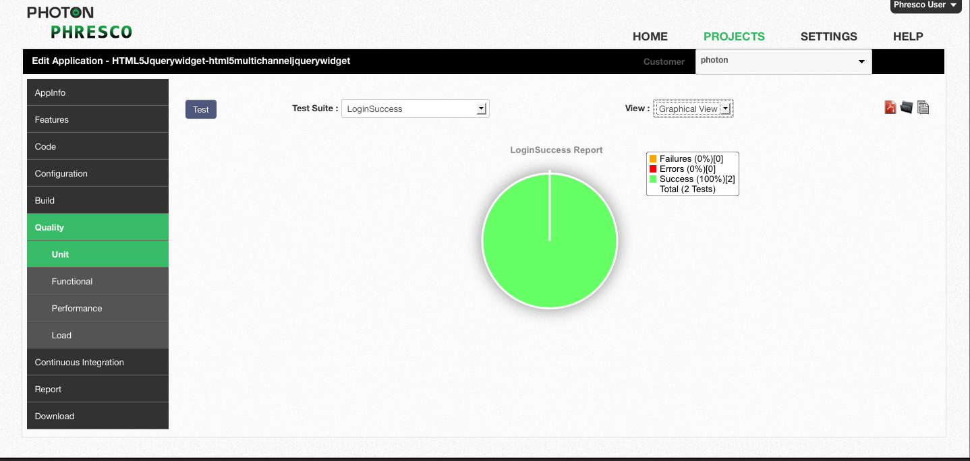

*Figure 8‑5: HTML5 widget unit test report for single test case in graphical view*

### Functional Test cases – Selenium Grid

#### Structure of Functional Test in Java for Selenium Grid

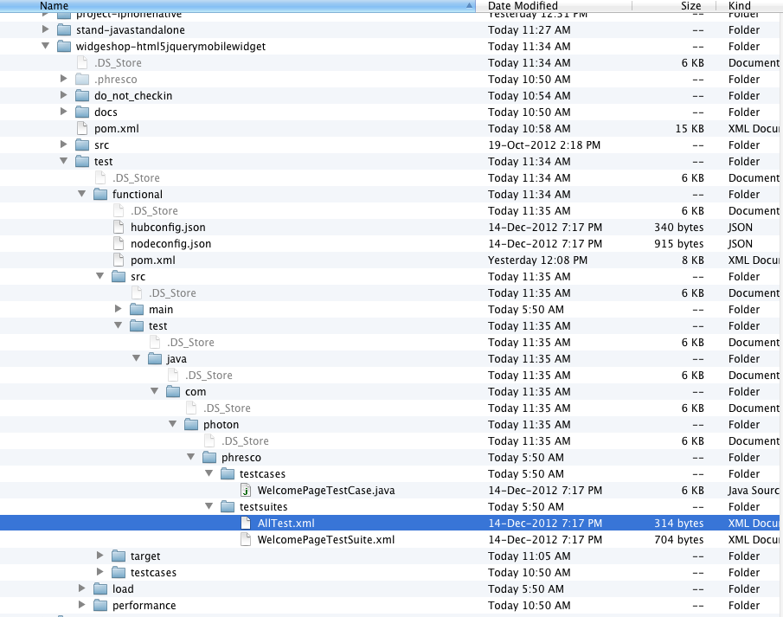

***Figure 8.6: Java functional tests structure***

* 1. **AllTest**: This is a root TestNG suite xml that can either call a suite of xmls or individual test cases.
  2. **Suite Xml**: This is also a TestNG suite xml which calls the rest of the individual test cases.
  3. **Test Cases**: These are individual java classes which perform unique testing scenarios against the application.

#### Existing Test Cases and Suites Out Of the Box in Phresco

In Phresco testing Framework a TestNG suite xml is named as “AllTest”.

TestSuite contains a bunch of test cases, each of which performs a unique scenario on the application. Test developers can start writing new suite xml and test cases by following the syntax and structure of Phresco frameworks out of the box class structure. AllTest xml calls all the suite xmls and the test cases within it. Once suite xmls and test cases are written developers can execute those from Phresco Framework and can see the report. Following is the AllTest xml file which shows up how to add / include the xmls inside it.

<?xml version="1.0" encoding="UTF-8"?>

<suite name="AllTest" parallel="tests" thread-count="10">

<suite-files>

  <suite-file path="./WelcomePageTestSuite.xml" />

</suite-files>

</suite>

**Suite xmls**

Suite xml is a collection of test cases that are intended to be used to test a project code to show that it has some specified set of behaviors. A suite xml contains detailed instructions or goals for each collection of test cases. New test cases can also be added by using the same syntax.

<?xml version="1.0" encoding="UTF-8"?>

<suite name="WelcomePageTestSuite" parallel="tests" thread-count="5" verbose="3">

<test name="VerifyWelcomePageOnFirefox" junit="false preserve-order= "true">

parameter name="browser" value="firefox" />

<parameter name="platform" value="WINDOWS" />

<classes>

<class name="com.photon.phresco.testcases.WelcomePageTestCase"/>

</classes>

</test>

</suite>

**Test cases**

A test case is a set of conditions under which a tester will determine whether an [application](http://en.wikipedia.org/wiki/Software_application) is meeting the requirement. This helps the user to verify a particular functionality during the testing process.

package com.photon.phresco.testcases;

import java.io.IOException;

import org.testng.Assert;

import org.testng.Reporter;

import org.testng.annotations.AfterTest;

import org.testng.annotations.BeforeTest;

import org.testng.annotations.Parameters;

import org.testng.annotations.Test;

import com.photon.phresco.Screens.WelcomeScreen;

import com.photon.phresco.uiconstants.PhrescoUiConstants;

import com.photon.phresco.uiconstants.UIConstants;

import com.photon.phresco.uiconstants.WidgetData;

public class WelcomePageTestCase {

private UIConstants uiConstants;

private PhrescoUiConstants phrescoUIConstants;

private WelcomeScreen welcomeScreen;

private String methodName;

private String selectedBrowser;

private WidgetData WidgetConstants;

// private Log log = LogFactory.getLog(getClass());

@Parameters(value = { "browser", "platform" })

@BeforeTest

public void setUp(String browser, String platform) throws Exception {

try {

phrescoUIConstants = new PhrescoUiConstants();

uiConstants = new UIConstants();

WidgetConstants = new WidgetData();

String selectedBrowser = browser;

String selectedPlatform = platform;

methodName=Thread.currentThread().getStackTrace()[1].getMethodName();

Reporter.log("Selected Browser to execute testcases--->>"+ selectedBrowser);

String applicationURL = phrescoUIConstants.PROTOCOL + "://"

+ phrescoUIConstants.HOST + ":" + phrescoUIConstants.PORT

+ "/";

welcomeScreen = new WelcomeScreen(selectedBrowser, selectedPlatform, applicationURL, phrescoUIConstants.CONTEXT, WidgetConstants, uiConstants);

} catch (Exception exception) {exception.printStackTrace();

}

}

@Test

Public void testWelcomePageScreen() throws InterruptedException, IOException, Exception {

try {

System.out.println("---------testWelcomePageScreen-------------");

Assert.assertNotNull(welcomeScreen);

Thread.sleep(1000);

} catch (Exception t) {

t.printStackTrace();

}

}

@Test

public void testToVerifyTheAudioDevicesAddToCart() throws InterruptedException, IOException, Exception {

try {

System.out.println("---------testToVerifyTheAudioDevicesAddToCart()-----------");

welcomeScreen.AudioDevices(methodName);

welcomeScreen.billingInfo(methodName);

} catch (Exception t) {

t.printStackTrace();

}

}

@AfterTest

public void tearDown() {

welcomeScreen.closeBrowser();

}

}

#### To Add A New Test Suite in Alltest Xml

User can add a new test suite to the AllTest xml as follows.

**Example**

<?xml version="1.0" encoding="UTF-8"?>

<suite name="AllTest" parallel="tests" thread-count="10">

    <suite-files>

    <suite-file path="./WelcomePageTestSuite.xml" />

<suite-file path="./LoginPageTestSuite.xml" />

</suite-files>

</suite>

#### To Add New Test Case in Test Suite Xml

You can add a new test case to the Test suite using the following method. Here is an example for adding a new test case in the name “CamerasAddcart

<suite name="WelcomePageTestSuite" parallel="test” thread-count="5" verbose="3">

<test name="VerifyWelcomePageOnFirefox" junit="false" preserve-order="true">

<parameter name="browser" value="firefox" />

<parameter name="platform" value="WINDOWS" />

<classes>

<class name="com.photon.phresco.testcases.WelcomePageTestCase" />

<class name="com.photon.phresco.testcases.LoginPageTestCase" />

</classes>

</test>

</suite>

#### Report generated after execution

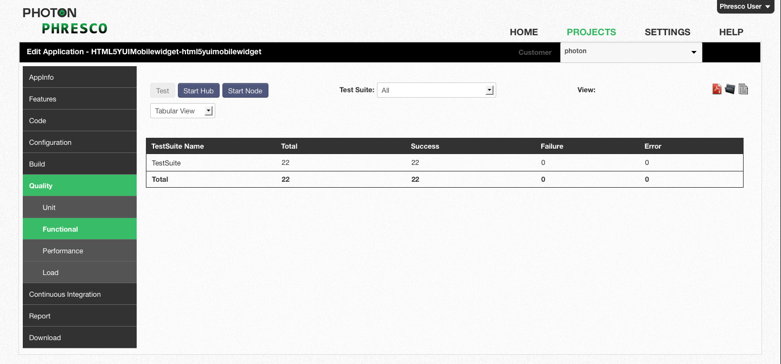 ***Figure 8.7: HTML5 widget functional test report for all test cases in tabular view****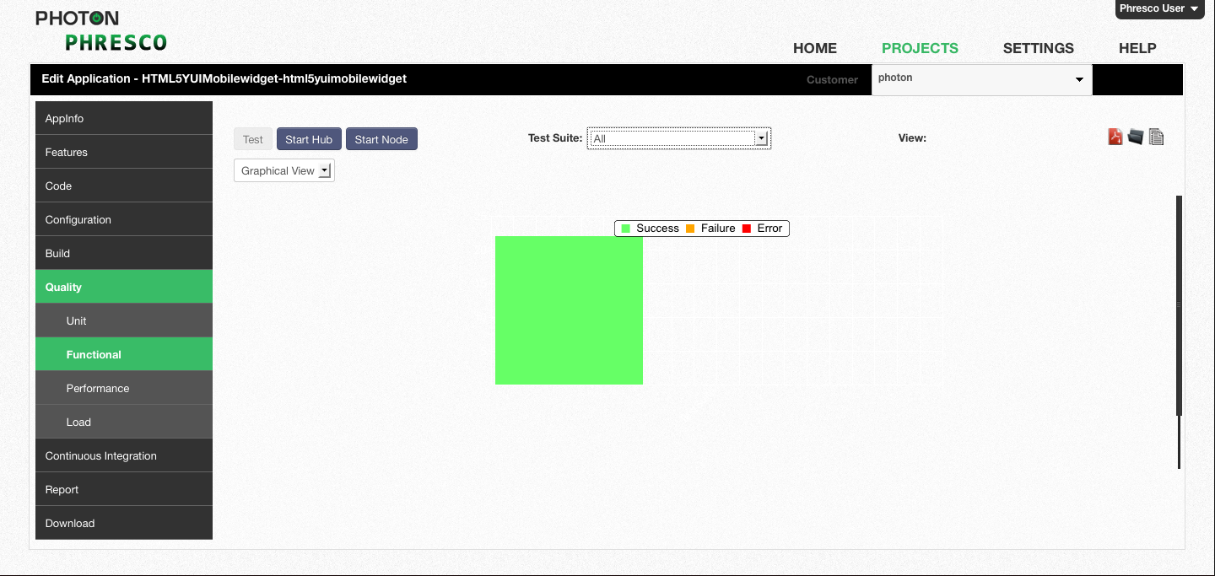* ***Figure 8.8: HTML5 widget functional test report for all test cases in graphical view***

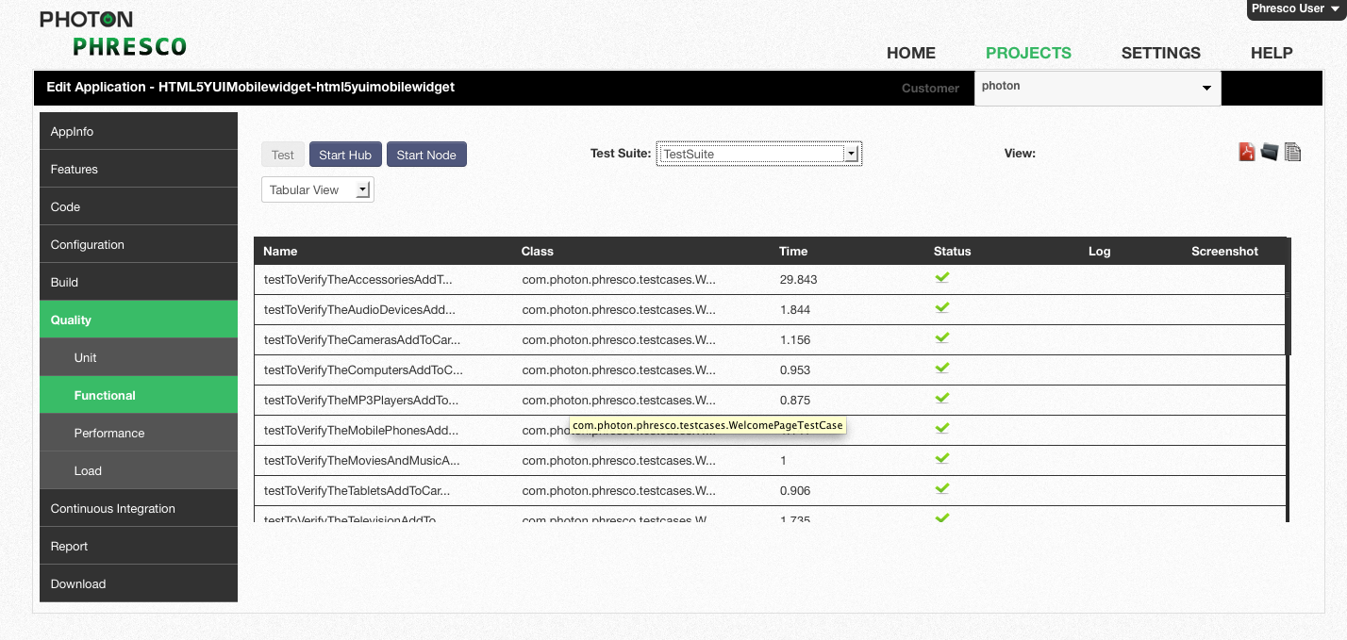***Figure 8.9: HTML5 widget functional test report for single test case in tabular view***

**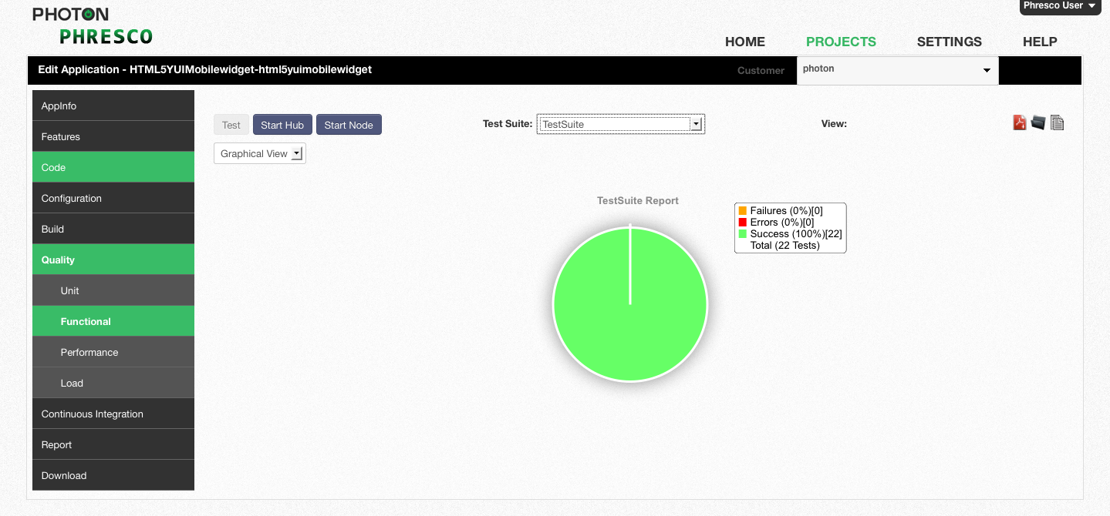 *Figure 8.10: HTML5 widget functional test report for single test case in graphical view***

|  |
| --- |
| * **Note** * Phresco supports Functional Tests for Widgets, PHP Technologies, Nodejs Webservices, Java Webservices in Selenium Grid format. * Refer section 8.1.2 for the Functional Test case structure which is similar to Selenium Grid Functional Test case structure. * In addition to this,Phresco also supports Cucumber for Widgets. |

## Functional Test cases for Selenium Webdriver

#### Structure of Functional Test in Java

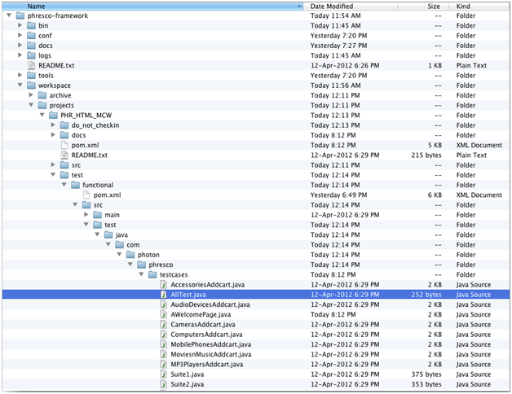

*Figure 8‑11: Java functional tests structure*

* 1. AllTest: This is a root JUnit suite class that can either call a suite of classes or individual test cases.
  2. Suite Class: This is also a JUnit suite class which calls the rest of the individual test cases.
  3. Test Cases: These are individual java classes which perform unique testing scenarios against the application.

#### Existing Test Cases and Suites Out Of the Box in Phresco

In Phresco testing Framework a JUnit suite class is named as “AllTest”.

The TestSuite contains a bunch of test cases, each of which performs a unique scenario on the application. Test developers can start writing new suite classes and test cases by following the syntax and structure of Phresco frameworks out of the box class structure. AllTest class calls all the suite classes and the test cases within it. Once suite classes and test cases are written developers can execute those from Phresco Framework and can see the report. Following is the AllTest file which shows up how to add / include the class inside it.

 package com.photon.Phresco.testcases  
  
import org.junit.runner.RunWith;  
import org.junit.runners.Suite;  
import org.junit.runners.Suite.SuiteClasses;  
  
@RunWith(Suite.class)  
@SuiteClasses({Suite1.class,Suite2.class})  
public class AllTest {

}

**Suite class**

Suite class is a collection of test cases that are intended to be used to test a project code to show that it has some specified set of behaviors. A suite class contains detailed instructions or goals for each collection of test cases. New test cases can also be added by using the same syntax.

package com.photon.Phresco.testcases;

import org.junit.runner.RunWith;

import org.junit.runners.Suite;

import org.junit.runners.Suite.SuiteClasses;

@RunWith(Suite.class)

@SuiteClasses({ WelcomePage.class,TeleVisionAddcart.class,

ComputersAddcart.class, MobilePhonesAddcart.class,AudioDevicesAddcart.class, CamerasAddcart.class

})

public class Suite1 {

}

**Test cases**

A test case is a set of conditions under which a tester will determine whether an [application](http://en.wikipedia.org/wiki/Software_application) is meeting the requirement. This helps the user to verify a particular functionality during the testing process. Elements can be identified and screen shots can be captured when the test fails.

package com.photon.Phresco.testcases;

import java.io.IOException;

import junit.framework.TestCase;

import org.junit.Test;

//import static org.testng.AssertJUnit.*;

import org.openqa.selenium.server.SeleniumServer;

import com.photon.Phresco.Screens.MenuScreen;

import com.photon.Phresco.Screens.WelcomeScreen;

import com.photon.Phresco.selenium.report.Reporter;

import com.thoughtworks.selenium.Selenium;

import com.photon.Phresco.uiconstants.PhrescoUiConstants;

public class AWelcomePage extends TestCase {

private SeleniumServer serv;

protected Selenium selenium;

private PhrescoUiConstants phrsc;

private int SELENIUM_PORT;

private String browserAppends;

@Test

public void testWel() throws InterruptedException, IOException, Exception {

try {

phrsc = new PhrescoUiConstants();

String serverURL = phrsc.PROTOCOL + "://"

+ phrsc.HOST + ":"

+ phrsc.PORT + "/";

browserAppends = "*" + phrsc.BROWSER;

assertNotNull("Browser name should not be null",browserAppends);

SELENIUM_PORT = Integer.parseInt(phrsc.SERVER_PORT);

assertNotNull("selenium-port number should not be null",

SELENIUM_PORT);

WelcomeScreen wel=new WelcomeScreen(phrsc.SERVER_HOST, SELENIUM_PORT,

browserAppends, serverURL, phrsc.SPEED,

phrsc.CONTEXT );

assertNotNull(wel);

MenuScreen menu = wel.menuScreen();

assertNotNull(menu);

} catch (Exception t) {

t.printStackTrace();

System.out.println("ScreenCaptured");

selenium.captureEntirePageScreenshot("\\WelPageFails.png",

"background=#CCFFDD");

}

}

@Override

public void setUp() throws Exception {

serv = new SeleniumServer();

try {

serv.start();

} catch (Exception e) {

clean();

throw e;

}

}

@Override

public void tearDown() {

clean();

}

private void clean() {

if (serv != null) {

serv.stop();

}

if (selenium != null) {

selenium.stop();

}

}

}

#### To Add A New Test Suite in Alltest Class

You can add a new test suite to the AllTest class as follows.

**Example**

package com.photon.Phresco.testcases;

import org.junit.runner.RunWith;

import org.junit.runners.Suite;

import org.junit.runners.Suite.SuiteClasses;

@RunWith(Suite.class)

@SuiteClasses({Suite1.class,Suite2.class})

public class AllTest {

}

#### To Add New Test Case in Test Suite

You can add a new test case to the Test suite using the following method. Here is an example for creating a new test case in the name “CamerasAddcart”

package com.photon.Phresco.testcases;

import org.junit.runner.RunWith;

import org.junit.runners.Suite;

import org.junit.runners.Suite.SuiteClasses;

@RunWith(Suite.class)

@SuiteClasses({ WelcomePage.class,TeleVisionAddcart.class,ComputersAddcart.class,

MobilePhonesAddcart.class,AudioDevicesAddcart.class,

CamerasAddcart.class

})

public class Suite1 {

}

#### Report generated after execution

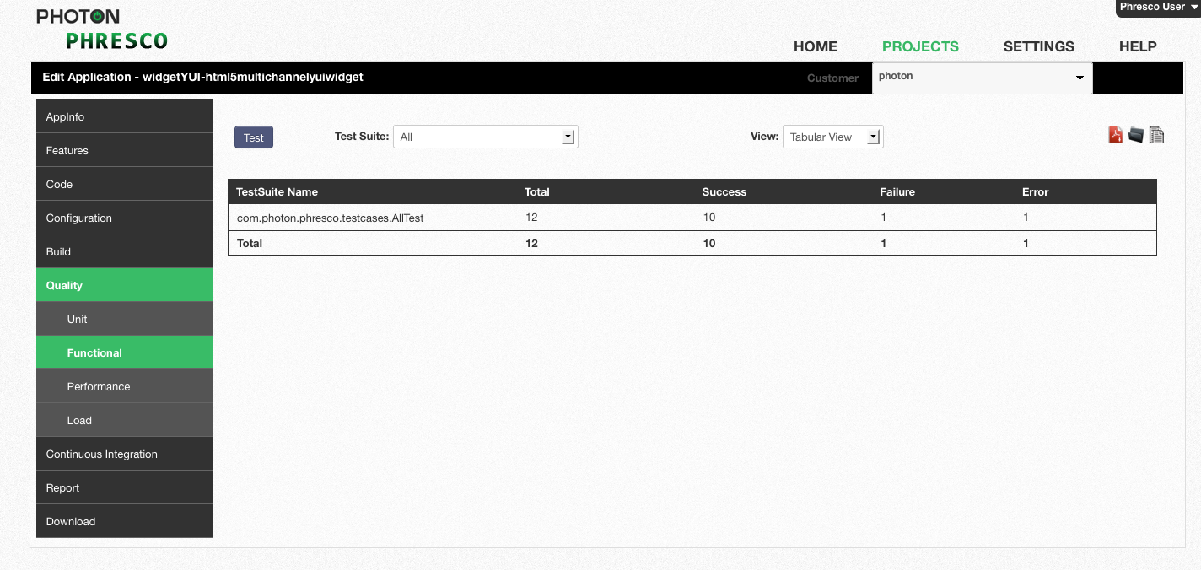

*Figure 8‑12: HTML5 widget functional test report for all test cases in tabular view*

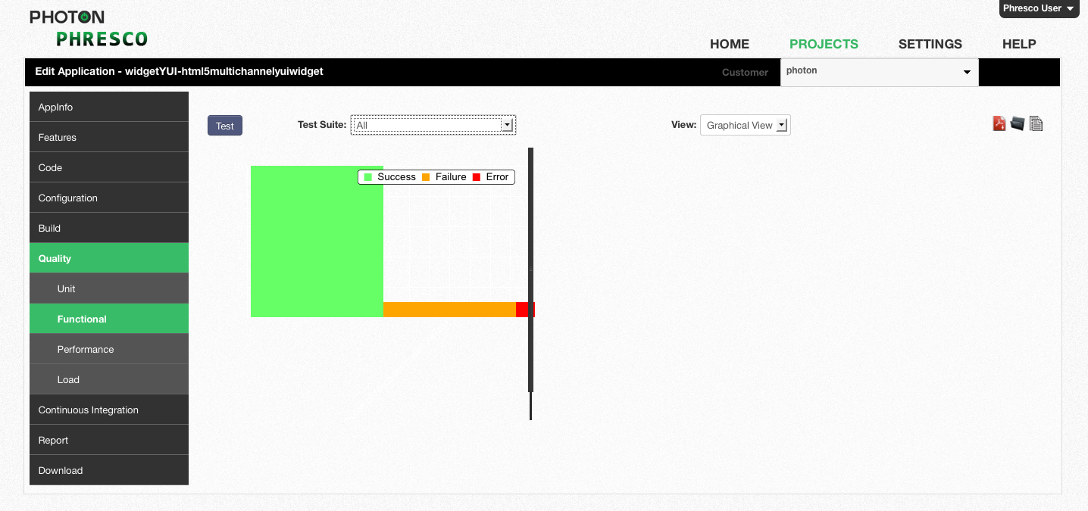

Figure 8-13: *HTML5 widget functional test report for all test cases in graphical view*

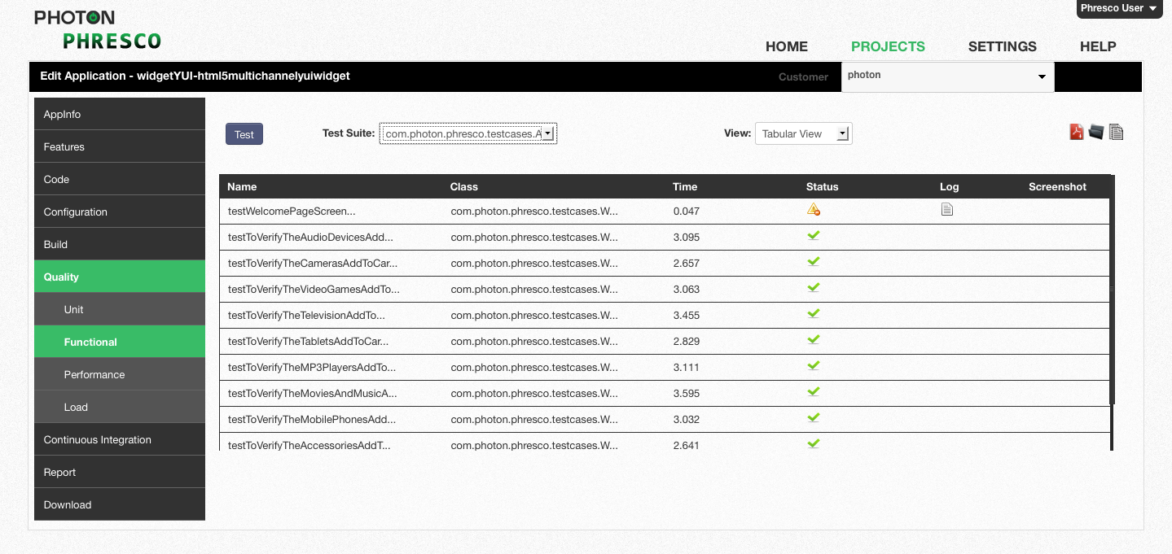

Figure 8‑14: *HTML5 widget functional test report for single test case in tabular view*

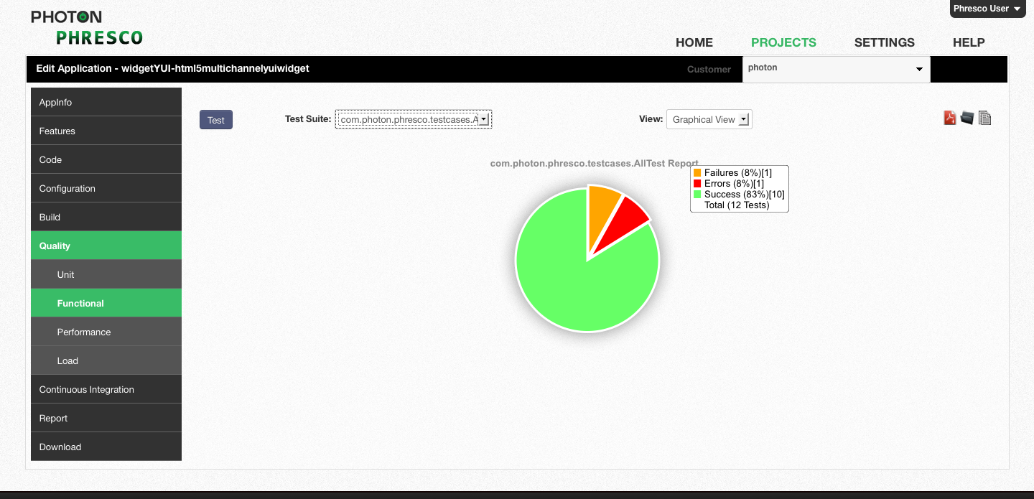

Figure 8‑15: *HTML5 widget functional test report for single test case in graphical view*

## Test Cases for Php Technology

Selenium web driver is used to execute the test cases for Php, Drupal, and WordPress technologies in the latest version.

### Unit Test Cases

#### Structure of Alltest and Test Cases

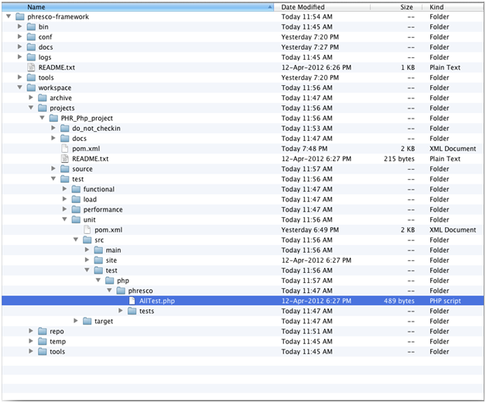

*Figure 8‑66: PHP unit tests structure*

1. **AllTest:** It is the root file that carries all the php suite file to initiate the testing process. Each test case can be called separately to run the unit test.
2. **Test cases**: These are individual test classes which perform unique testing scenarios against the application.

#### Existing Test Cases and Suites Out Of the Box in Phresco

**AllTest for PHP**

AllTest contains a bunch of test cases, each of which performs a unique scenario on the application. Test developers can start writing new suite classes and test cases by following the syntax and structure of Phresco framework’s out of the box class structure. AllTest class calls all the suite classes and the test cases within it. Once suite classes and test cases are written developers can execute those from Phresco Framework and can see the report. Following is the AllTest file which shows up how to add / include the class inside it.

<? php

require_once 'tests/UsernameValidation.php';

require_once 'tests/DateValidation.php';

class AllTest extends PHPUnit_Framework_TestSuite{

protected function setUp(){

}

public static function suite(){

$testSuite = new AllTest('Phpunittest');

$testSuite->addTest(new UsernameValidation("testValidation"));

$testSuite->addTest(new DateValidation("testDate"));

return $testSuite;

}

protected function tearDown(){

}

}

**Test case**

A test case is a set of conditions under which a tester will determine whether an [application](http://en.wikipedia.org/wiki/Software_application) is meeting the requirement. This helps the user to verify a particular functionality during the testing process.

This test case is written for testing the characters of the username to be entered manually. The characters are defined in the base screen and only if it matches with manually entered characters, the unit test case will pass. Testing the username is one unit test case and there can be ‘n’ number of test cases.

<?php

require_once 'PHPUnit/Framework.php';

require_once 'Phresco/tests/BaseScreen.php';

class UsernameValidation extends PHPUnit_Framework_TestCase {

public function setUp() {

$this->objValidator = new BaseScreen;

}

public function testValidation() {

$this->assertEquals(true,

$this->objValidator->check_username('jhonson'));

}

}

?>

#### To Add New Test Case in Alltest

You can add new test cases to the AllTest. An example for creating a new test case is given below.

public static function suite(){

$testSuite = new AllTest('Phpunittest');

$testSuite->addTest(new UsernameValidation("testValidation"));

$testSuite->addTest(new DateValidation("testDate"));

$testSuite->addTest(new EmailVerification("testEmail"));

#### Report generated after execution

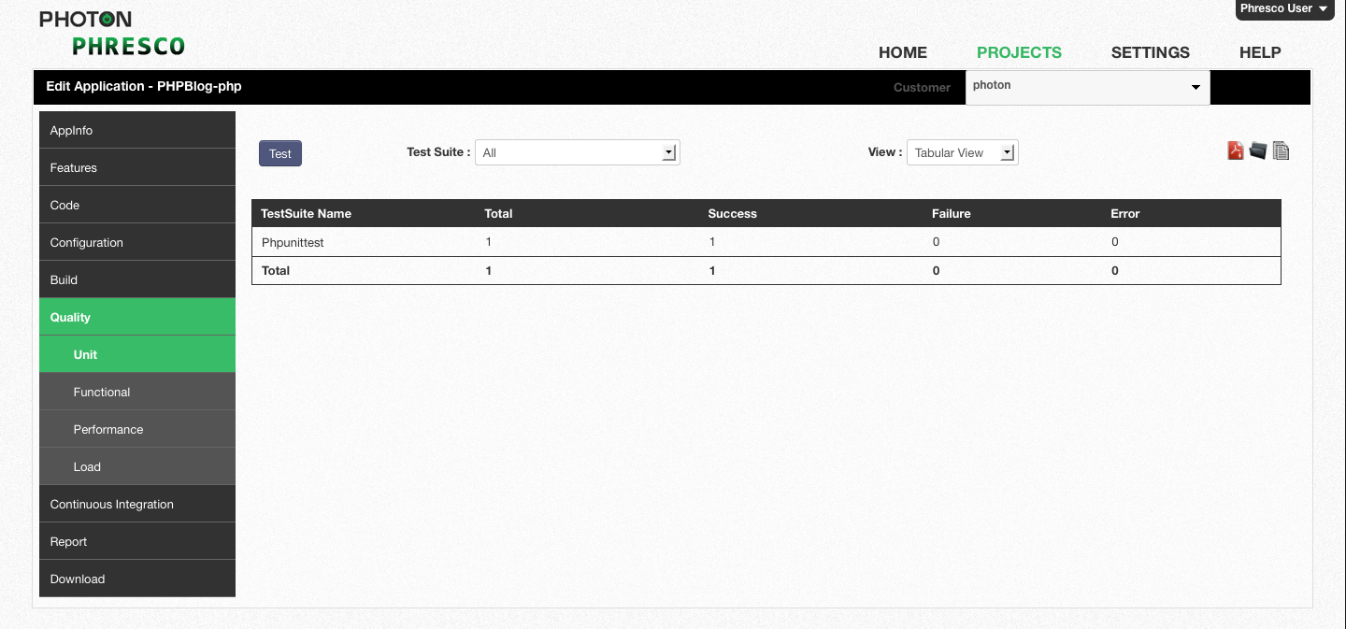

*Figure* 8‑77: *PHP unit test report for all test cases in tabular view*

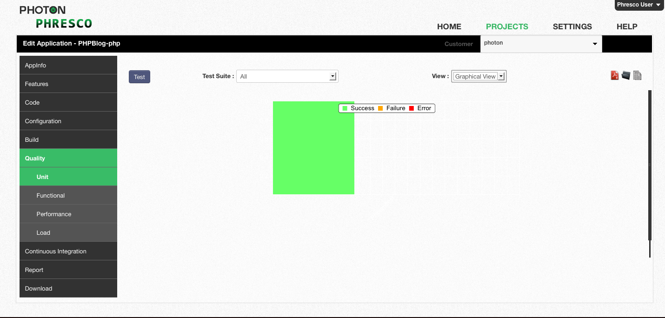

*Figure* 8‑88: *PHP unit test report for all test cases in graphical view*

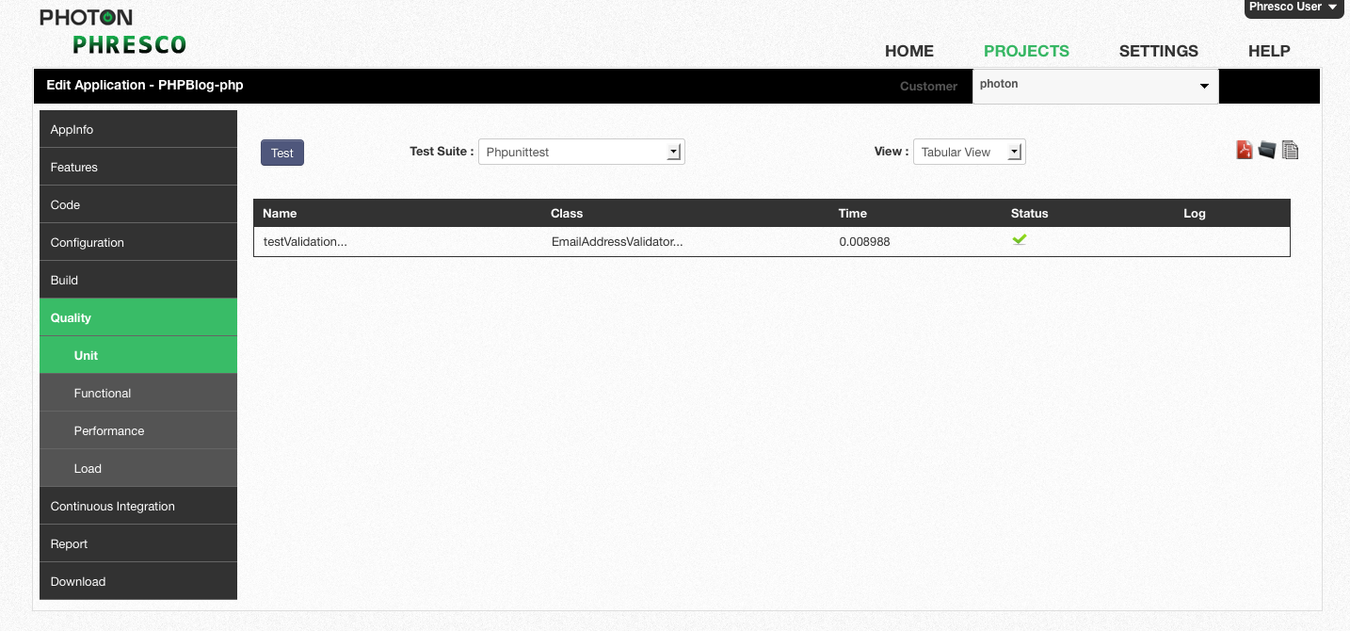

*Figure* 8‑99: *PHP unit test report for single test case in tabular view*

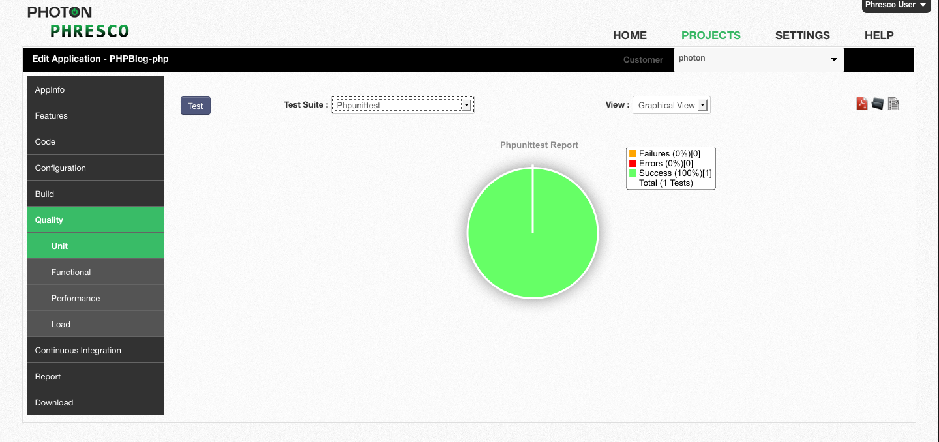

*Figure* 8‑20: *PHP unit test report for single test case in graphical view*

### Functional Test Case for Webdriver

#### Structure of Test Suites and Test Case

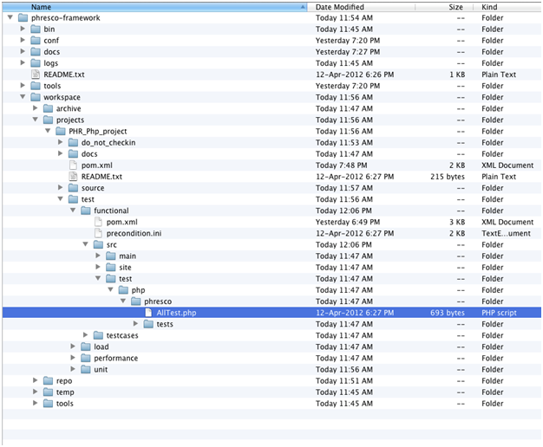

*Figure 8‑21: PHP functional tests structure*

1. **AllTest**: It is the root file that carries all the test suites to initiate the testing.
2. **Test suite**: All the Test suites should be incorporated in the **AllTest**
3. **Test case**: These are individual test classes which perform unique testing scenarios against the application.

#### Existing Test Cases and Suites Out Of the Box in Phresco

**Alltest for Php**

AllTest contains a bunch of test cases, each of which performs a unique scenario on the application. Test developers can start writing new suite classes and test cases by following the syntax and structure of Phresco framework’s out of the box class structure. AllTest class calls all the suite classes and the test cases within it. Once suite classes and test cases are written developers can execute those from Phresco Framework and can see the report. Following is the AllTest file which shows up how to add / include the class inside it.

require_once 'tests/UserModules.php';

require_once 'tests/SearchModules.php';

require_once 'tests/DbUpdateModules.php';

require_once 'tests/DbDeleteModules.php';

class AllTest extends PHPUnit_Framework_TestSuite

{

protected function setUp(){

parent::setUp();

}

public static function suite(){

$suite = new AllTest();

$suite->setName('AllTestsuite');

$suite->addTest(UserModules::suite());

$suite->addTest(SearchModules::suite());

$suite->addTest(DbUpdateModules::suite());

$suite->addTest(DbDeleteModules::suite());

return $suite;

}

protected function tearDown(){

parent::tearDown();

}

}

**Test Suites Example for Usermodules**

Test suite is a collection of test cases that are intended to be used to test a project code to show that it has some specified set of behaviors. A test suite contains detailed instructions or goals for each collection of test cases. New test cases can also be added by using the following syntax.

require_once 'Register_NewUser.php';

require_once 'LoginLogout_User.php';

require_once 'Account_Update.php';

class UserModules extends PHPUnit_Framework_TestSuite

{

protected function setUp(){

parent::setUp();

}

public static function suite(){

$testSuite = new UserModules();

$testSuite->setName('UserModules');

$testSuite->addTestSuite('Register_NewUser');

$testSuite->addTestSuite('LoginLogout_User');

$testSuite->addTestSuite('Account_Update');

return $testSuite;

}

protected function tearDown(){

}

}

**Test Case Example for Testregistration**

Test cases examine all the aspects including inputs and outputs. It gives the detailed steps that should to be followed during the testing process. Testing process follows only the steps that have been written for each test case. It also helps in identifying an element and capturing screen shots when the test fails.

require_once 'PhpCommonFun.php';

class Register_NewUser extends PhpCommonFun

{

protected function setUp(){

parent::setUp();

}

public function testRegisters(){

parent::Browser();

$testcases = __FUNCTION__;

$doc = new DOMDocument();

$doc->load('test-classes/Phresco/tests/phpsetting.xml');

$users = $doc->getElementsByTagName("register");

foreach( $users as $register ){

$names = $register->getElementsByTagName("username");

$name = $names->item(0)->nodeValue;

$emails = $register->getElementsByTagName("email");

$email = $emails->item(0)->nodeValue;

$passwords = $register->getElementsByTagName("password");

$password = $passwords->item(0)->nodeValue;

}

$this->getElement(PHP_REG_LINK,$testcases);

$this->clickandLoad(PHP_REG_LINK);

$this->getElement(PHP_REG_UNAME_TBOX,$testcases);

$this->type(PHP_REG_UNAME_TBOX,$name);

$this->getElement(PHP_REG_EMAIL_TBOX,$testcases);

$this->type(PHP_REG_EMAIL_TBOX,$email);

$this->getElement(PHP_REG_PASS_TBOX,$testcases);

$this->type(PHP_REG_PASS_TBOX,$password);

$this->getElement(PHP_REG_SUBMIT,$testcases);

$this->submit(PHP_REG_SUBMIT,$testcases);

try{

$this->assertTrue($this->isTextPresent(PHP_REG_MSG));

}

catch (PHPUnit_Framework_AssertionFailedError $e) {

$this->doCreateScreenShot(__FUNCTION__);

}

}

public function tearDown(){

$this->closeWindow();

}

#### To Add New Test Suite in Alltest

An example for creating new test suite in the name ‘DbDeleteModules’.

$suite = new AllTest();

$suite->setName('AllTestsuite');

$suite->addTest(UserModules::suite());

$suite->addTest(SearchModules::suite());

$suite->addTest(DbUpdateModules::suite());

$suite->addTest(DbDeleteModules::suite());

#### To Add New Test Case in Test Suite

An example for creating a new test case in the name ‘testAccountUpdate’

$testSuite = new UserModules();

$testSuite->setName('UserModules');

$testSuite->addTestSuite('Register_NewUser');

$testSuite->addTestSuite('LoginLogout_User');

$testSuite->addTestSuite('Account_Update');

**Report generated after execution**

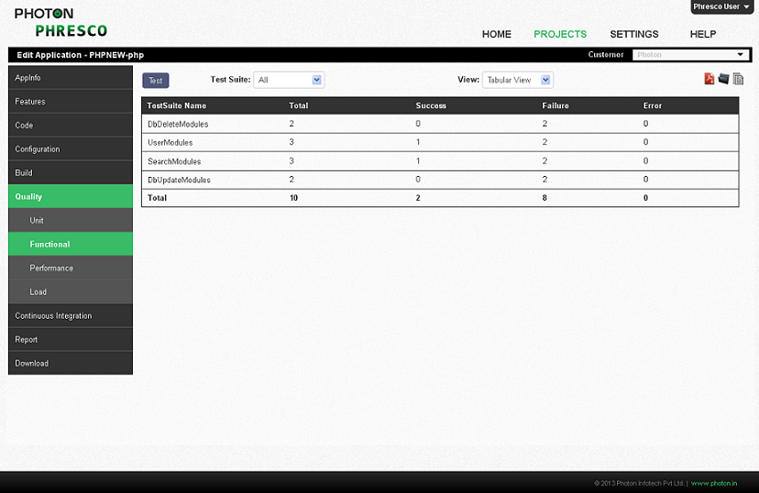

*Figure* 8‑22: *PHP functional test report for all test cases in tabular view*

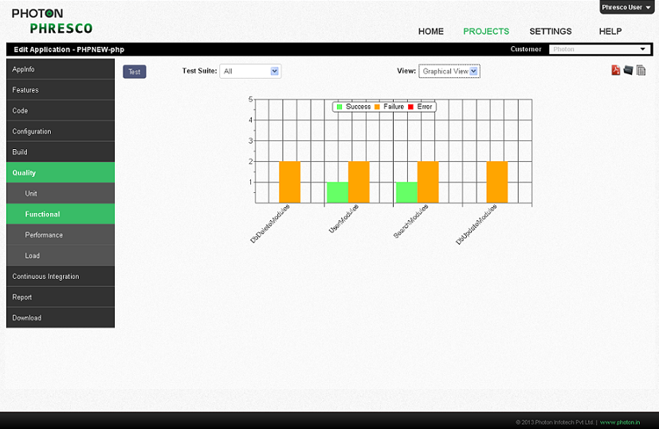

*Figure* 8‑23: *PHP functional test report for all test cases in graphical view*

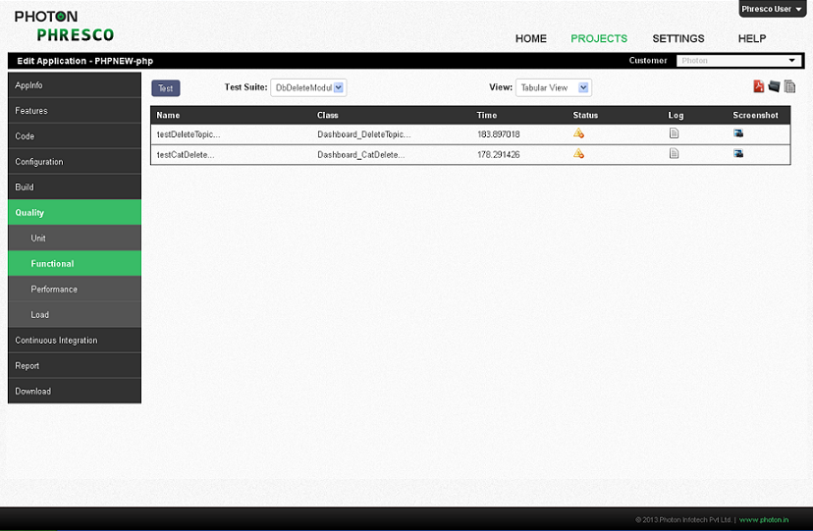

*Figure* 8‑24: *PHP functional test report for single test case in tabular view*

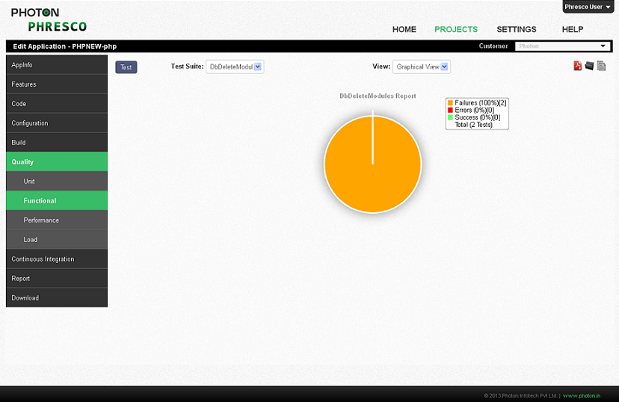

*Figure* 8‑25: *PHP functional test report for single test case in graphical view*

## Test Cases for SharePoint Technology

### Unit Test Case

#### Structure Of Alltest And Test Cases

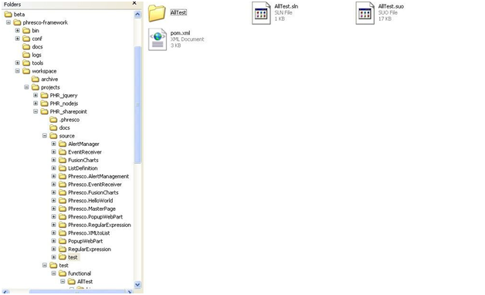

*Figure 8‑106: SharePoint unit tests structure*

* 1. **AllTest**: This is a root folder/file that carries all the classes to initiate the testing.
  2. **Class**: All the classes is incorporated in the AllTest
  3. **Test Case**: All the test cases should be added within the Class

**Alltest for SharePoint**

AllTest contains a bunch of test cases, each of which performs a unique scenario on the application. Test developers can start writing new suite classes and test cases by following the syntax and structure of Phresco framework’s out of the box class structure. AllTest class calls all the suite classes and the test cases within it.

Once suite classes and test cases are written developers can execute those from Phresco Framework and can see the report. Following is the AllTest file which shows up how to add / include the class inside it.

**Class example**

Class is a collection of test cases that are intended to be used to test a project code to show that it has some specified set of behaviors. A class contains detailed instructions or goals for each collection of test cases. New test cases can also be added by using the same syntax.

using System;

using System.Web;

using System.Text;

using System.Collections.Generic;

using System.Linq;

using NUnit.Framework;

using Phresco.EventReceiver;

namespace Phresco.UnitTesting{

[TestFixture]

public class ItemEventReceiver{

[Test]

public void ItemEventReceiverTests() {

ItemEventReceiver itemEventReceiver = new ItemEventReceiver();

// string itemEventReceiverMessage = "";

//Assert.AreEqual("", itemEventReceiver.);

}

}

}

**Test case**

Test cases examine all the aspects including inputs and outputs. It gives the detailed steps that should to be followed during the testing process. Testing process follows only the steps that have been written for each test case.

#### Report generated after execution

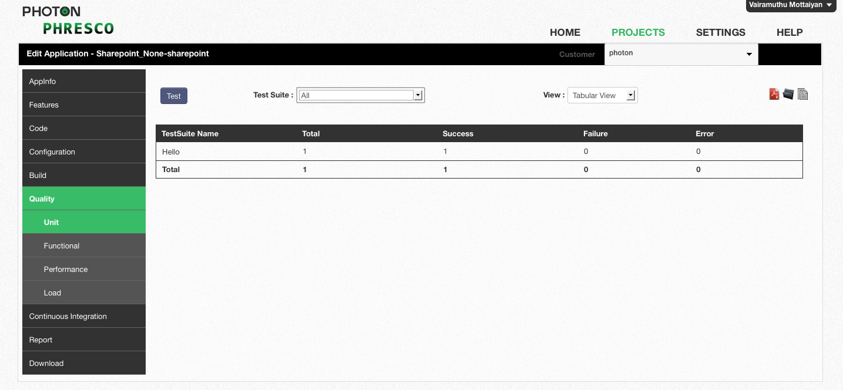

*Figure 8‑117: SharePoint unit test report for all test cases in tabular view*

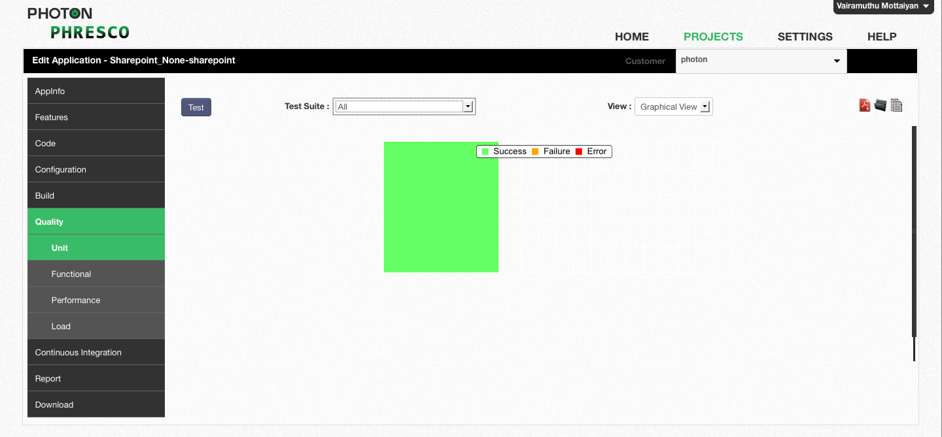

*Figure 8‑128*: *SharePoint unit test report for all test cases in tabular view*

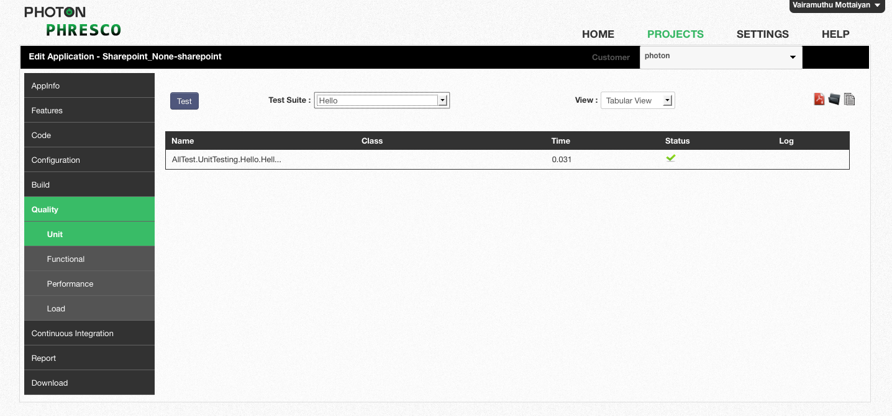

*Figure 8‑139: SharePoint unit test report for single test case in tabular view*

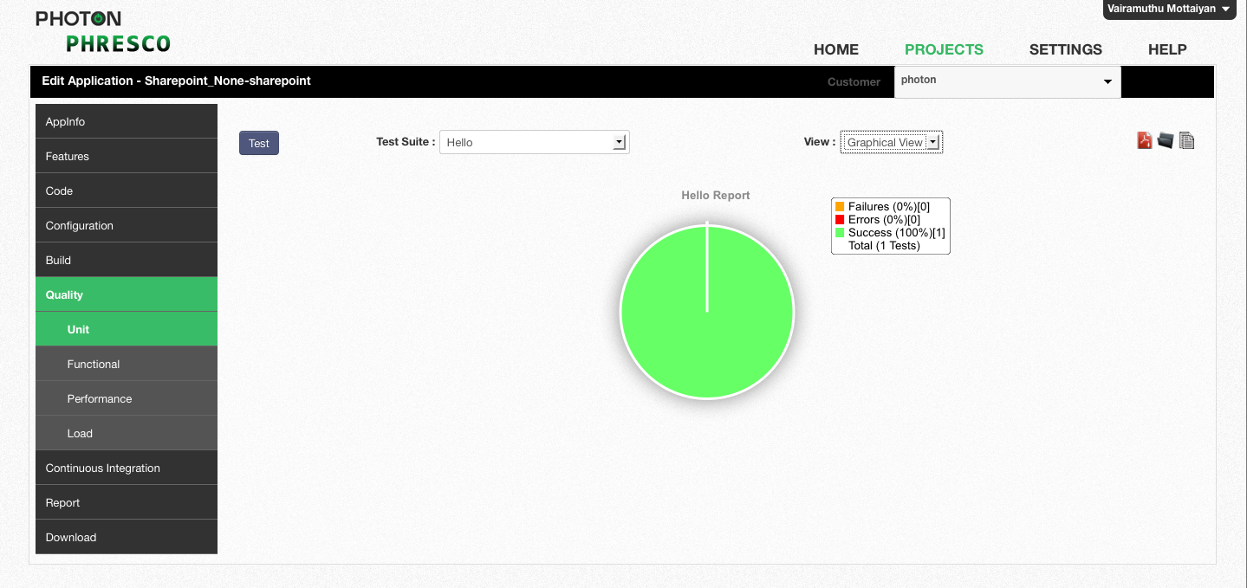

*Figure 8‑30: SharePoint unit test report for single test case in graphical view*

|  |
| --- |
| * **Note** * Phresco supports Functional Tests for Sharepoint and ASP.Net in TestNG and Webdriver format. * Refer section 8.1.2 for the Functional Test case structure which is similar to Selenium Grid Functional Test case structure. |

## Java Standalone Application

### Unit Test Case

#### Structure of Test Case

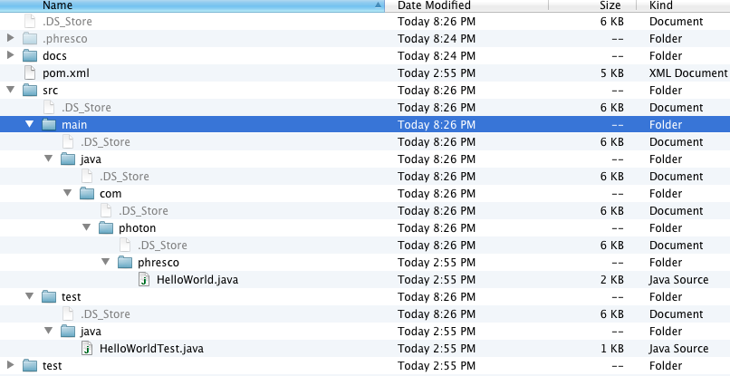

*Figure 8‑31: Java Standalone folder structure*

1. **Test case**: All the Test cases should be added within the test suite.

#### Existing Test Cases and Suites Out Of the Box in Phresco

**Test case example**

A test case is a set of conditions under which a tester will determine whether an [application](http://en.wikipedia.org/wiki/Software_application) is meeting the requirement. This helps the user to verify a particular functionality during the testing process.

**import** junit.framework.Test**;**

**import** junit.framework.TestCase**;**

**import** junit.framework.TestSuite**;**

**public** **class** **HelloWorldTest**

**extends** TestCase

**{**

**public** **HelloWorldTest(** String testName **)**

**{**

**super(** testName **);**

**}**

**public** **static** Test **suite()**

**{**

**return** **new** **TestSuite(**HelloWorldTest **.**class **);**

**}**

**public** **void** **testApp()**

**{**

        assertTrue**(** **true** **);**

**}**

**}**

### Functional Test Case

#### Structure of Test Suites and Test Case

1. **AllTest**: Alltest is a java suite class that can either initiate a suite class or a group of test cases.
2. **Test suite**: Test suite is a collection of test cases.
3. **Test case**: All the Test cases should be added within the test suite.

#### Existing Test Cases and Suites Out Of the Box in Phresco

**Alltest for Java Standalone Application**

AllTest is the root category which holds the test suite. AllTest contains a bunch of test suites, each of which performs a unique scenario on the application. Test developers can start writing new suite classes by following the syntax and structure of Phresco framework’s out of the box class structure. Once test suite classes and test cases are written developers can execute those from Phresco Framework and can see the report. Following is the AllTest file which shows up how to add / include the class inside it.

package com.photon.Phresco.testcases;

import org.junit.runner.RunWith;

import org.junit.runners.Suite;

import org.junit.runners.Suite.SuiteClasses;

@RunWith(Suite.class)

@SuiteClasses({SampleHelloWorld.class})

public class AllTest {

}

**Test Suites Example**

Test suite is a collection of test cases that are intended to be used to test a project code to show that it has some specified set of behaviors. A test suite contains detailed instructions or goals for each collection of test cases. New test cases can also be added.

**Test Case Example**

A test case is a set of conditions under which a tester will determine whether an [application](http://en.wikipedia.org/wiki/Software_application) is meeting the requirement. This helps the user to verify a particular functionality during the testing process. Functional test case for java standalone application is written using the FEST tool.

package com.photon.Phresco.testcases;

import static org.fest.assertions.Assertions.assertThat;

import static org.fest.swing.edt.GuiActionRunner.execute;

import org.fest.swing.annotation.RunsInEDT;

import org.fest.swing.edt.GuiQuery;

import org.fest.swing.fixture.FrameFixture;

import org.fest.swing.junit.testcase.FestSwingJUnitTestCase;

import org.junit.Test;

import com.photon.Phresco.HelloWorld;

public class HelloWorldTest extends FestSwingJUnitTestCase {

private FrameFixture Phresco;

protected void onSetUp() {

Phresco = new FrameFixture(robot(), createNewEditor());

Phresco.show();

Phresco.maximize();

System.out.println("**************Executed onsetup**************");

}

@RunsInEDT

private static HelloWorld createNewEditor() {

return execute(new GuiQuery<HelloWorld>() {

protected HelloWorld executeInEDT() throws Throwable {

return new HelloWorld();

}

});

}

@Test

public void testHelloWorld() throws InterruptedException {

Thread.sleep(5000);

assertThat(Phresco.label().text()).contains("Hello World");

}

}

#### To Add New Test Case In Test Suite

You can add a new test case to the Test suite using the following method.

@Test

public void testHelloWorld() throws InterruptedException {

Thread.sleep(5000);

assertThat(Phresco.label().text()).contains("Hello World");

#### Report generated after execution

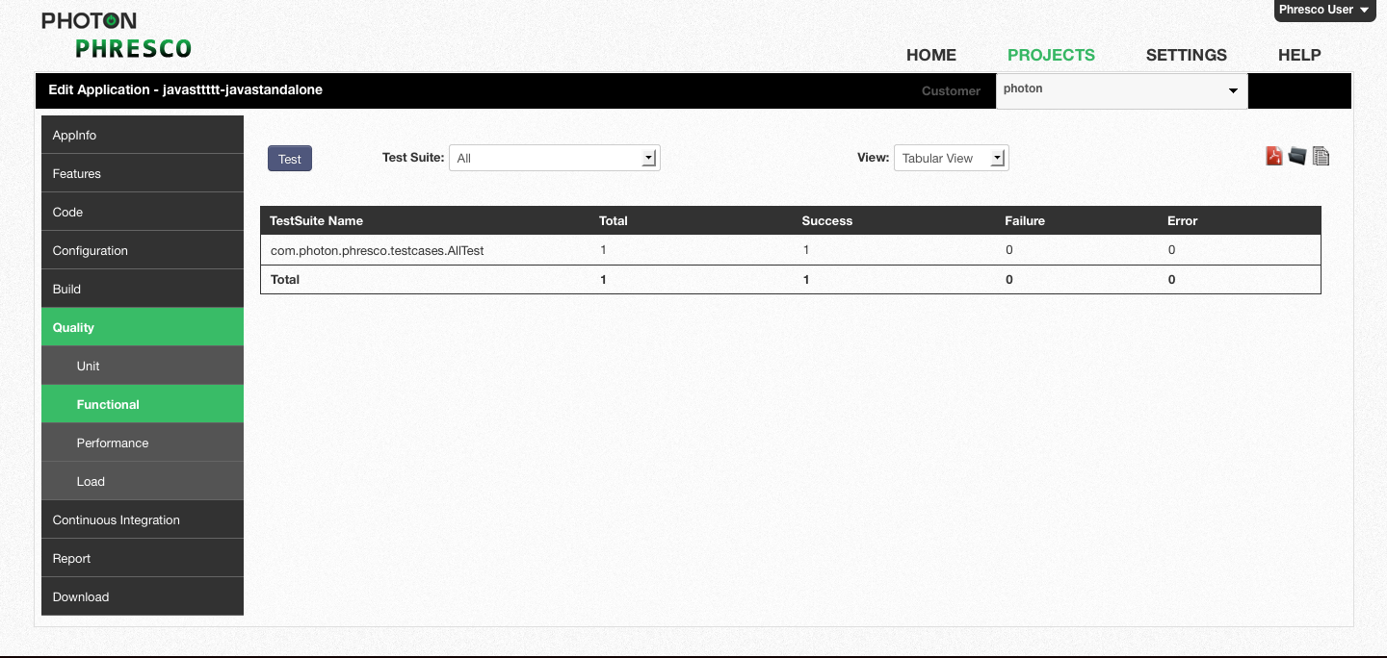

Figure 8‑32: *Java Standalone functional test report for all test cases in tabular view*

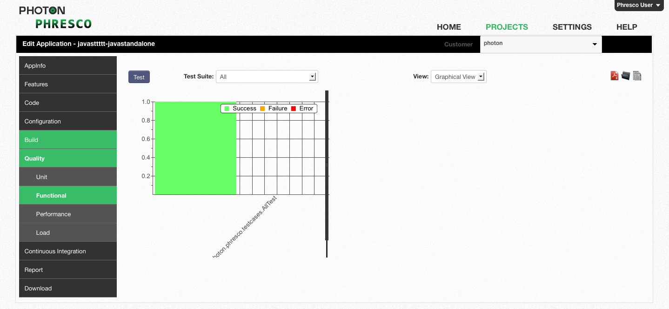

Figure 8‑33: *Java Standalone functional test report for all test cases in graphical view*

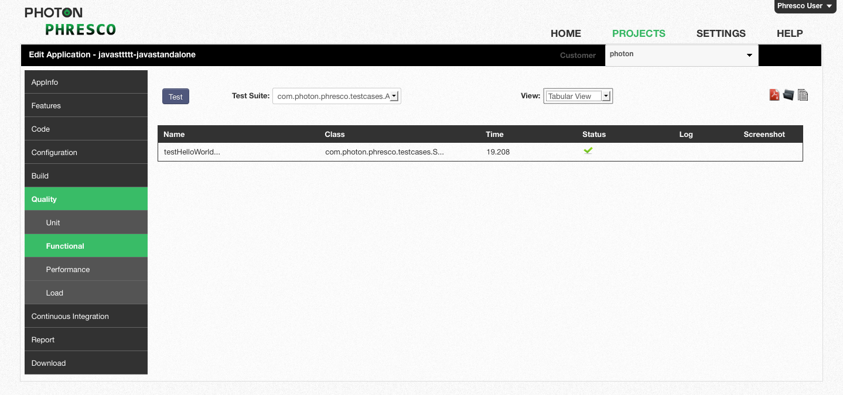

Figure 8‑34: *Java Standalone functional test report for single test case in tabular view*

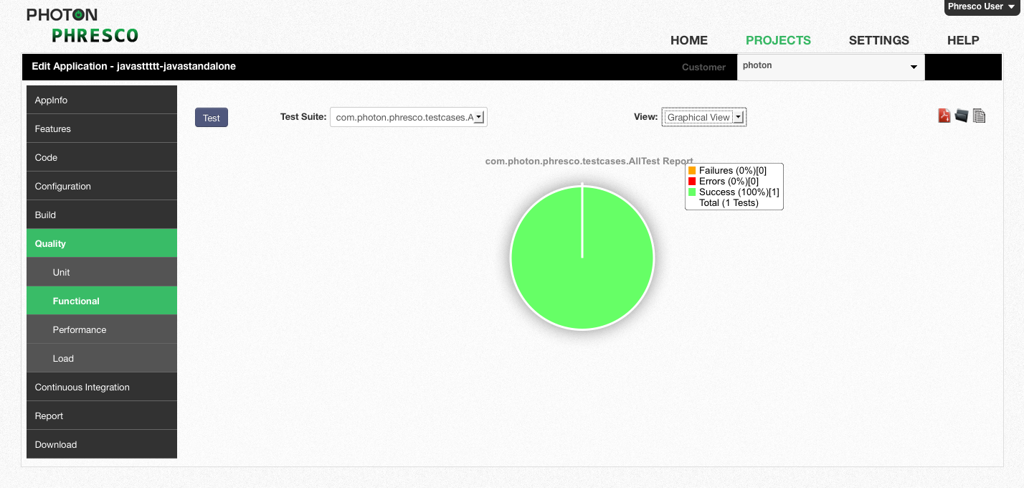

Figure 8‑35: *Java Standalone functional test report for single test case in graphical view*

## Android application

### Unit Test Case

#### Structure of Alltest and Test Cases

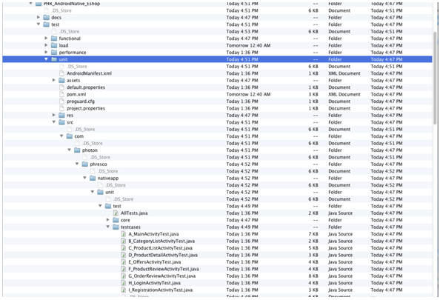

*Figure 8‑36: Android unit tests structure*

1. **AllTest (test suite):** AllTest is the class that carries all the test classes to initiate the testing process. Each test class can be called within the AllTest.
2. **Test class:** Test classes hold different test methods
3. **Test methods/test cases:** Test cases are called in the test classes which test the source code.

#### Existing Test Cases Out Of the Box in Phresco

**AllTest for Android Technology**

AllTest contains a bunch of test cases, each of which performs a unique scenario on the application. Test developers can start writing new suite classes and test cases by following the syntax and structure of Phresco framework’s out of the box class structure. AllTest class calls all the suite classes and the test cases within it. Once suite classes and test cases are written developers can execute those from Phresco Framework and can see the report. Following is the AllTest file which shows up how to add / include the class inside it.

package com.photon.Phresco.nativeapp.unit.test;

import junit.framework.TestCase;

import junit.framework.TestSuite;

import com.photon.Phresco.nativeapp.unit.test.testcases.A_MainActivityTest;

import com.photon.Phresco.nativeapp.unit.test.testcases.B_CategoryListActivityTest;

import com.photon.Phresco.nativeapp.unit.test.testcases.C_ProductListActivityTest;

import com.photon.Phresco.nativeapp.unit.test.testcases.D_ProductDetailActivityTest;

import com.photon.Phresco.nativeapp.unit.test.testcases.E_OffersActivityTest;

import com.photon.Phresco.nativeapp.unit.test.testcases.F_ProductReviewActivityTest;

import com.photon.Phresco.nativeapp.unit.test.testcases.G_OrderReviewActivityTest;

import com.photon.Phresco.nativeapp.unit.test.testcases.H_LoginActivityTest;

public class AllTests extends TestCase {

public static TestSuite suite() {

TestSuite suite = new TestSuite(AllTests.class.getName());

suite.addTestSuite(A_MainActivityTest.class);

suite.addTestSuite(B_CategoryListActivityTest.class);

suite.addTestSuite(C_ProductListActivityTest.class);

suite.addTestSuite(D_ProductDetailActivityTest.class);

suite.addTestSuite(E_OffersActivityTest.class);

suite.addTestSuite(F_ProductReviewActivityTest.class);

suite.addTestSuite(G_OrderReviewActivityTest.class);

suite.addTestSuite(H_LoginActivityTest.class);

return suite;

}

public ClassLoader getLoader() {

return AllTests.class.getClassLoader();

}

}

**Test Method Example for Loginactivitytest**

This test method is written for testing the login activity. There can be n number of test methods under a test class. Test class calls the test methods. An example of a test class is given below

package com.photon.Phresco.nativeapp.unit.test.testcases;

import java.io.IOException;

import junit.framework.TestCase;

import org.json.JSONException;

import org.json.JSONObject;

import org.junit.After;

import org.junit.AfterClass;

import org.junit.Before;

import org.junit.BeforeClass;

import org.junit.Test;

import com.photon.Phresco.nativeapp.eshop.json.JSONHelper;

import com.photon.Phresco.nativeapp.eshop.logger.PhrescoLogger;

import com.photon.Phresco.nativeapp.unit.test.core.Constants;

public class H_LoginActivityTest extends TestCase{

private static final String TAG = "H_LoginActivityTest *********** ";

/**

* @throws java.lang.Exception

*/

@BeforeClass

public static void setUpBeforeClass() {

}

/**

* @throws java.lang.Exception

*/

@AfterClass

public static void tearDownAfterClass() {

}

/**

* @throws java.lang.Exception

*/

@Before

public void setUp() {

}

/**

* @throws java.lang.Exception

*/

@After

public void tearDown() {

}

/**

* send valid login email id and password to web server

*

*/

@Test

public final void testLogin() {

JSONObject jObjMain = new JSONObject();

JSONObject jObj = new JSONObject();

try {

PhrescoLogger.info(TAG + " testLogin -------------- START ");

jObj.put("loginEmail", "tester@Phresco.com");

jObj.put("password", "123");

jObjMain.put("login", jObj);

JSONObject responseJSON = null;

responseJSON=JSONHelper.postJSONObjectToURL(Constants.getWebContextURL() + Constants.getRestAPI() + Constants.LOGIN_POST_URL, jObjMain.toString());

assertNotNull("Login response is not null",responseJSON.length() > 0);

PhrescoLogger.info(TAG + " testLogin -------------- END ");

} catch (IOException ex) {

PhrescoLogger.info(TAG + " - testLogin - IOException : " + ex.toString());

PhrescoLogger.warning(ex);

} catch (JSONException ex) {

PhrescoLogger.info(TAG + " - testLogin - JSONException : " + ex.toString());

PhrescoLogger.warning(ex);

}

}

**Test Case Example for Test Login**

A test case is a set of conditions under which a tester will determine whether an [application](http://en.wikipedia.org/wiki/Software_application) is meeting the requirement. This helps the user to verify a particular functionality during the testing process.

Example of test case in login activity is given below:

@Test

public final void testLogin() {

JSONObject jObjMain = new JSONObject();

JSONObject jObj = new JSONObject();

try {

PhrescoLogger.info(TAG + " testLogin -------------- START ");

jObj.put("loginEmail", "tester@Phresco.com");

jObj.put("password", "123");

jObjMain.put("login", jObj);

JSONObject responseJSON = null;

responseJSON=JSONHelper.postJSONObjectToURL(Constants.getWebContextURL() + Constants.getRestAPI() + Constants.LOGIN_POST_URL, jObjMain.toString());

assertNotNull("Login response is not null",responseJSON.length() > 0);

PhrescoLogger.info(TAG + " testLogin -------------- END ");

} catch (IOException ex) {

PhrescoLogger.info(TAG + " - testLogin - IOException : " + ex.toString());

PhrescoLogger.warning(ex);

} catch (JSONException ex) {

PhrescoLogger.info(TAG + " - testLogin - JSONException : " + ex.toString());

PhrescoLogger.warning(ex);

}

}

#### To Add New Test Method in Alltest Class

You can add a new test method to the AllTest class as follows.

Here is an example for creating a new test suite in the name ‘RegistrationActivityTest’

import com.photon.Phresco.nativeapp.unit.test.testcases.A_MainActivityTest;

import com.photon.Phresco.nativeapp.unit.test.testcases.B_CategoryListActivityTest;

import com.photon.Phresco.nativeapp.unit.test.testcases.C_ProductListActivityTest;

import com.photon.Phresco.nativeapp.unit.test.testcases.D_ProductDetailActivityTest;

import com.photon.Phresco.nativeapp.unit.test.testcases.E_OffersActivityTest;

import com.photon.Phresco.nativeapp.unit.test.testcases.F_ProductReviewActivityTest;

import com.photon.Phresco.nativeapp.unit.test.testcases.G_OrderReviewActivityTest;

import com.photon.Phresco.nativeapp.unit.test.testcases.H_LoginActivityTest;

import com.photon.Phresco.nativeapp.unit.test.testcases.I_RegistrationActivityTest;

#### Report generated after execution

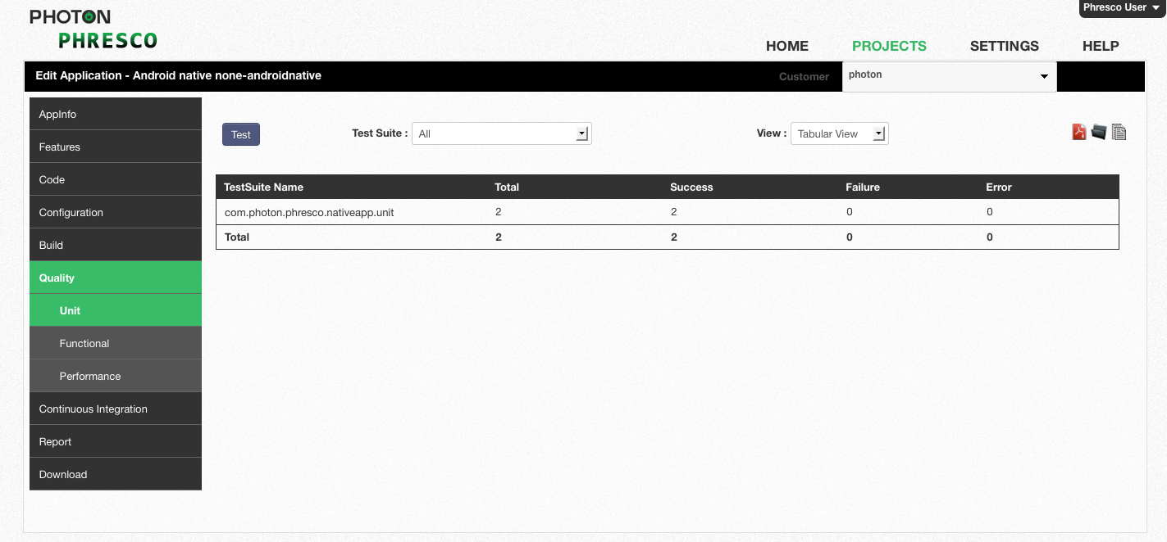

*Figure 8‑147: Android unit test report for all test cases in tabular view*

### 

Figure 8‑158: *Android unit test report for all test cases in graphical view*

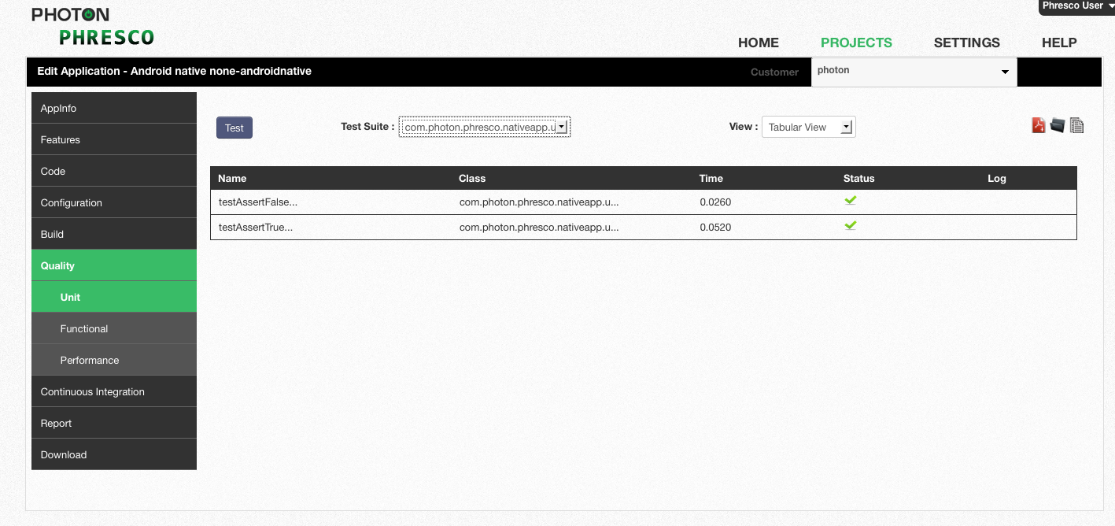

Figure 8‑169: *Android unit test report for single test case in graphical view*

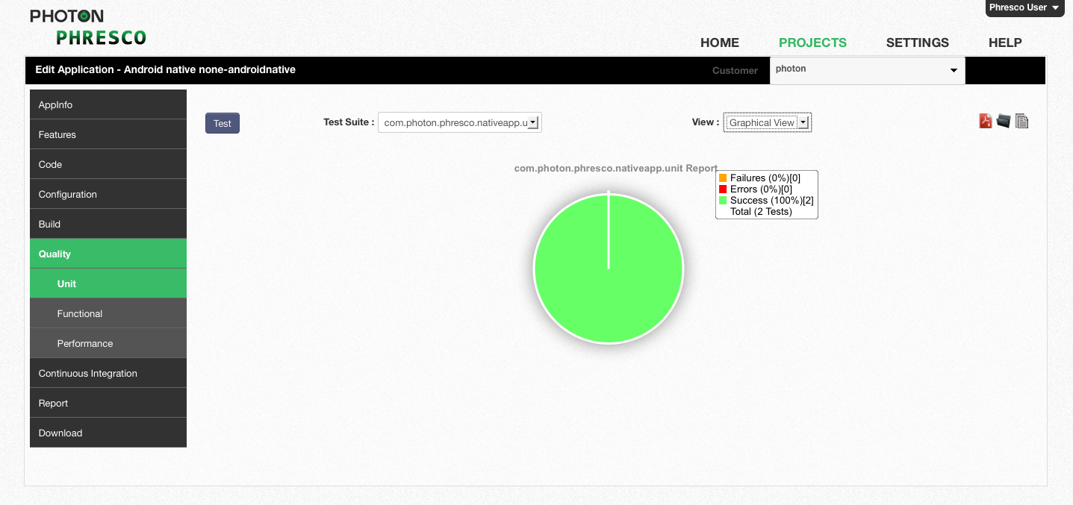

Figure 8‑40: *Android unit test report for single test case in graphical view*

### Functional Test Case for Android Native - Robotium

#### Structure of Functional Test of Android Native

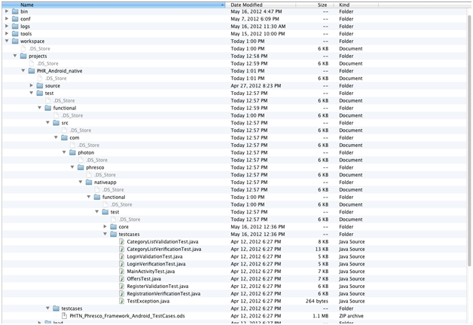

*Figure 8‑41: Android* *Native functional tests structure*

1. **MainActivity test:** Main activity test is the root folder that calls all the test cases written separately.This initiates the testing process.
2. **Test cases :** Test cases are the test methods that are called by the main activity test. Test cases can be many in number

**Main Activity Test**

Main activity test is a class that calls all the test cases within itself. It contains a bunch of test cases, each of which performs a unique scenario on the application. Test developers can start writing new suite classes and test cases by following the syntax and structure of Phresco framework’s out of the box class structure. Once test cases are written developers can execute those from Phresco Framework and can see the report. Following is the file which shows up how to add / include the class inside it.

package com.photon.Phresco.nativeapp.functional.test.testcases;

import android.test.ActivityInstrumentationTestCase2;

import android.test.suitebuilder.annotation.Smoke;

import android.util.Log;

import com.jayway.android.robotium.solo.Solo;

import com.photon.Phresco.nativeapp.eshop.activity.MainActivity;

@SuppressWarnings("unchecked")

public class MainActivityTest extends ActivityInstrumentationTestCase2<MainActivity> {

/**

* This is suite testcase by this testcase will call other testcases . In

* static block we are loading the MainActivity class and from the

* constructor will pass the package and activity full class name then in

* setUp() created the Solo class object

*

*/

public static final String PACKAGE_NAME = "com.photon.Phresco.nativeapp";

private static final String LAUNCHER_ACTIVITY_FULL_CLASSNAME = "com.photon.Phresco.nativeapp.eshop.activity.MainActivity";

private static Class<MainActivity> mainActivity;

private Solo soloMain;

private LoginValidationTest loginValid;

private final String TAG = "MainTestCase****";

/**

* This block will be executed first and it will loads the SplashActivity .

*/

static {

try {

mainActivity = (Class<MainActivity>) Class.forName(LAUNCHER_ACTIVITY_FULL_CLASSNAME);

}

catch (ClassNotFoundException e) {

throw new RuntimeException(e);

}

}

/**

* In this constructor , we have to send the packagename and activity full

* class name.

*

* @throws Exception

*/

public MainActivityTest() throws Exception {

super(PACKAGE_NAME, mainActivity);

}

/**

* this method for create the Solo class object having two super class

* methods.

*

*/

@Override

public void setUp() {

soloMain = new Solo(getInstrumentation(), getActivity());

}

/**

* This test method will cAllTestLoginValidation() method.It verifies

* the Validation for Login screen.

*

*/

public void testValidationLogin() throws TestException {

try {

Log.i(TAG, "testValidationLogin---------Start");

// creating objectof the class LoginValidationTestCase

loginValid = new LoginValidationTest(soloMain);

loginValid.testLoginValidation();

Log.i(TAG, "testValidationLogin---------End");

} catch (TestException e) {

e.printStackTrace();

}

}

**Test cases**

A test case is a set of conditions under which a tester will determine whether an [application](http://en.wikipedia.org/wiki/Software_application) is meeting the requirement. This helps the user to verify a particular functionality during the testing process. Elements can be identified and screen shots can be captured when the test fails. Test cases can be added by writing the test cases separately and by calling within the Main activity test.

package com.photon.Phresco.nativeapp.functional.test.testcases;

import java.util.ArrayList;

import java.util.Iterator;

import junit.framework.TestCase;

import android.util.Log;

import android.view.View;

import android.widget.EditText;

import android.widget.ImageView;

import com.photon.Phresco.nativeapp.R;

import com.jayway.android.robotium.solo.Solo;

public class LoginValidationTest extends TestCase {

private Solo soloLoginValid;

private String activityName;

public ImageView clickCancel;

private String TAG = "*****LoginValidationTestCase******";

public LoginValidationTest(Solo solo) {

this.soloLoginValid = solo;

}

public void testLoginValidation() throws TestException {

try {

Log.i(TAG, "------It is testLoginValidation()-----------");

activityName = soloLoginValid.getCurrentActivity().getClass().getSimpleName();

if (activityName.equalsIgnoreCase("MainActivity")) {

Log.i(TAG, "------It is MainActivity-----------" + activityName);

soloLoginValid.waitForActivity("HomeActivity", 2000);

for (int i = 0; i < 40; i++) {

activityName = soloLoginValid.getCurrentActivity().getClass().getSimpleName();

if (activityName.equalsIgnoreCase("HomeActivity")) {

Log.i(TAG, "------for()-- loop-----");

break;

}

soloLoginValid.waitForActivity("HomeActivity", 2000);

}

} else {

Log.i(TAG, "------ testLoginValidation failed-----------");

throw new TestException("Current Activity Failed----"

+ soloLoginValid.getCurrentActivity().getClass().getSimpleName() + "failed");

}

if (activityName.equalsIgnoreCase("HomeActivity")) {

Log.i(TAG, "------HomeActivity-----------");

System.out.println(" Activity name ---->" + soloLoginValid.getCurrentActivity());

ArrayList<View> al = soloLoginValid.getViews();

Iterator<View> it = al.iterator();

while (it.hasNext()) {

String viewName = it.next().getClass().getSimpleName();

if (viewName.equalsIgnoreCase("ImageView")) {

Log.i(TAG, "------ImageView found-----------");

break;

}

continue;

}

} else {

Log.i(TAG, "------HomeActivity not found-----------");

throw new TestException(TAG + soloLoginValid.getCurrentActivity().getClass().getSimpleName() + "failed");

}

// click on Loginbutton

soloLoginValid.waitForActivity("MainActivity", 5000);

// get the login button view with id i.e home_login_btn

ImageView loginButton = (ImageView) soloLoginValid

.getView(R.id.home_login_btn);

// click on login button with view id

soloLoginValid.clickOnView(loginButton);

// control waits for 2 seconds to activate the screen

soloLoginValid.waitForActivity("SplashActivity", 2000);

// clears the text at first Editfield

EditText emailField = (EditText) soloLoginValid.getView(R.id.txt_email);

soloLoginValid.clearEditText(emailField);

// it will type the text at first field which i gave in method

soloLoginValid.enterText(emailField, "android@");

// clear the text at second Editfield

EditText passwordField = (EditText) soloLoginValid

.getView(R.id.txt_password);

soloLoginValid.clearEditText(passwordField);

// finding the password field view

// click the password field based on EditText view object

soloLoginValid.clickOnView(passwordField);

soloLoginValid.waitForActivity("MainActivity", 1000);

soloLoginValid.enterText(passwordField, "*****");

soloLoginValid.waitForActivity("MainActivity", 1000);

// click on Login button

ImageView clickLogin = (ImageView) soloLoginValid

.getView(R.id.login_btn);

soloLoginValid.clickOnView(clickLogin);

// soloSplash.clickOnImageButton(1);

soloLoginValid.waitForActivity("LoginActivity");

soloLoginValid.clickOnView(emailField);

soloLoginValid.waitForActivity("LoginActivity", 1000);

boolean valid = soloLoginValid.searchText("Invalid Email address!");

if (valid) {

assertTrue("Invalid Email address!", valid);

} else {

throw new TestException("Testcase failed");

}

soloLoginValid.waitForActivity("LoginActivity", 1000);

// Get the view location of cancel button.

clickCancel = (ImageView) soloLoginValid.getView(R.id.cancel_btn);

soloLoginValid.waitForActivity("MainActivity", 1000);

// click on cancel button

soloLoginValid.clickOnView(clickCancel);

soloLoginValid.waitForActivity("LoginActivity", 1000)

} catch (TestException e) {

e.printStackTrace();

}

}

}

#### To Add A New Test Case

You can add a new test case to the Main activity test using the following method. Here is an example for creating a new test case ‘testRegististrationValidation’

public static final String PACKAGE_NAME = "com.photon.Phresco.nativeapp";

private static final String LAUNCHER_ACTIVITY_FULL_CLASSNAME = "com.photon.Phresco.nativeapp.eshop.activity.MainActivity";

private static Class<MainActivity> mainActivity;

private Solo soloMain;

private LoginValidationTest loginValid;

private testRegististrationValidation;

private final String TAG = "MainTestCase****";

@Smoke

public void testRegististrationValidation() throws TestException {

try {

Log.i(TAG, "testRegististrationValidation---------Start");

// creating object of the testclass RegisterValidationTestCase

registrationValid = new RegisterValidationTest(soloMain);

registrationValid.testRegisterValidation();

Log.i(TAG, "testRegististrationValidation---------End");

} catch (TestException e) {

e.printStackTrace();

}

}

#### Report generated after execution

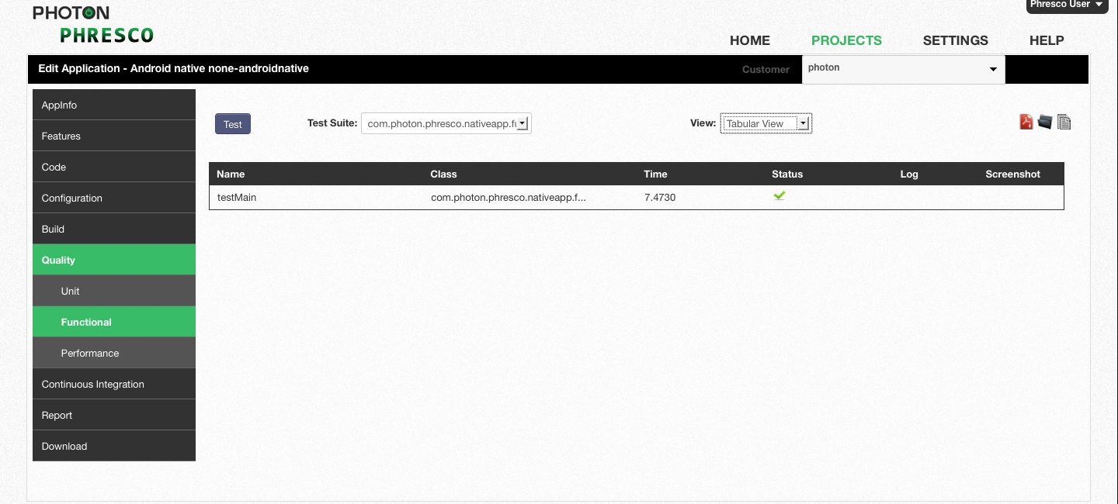

Figure 8‑42: *Android* *Native functional test report for all test cases in tabular view*

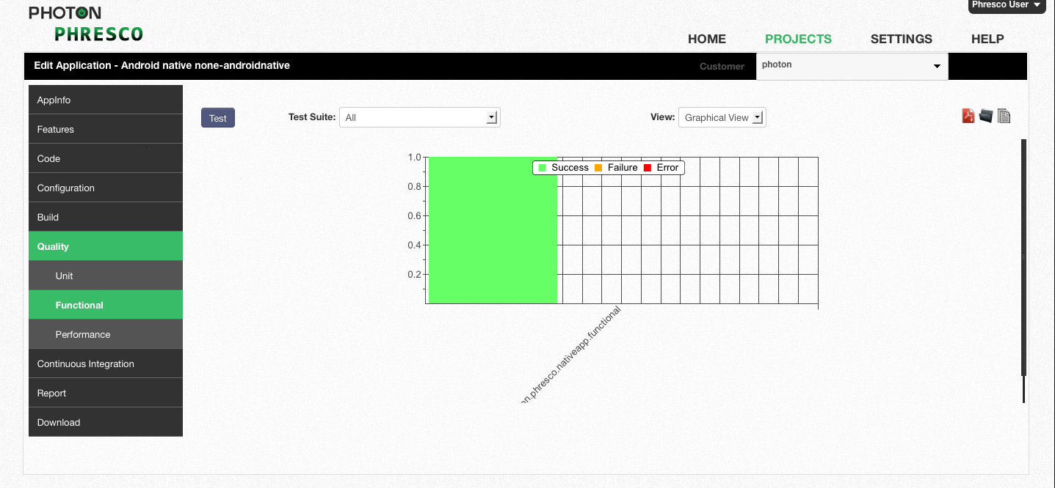

Figure 8‑4317: *Android* *Native functional test report for all test cases in graphical view*



Figure 8‑44: *Android* *Native functional test report for single test case in tabular view*

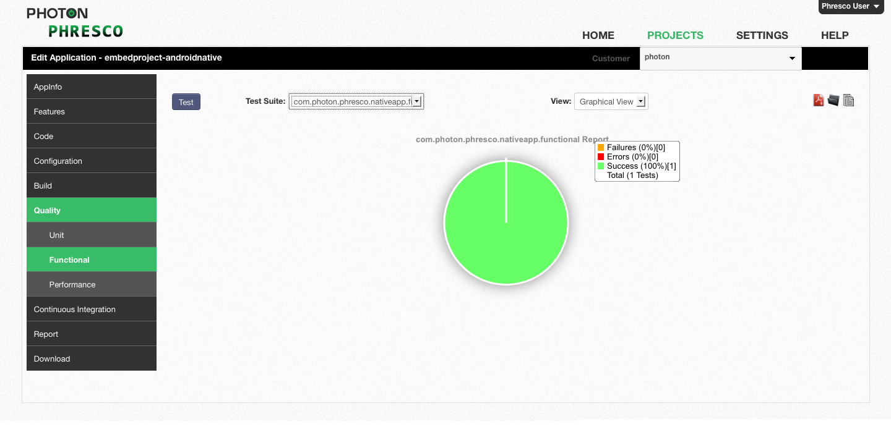

*Figure 8‑45: Android Native functional test report for single test case in graphical view*

## Functional Test cases for Android Hybrid – Monkey Talk

### Structure of Functional Test for Android Hybrid



*Figure 8‑46: Android Hybrid functional tests structure*

* 1. AllTest: This is a root mts file that can either call a suite of Test cases or an individual Test case.
  2. Test Cases: These perform unique testing scenarios against the application.This is an mt file.

#### Existing Test Cases and Suites Out Of the Box in Phresco

**AllTest**

In Phresco testing Framework a mts suite file is named as “AllTest”.

The AllTest contains a bunch of test cases, each of which performs a unique scenario on the application. Test developers can start writing new suites and test cases by following the syntax and structure of Phresco frameworks out of the box structure. Following is the AllTest file which shows up how to add / include the Test cases inside it.

Test Register Run %thinktime=5000 %timeout=2000

Test Login Run %thinktime=5000 %timeout=2000

Test Browse Run %thinktime=8000 %timeout=2000

**Test cases**

A Test case is a set of conditions under which a tester will determine whether an [application](http://en.wikipedia.org/wiki/Software_application) is meeting the requirement. This helps the user to verify a particular functionality during the testing process. Elements can be identified and screen shots can be captured when the test fails.

Label Register Tap

Input regfirstname EnterText Mobile %thinktime=2000 %timeout=1000

Input reglastname EnterText mobiletablet %thinktime=2000 %timeout=1000

Input regemail EnterText mt@photoninfotech.net %thinktime=2000 %timeout=1000

Input #4 EnterText mypass %thinktime=2000 %timeout=1000

Input #5 EnterText 04425354565 %thinktime=2000 %timeout=1000

WebView * drag 308 394 295 397 2 -2

WebView * swipe Left %thinktime=10000

WebView * drag 75 21 57 26 2 1

WebView * swipe Left %thinktime=5000

#### To Add New Test Case in All Test

You can add a new test case to the Test suite using the following method. Here is an example for creating a new test case.

Test Register Run %thinktime=5000 %timeout=2000

Test Login Run %thinktime=5000 %timeout=2000

Test Browse Run %thinktime=8000 %timeout=2000

Test Billing Run %thinktime=10000 %timeout=2000

#### Report generated after execution

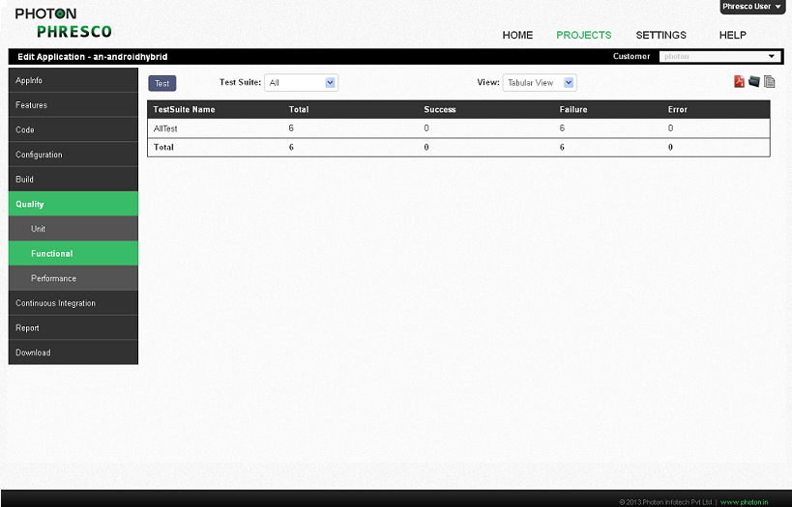

*Figure 8‑187: Android Hybrid functional test report for all test cases in tabular view*

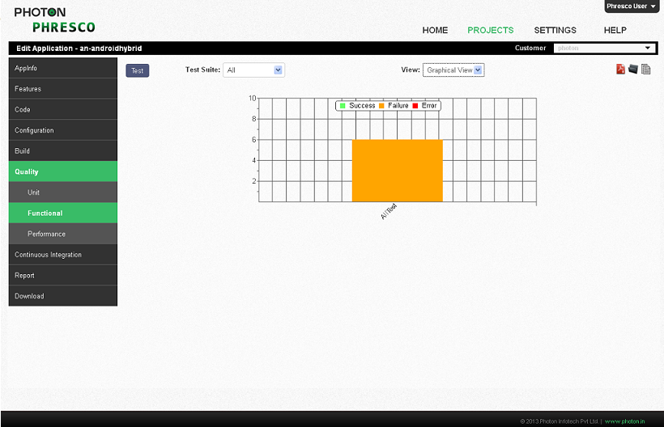

Figure 8‑198: *Android Hybrid functional test report for all test cases in graphical view*

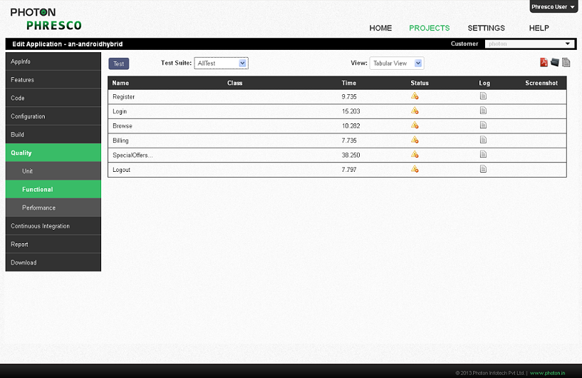

Figure 8‑209: *Android Hybrid functional test report for single test case in tabular view*

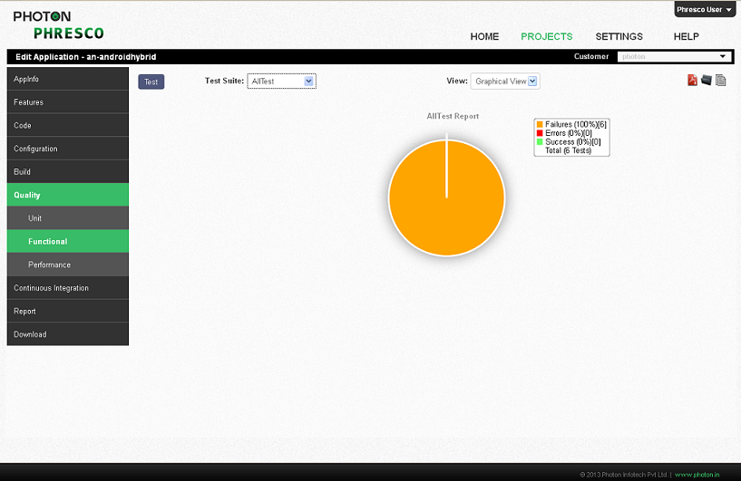

Figure 8‑50: *Android Hybrid functional test report for single test case in graphical view*

**Limitations in Monkey Talk**

* The Test case execution faces issues due to the element ID change when the auto popup key board pops up
* The Test case execution faces few problems on executing the same scripts in different resolutions

|  |
| --- |
| * **Note:** * In addition to this Phresco also supports Calabash for Android application.   . |
|  |
|  |

### Performance Test for Android

Phresco enables the users to test the performance for their android project. It triggers the test cases simultaneously on all the selected devices and once the tests are completed the results will be available on screen in tabular and graphical formats.

**Steps to be followed to trigger performance test**

1. Click the Applications-> Project created->Quality->Performance test->Test
2. A Performance Test pop up box appears and the number of android devices can be selected for testing.
3. When three devices are connected the performance testing occurs simultaneously as shown in figure:



*Figure 8‑51: Choosing multiple devices for performance test.*

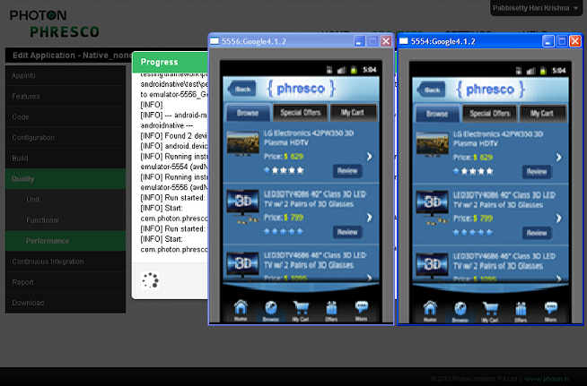

*Figure 8‑52: Performance test in multiple devices*

#### Report generated after execution

Report for the performance testing is generated in both graphical and tabular form. The response time and the throughput are given as the report after the performance testing.

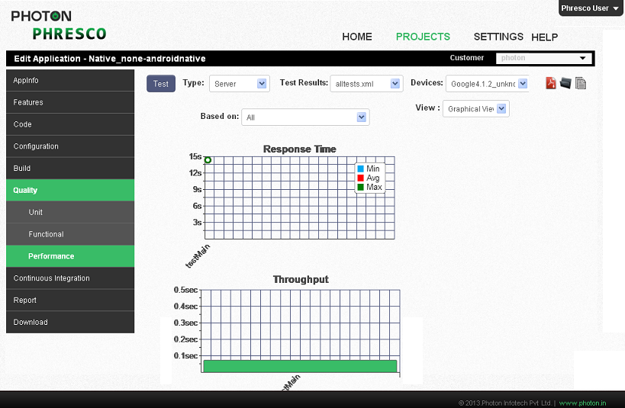

*Figure 8‑53: Android graphical report for performance test*

## iPhone Applications

### Unit Test Case

Xcode offers two types of unit tests: logic tests and application tests.

**Logic tests**

This checks the exact functionality of a unit of code by itself without the help of application. Specific test cases can be put together to exercise a unit of code. Stress testing of the code can also be performed using logic tests. Logic tests run only on the simulators.

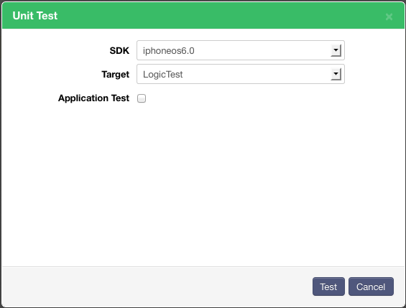

*Figure 8‑54: iPhone Unit test case*

**Application tests**

This check the units of code in the context of the app. Application tests are used to test the connections of user interface controls and also to test the work of the controls and controller objects.

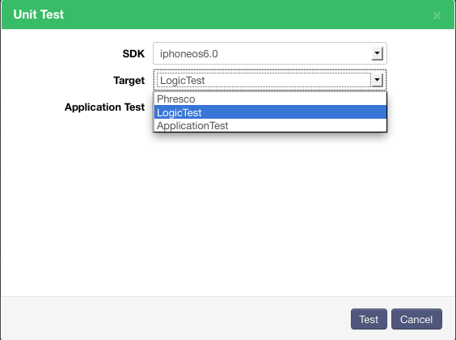

*Figure 8‑55: iPhone Unit test case*

In order to run application test from Xcode 4.2 or 4.3 follow the below steps.

**Step – 1**

Following configurations are to be done for Unit test target Build settings

* In Other test flag field add  -RegisterForSystemEvents
* In BundleLoader field add $(BUILT_PRODUCTS_DIR)/Phresco.app/Phresco
* In TestHost field add $(BUNDLE_LOADER)
* In Test After Build field add Yes
* In Header search path field add usr/include/libxml2

In Target Dependencies

* Add Phresco.app in target dependencies of unit test target.

**Step -2**

In Xcode 4.2

Modify the file “RunPlatformUnitTests” which is available in the path "/Developer/ Platforms/iPhoneSimulator.platform/Developer/Tools".

If loop in main method file should be replaced with the below text

 mkdir -p "${BUILT_PRODUCTS_DIR}/Documents"

       mkdir -p "${BUILT_PRODUCTS_DIR}/Library/Caches"

       mkdir -p "${BUILT_PRODUCTS_DIR}/Library/Preferences"

       mkdir -p "${BUILT_PRODUCTS_DIR}/tmp"

       export CFFIXED_USER_HOME="${BUILT_PRODUCTS_DIR}/"

       RunTestsForApplication "${TEST_HOST}" "${TEST_BUNDLE_PATH}"

In Xcode4.3,

Modify the file “RunPlatformUnitTests” which is available in the path "/Applications/Xcode.app/Contents/Developer/Platforms/iPhoneSimulator.platform/Developer/Tools".

|  |
| --- |
| * **Note:** * For logical test, Step 2 should not be considered. * In Xcode4.5, the Other test flag field should be kept empty. |
|  |
|  |

#### Structure of Alltest and Test Cases

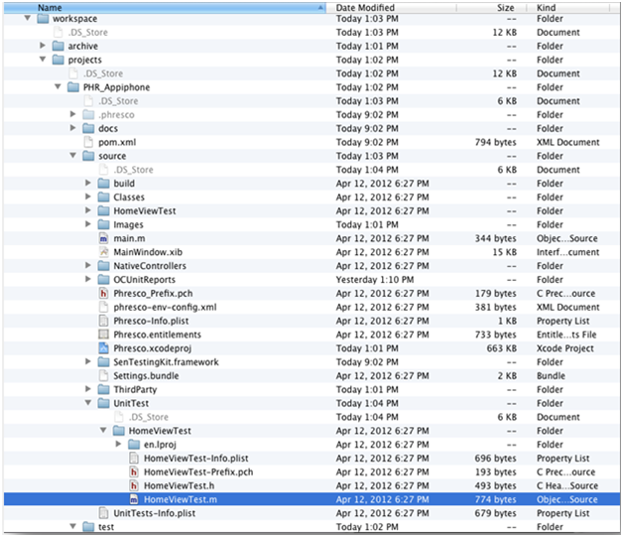

*Figure 8‑56: iPhone unit tests structure*

1. **Home view test:** This is a test suite in which all other test cases are called.
2. **Test cases:** Test cases are present inside the test suites

**Homeviewtest for iPhone Application**

The testSuite contains a bunch of test cases, each of which performs a unique scenario on the application. Test developers can start writing new suite classes and test cases by following the syntax and structure of Phresco framework’s out of the box class structure. HomeViewTest class calls all the suite classes and the test cases within it. Once suite classes and test cases are written developers can execute those from Phresco Framework and can see the report. Following is the HomeViewTest files which shows up how to add / include the class inside it.

#import <SenTestingKit/SenTestingKit.h>  
#import <UIKit/UIkit.h>  
  
#import "PhrescoAppDelegate.h"  
#import "RootViewController.h"  
#import "HomeViewController.h"  
#import "BrowseViewController.h"  
#import "ResultViewController.h"  
#import "ProductDetailsViewController.h"  
#import "AddToBagViewController.h"  
#import "ViewCartController.h"  
#import "CheckOutViewController.h"  
#import "CheckOutOVerallViewController.h"  
#import "ReviewViewController.h"  
#import "ReviewCommentsViewController.h"  
#import "LoginViewController.h"  
#import "RegistrationViewController.h"  
HomeViewTest.h  
  
@interface HomeViewTest : SenTestCase{

@private  
iShopAppDelegate *appDelegate;  
RootViewController *rootController;  
HomeViewController *homeController;  
BrowseViewController *browseController;  
ResultViewController *resultController;  
ProductDetailsViewController *pdtDetailController;  
AddToBagViewController *addCartController;  
ViewCartController *viewCartController;  
CheckOutViewController *checkViewController;  
CheckOutOVerallViewController *checkOverallController;  
ReviewViewController *reviewController;  
ReviewCommentsViewController *reviewCommentsController;  
LoginViewController *loginController;  
RegistrationViewController *registerController;

      
    UITableView *tblView;  
}  
-(void) testAction;  
@end  
  
//////  
  
- (void)testExample{

    [rootController tabBarButtonAction:@"0"];  
  // STFail(@"Unit tests are not implemented yet in HomeViewTest");  
}  
-(void) testAction{

    [homeController buttonAction:@"0"];  
      
}  
-(void) testBrowse{

    //[browseController  tableView:tblView didSelectRowAtIndexPath:0];  
      
    STAssertThrows([browseController tableView:tblView didSelectRowAtIndexPath:-1] , @"Invalid index");  
      
    
}  
-(void) testProductResult{

    [resultController  tableView:tblView didSelectRowAtIndexPath:0];  
    [resultController reviewButtonSelected:@"0"];  
      
}  
-(void) testProductDetail{

    [pdtDetailController addToCart:@"0"];    
  
}  
  
-(void) testAddToCart{

   [addCartController removeIndex:@"0"];  
         
}  
-(void) testViewCart{

    [viewCartController browseButtonSelected:@"0"];  
      
}  
-(void) testCheckCart{  
  
    [checkViewController cancelAction:@"0"];  
      
}  
-(void) testCheckOverall{

    [checkViewController reviewAction:@"0"];  
      
}  
-(void) testReview{

    [reviewController tableView:tblView didSelectRowAtIndexPath:0];  
      
}  
-(void) testComments{

    [reviewCommentsController goBack:0];  
      
}  
  
-(void) testLogin{

    [loginController registerButtonSelected:0];  
      
}  
  
-(void) testRegister{

    [registerController registerButtonSelected:0];  
  
}  
@end

**Test Register Example for a Test Case**

A test case is a set of conditions under which a tester will determine whether an [application](http://en.wikipedia.org/wiki/Software_application) is meeting the requirement. This helps the user to verify a particular functionality during the testing process.

The following is the example of a test register

-(void) testRegister{

    [registerController registerButtonSelected:0];  
 }

#### To Add New Test Case in Homeviewtest

You can add a new test case to the Homeviewtest using the following method. Here is an example for creating a new test case ‘testsploffers’.

-(void) testSplOffers{

    [splOfferController tableView:tblView didSelectRowAtIndexPath:0];  
      
}

#### Report generated after execution

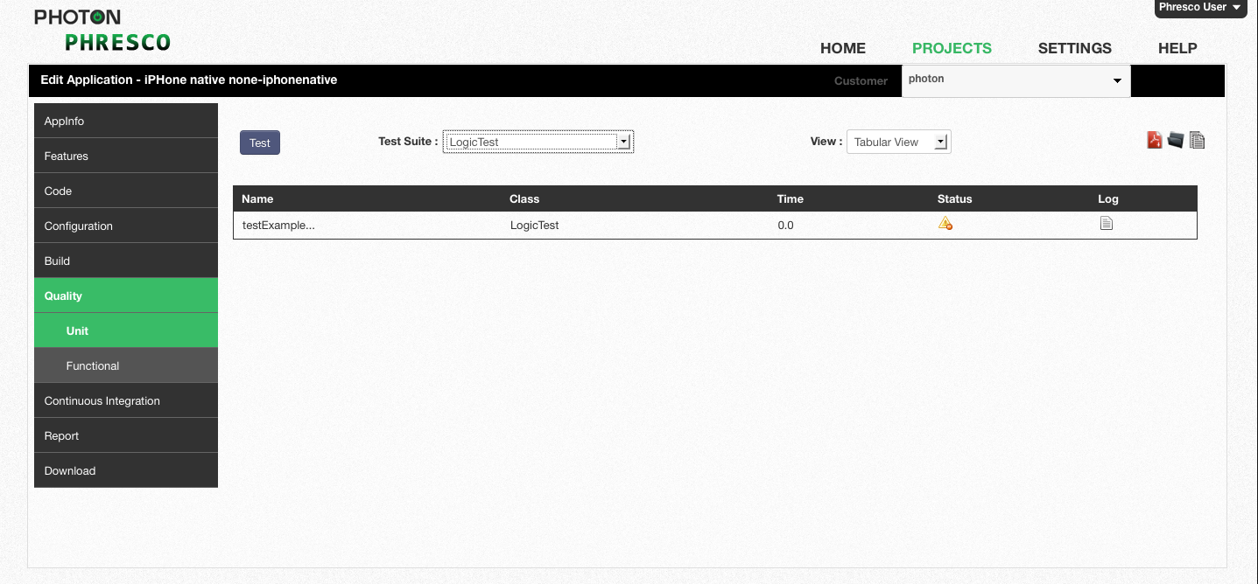

Figure 8‑57: *iPhone unit test report for single test case in tabular view*

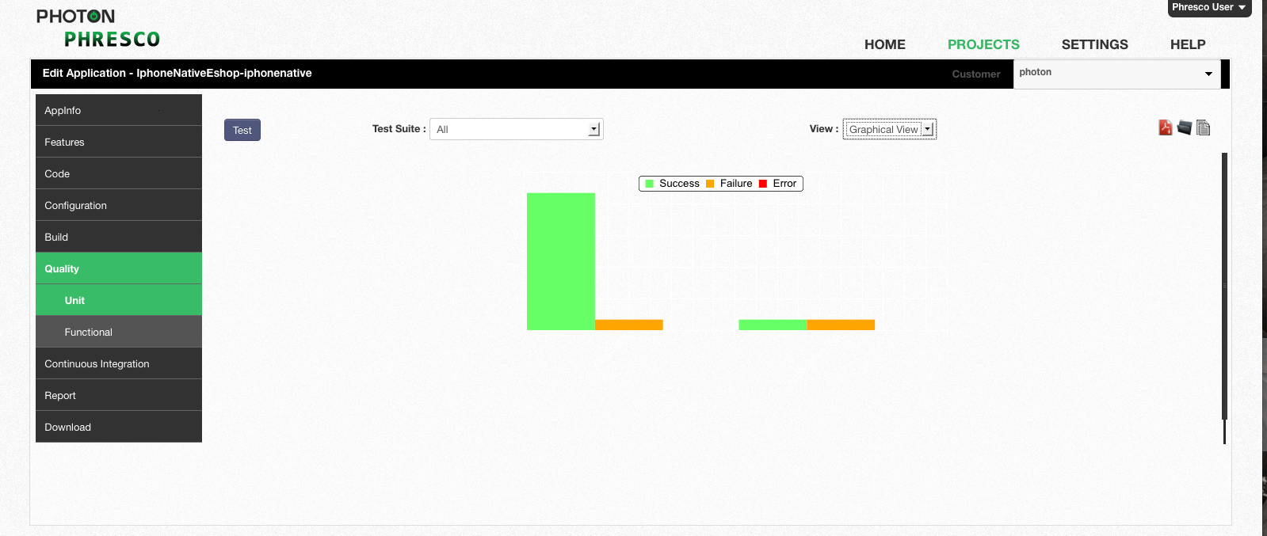

*Figure 8‑58: iPhone unit test report for all test cases in graphical view*

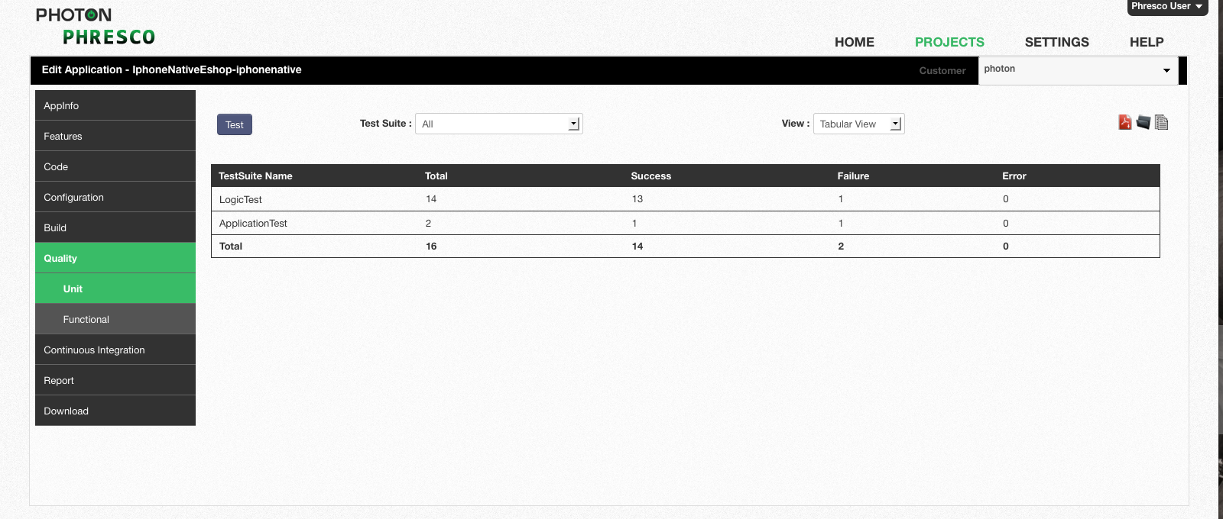

Figure 8‑219: *iPhone unit test report for all test cases in tabular view*

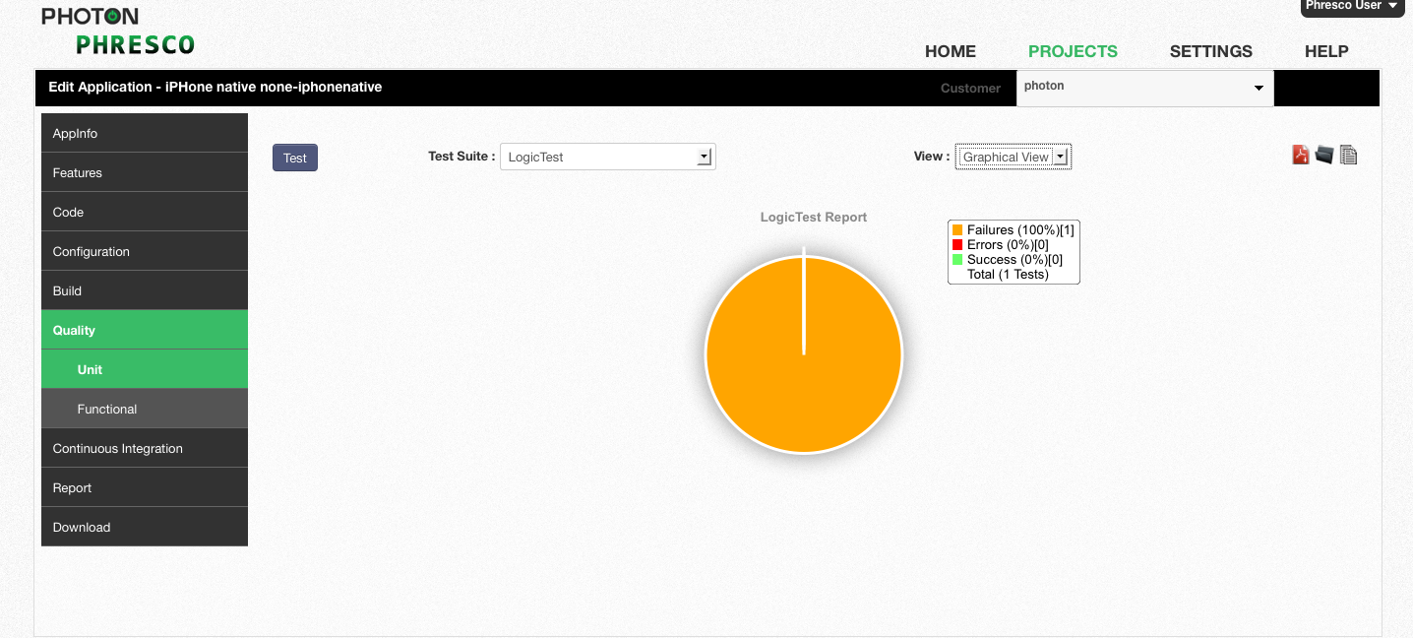

Figure 8‑60: *iPhone unit test report for single test case in graphical view*

### Functional Test Case

#### Structure of Alltest and Test Case

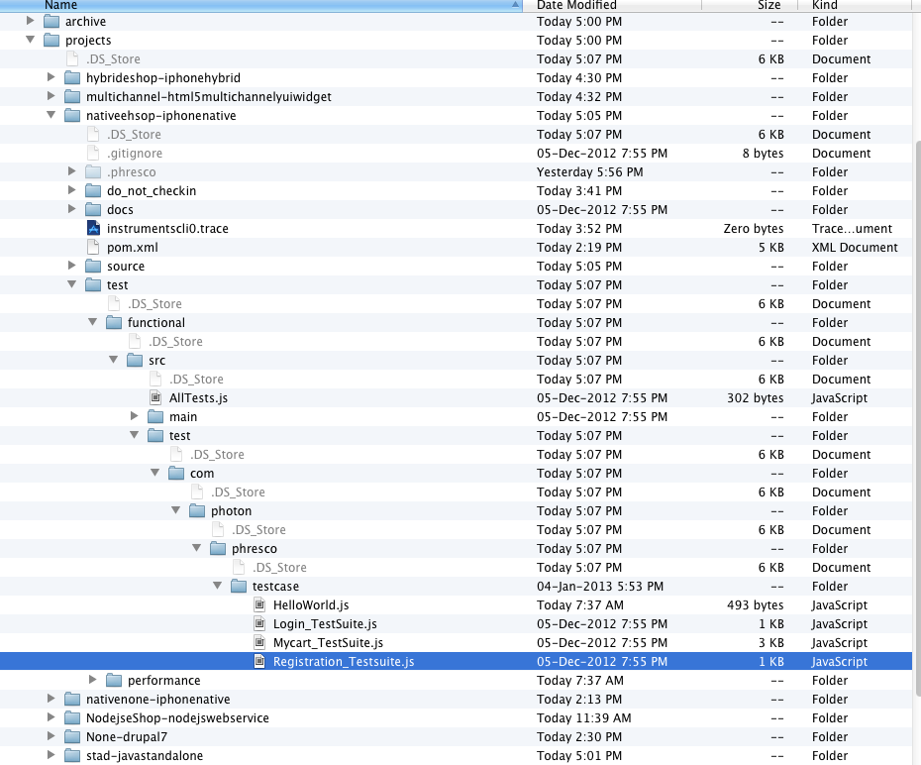

*Figure 8‑61: iPhone functional tests structure*

1. **AllTest**: Alltest is the root file that carries the Test suites.
2. **Test Suite:** This is the js file which contains multiple test cases.
3. **Test cases:** These perform unique testing scenarios against the application.

#### Existing Test Cases and Suites Out Of the Box in Phresco

**All Test for iPhone**

AllTest calls all the suite files and the test cases within it. Once suite files and test cases are written developers can execute those from Phresco Framework and can see the report. Following is the AllTest file which shows up how to add / include the suite file inside it.

#import "main/com/photon/phresco/util/MainActivity.js"

#import "main/com/photon/phresco/util/UIElements.js"

#import "test/com/photon/phresco/testcase/AudioDevice_suite.js

#import "test/com/photon/phresco/testcase/Television_suite.js"

**Test suite for iPhone**

Testsuite is a js file which holds all the other test cases. Functional test runs in the order by which the test suites are created. The Testsuite contains a bunch of test cases, each of which performs a unique scenario on the application. Test developers can start writing new suite file and test cases by following the syntax and structure of Phresco framework’s out of the box structure. Test suite contains the test cases within it. Once suite files and test cases are written testers can execute those from Phresco Framework and can see the report. Following is the Test suite file which shows up how to add / include the Test cases inside it.

#import "../../../../../main/com/photon/phresco/util/MainActivity.js"

#import "../../../../../main/com/photon/phresco/util/UIElements.js"

function testAudioDevice(testname){

try{

clickOnScroll(Browse_id);

clickOnScroll(AudioDevice_id);

clickOnScreen(110,127);

clickOnScreen(184,211);

clickOnScreen(259,223);

clickOnScroll(UpdateCart_id);

waitForFewSeconds(1);

clickOnScroll(Checkout_id);

clickOnScreen(259,223);

waitForFewSeconds(1);

clickOnScroll(MyCart_id);

clickOnScreen(259,223);

waitForFewSeconds(1);

clickOnScroll(Remove_id);

clickOnScroll(Back_id);

UIALogger.logPass(testname);

}

catch(error){

captureScreenshot(testname);

//UIALogger.logFail("Fail");

UIALogger.logError(testname);

}

}

testAudioDevice("AudioDeviceTest");

**To Add New Test Suite in All Test**

You can add a new test suite to the Main Test Suite using the following method.

#import "main/com/photon/phresco/util/MainActivity.js"

#import "main/com/photon/phresco/util/UIElements.js"

#import "test/com/photon/phresco/testcase/AudioDevice_suite.js

#import "test/com/photon/phresco/testcase/Television_suite.js"

#import "test/com/photon/phresco/testcase/Computer_suite.js"

**To Add New Test Case in Test Suite**

You can add a new test case to the Test suite using the following method.

#import "../../../../../main/com/photon/phresco/util/MainActivity.js"

#import "../../../../../main/com/photon/phresco/util/UIElements.js"

function testAudioDevice(testname){

try{

clickOnScroll(Browse_id);

clickOnScroll(AudioDevice_id);

clickOnScreen(110,127);

clickOnScreen(184,211);

clickOnScreen(259,223);

clickOnScroll(UpdateCart_id);

waitForFewSeconds(1);

clickOnScroll(Checkout_id);

clickOnScreen(259,223);

waitForFewSeconds(1);

clickOnScroll(MyCart_id);

clickOnScreen(259,223);

waitForFewSeconds(1);

clickOnScroll(Remove_id);

clickOnScroll(Back_id);

UIALogger.logPass(testname);

}

function testTelevision(testname){

try{

clickOnScroll(Browse_id);

clickOnScroll(Television_id);

waitForFewSeconds(1);

clickOnScreen(110,127);

clickOnScreen(184,211);

clickOnScreen(259,223);

waitForFewSeconds(1);

clickOnScroll(UpdateCart_id);

clickOnScroll(Checkout_id);

waitForFewSeconds(1);

clickOnScreen(259,223);

clickOnScroll(MyCart_id);

clickOnScreen(259,223);

clickOnScroll(Remove_id);

waitForFewSeconds(1);

clickOnScroll(Back_id);

UIALogger.logPass(testname);

}

catch(error){

captureScreenshot(testname);

//UIALogger.logFail("Fail");

UIALogger.logError(testname);

}

}

testAudioDevice("AudioDeviceTest");

testTelevision("TelvisionTest");

#### Report generated after execution

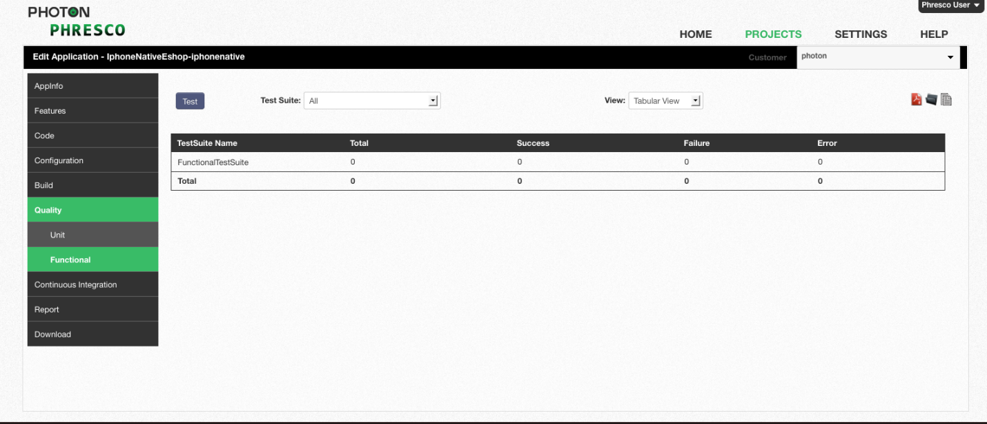

Figure 8‑62: *iPhone functional test report for single test case in tabular view*

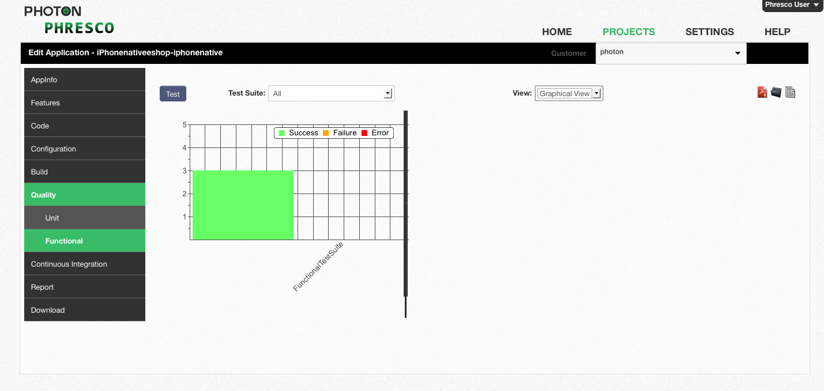

Figure 8‑63: *iPhone functional test report for all test cases in graphical view*

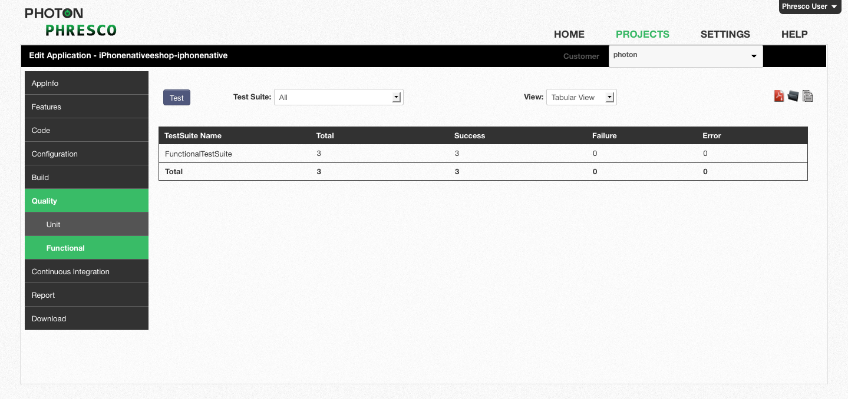

Figure 8‑64: *iPhone functional test report for all test cases in tabular view*

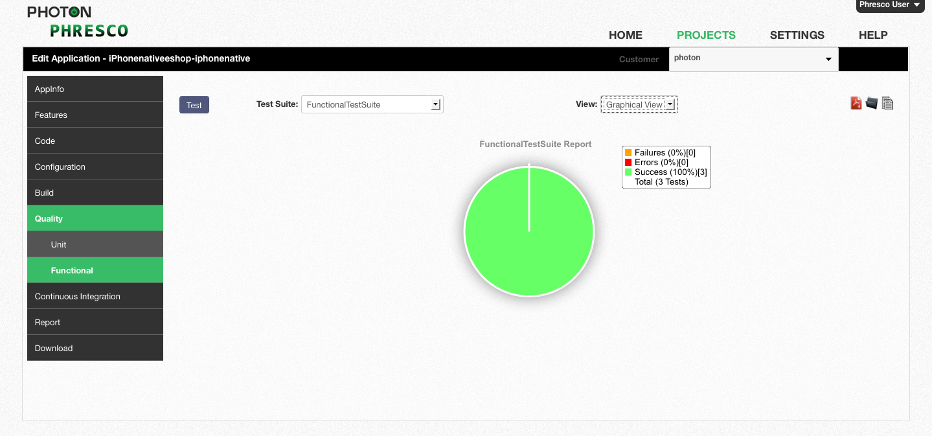

Figure 8‑65: *iPhone functional test report for single test case in graphical view*

|  |
| --- |
| * **Note:** * In addition to this,Phresco supports Calabash for iPhone application. |
|  |
|  |

## Node js Test Cases

### Unit Test Case

#### Structure of Test Suites and Test Case

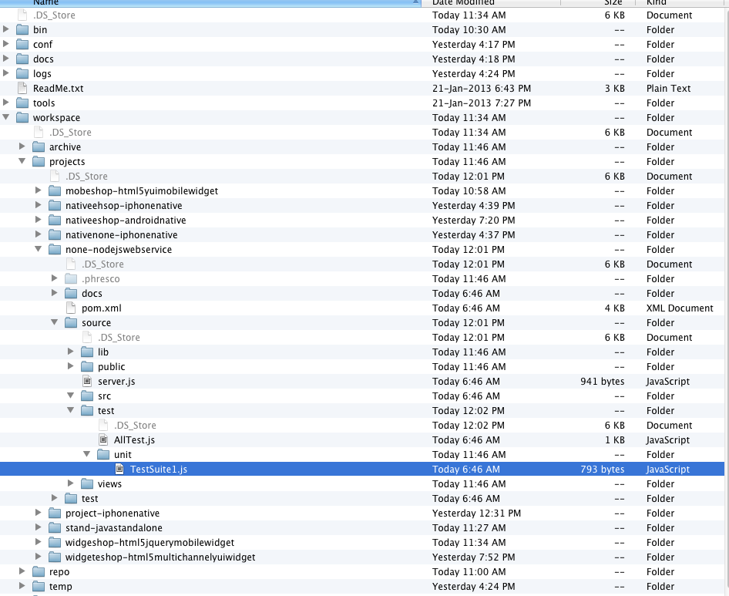

***Figure 8-66: Unit test folder structure for NodeJs***

1. **AllTest**: Alltest is the root file that carries the Test suite.
2. **Test suite**: Test suite is made to run through AllTest
3. **Test case**: All the Test cases should be added within the test suite.

#### Existing Test Cases and Suites Out Of the Box in Phresco

**Alltest for Node js**

AllTest is the root category which holds the test suite. AllTest contains a bunch of test suites, each of which performs a unique scenario on the application. Test developers can start writing new suite classes by following the syntax and structure of Phresco framework’s out of the box class structure. Once test suite classes and test cases are written developers can execute those from Phresco Framework and can see the report. Following is the AllTest file which shows up how to add / include the class inside it.

var nodeunit = require('nodeunit');

var reporter = nodeunit.reporters.junit;

var opts = {

"error_prefix": "\u001B[31m",

"error_suffix": "\u001B[39m",

"ok_prefix": "\u001B[32m",

"ok_suffix": "\u001B[39m",

"bold_prefix": "\u001B[1m",

"bold_suffix": "\u001B[22m",

"assertion_prefix": "\u001B[35m",

"assertion_suffix": "\u001B[39m"

}

opts.output = "target/surefire";

reporter.run(['source/test/eshop'], opts);

**Test Suites example**

Test suite is a collection of test cases that are intended to be used to test a project code to show that it has some specified set of behaviors. A test suite contains detailed instructions or goals for each collection of test cases. New test cases can also be added by using the following syntax.

**Test case example**

A test case is a set of conditions under which a tester will determine whether an [application](http://en.wikipedia.org/wiki/Software_application) is meeting the requirement. This helps the user to verify a particular functionality during the testing process.

exports.testSomething = function(test){

test.expect(1);

test.ok(true, "this assertion should pass");

test.done();

};

exports.testSomethingElse = function(test){

test.ok(true, "this assertion should fail");

test.done();

};

#### To Add New Test Case in Test Suite

You can add a new test case to the Test suite using the following method.

exports.testSomething = function(test){

test.expect(1);

test.ok(true, "this assertion should pass");

test.done();

};

exports.testSomethingElse = function(test){

test.ok(true, "this assertion should fail");

test.done();

};

#### Report generated after execution

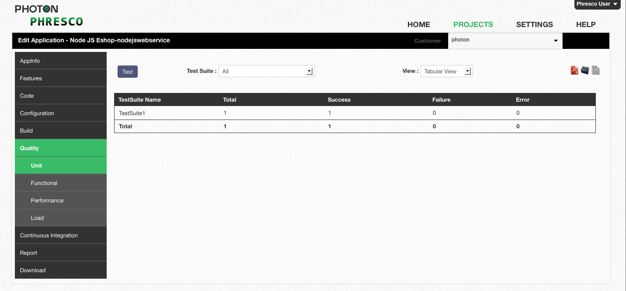

*Figure 8‑22: NodeJS unit test report for all test cases in tabular view*

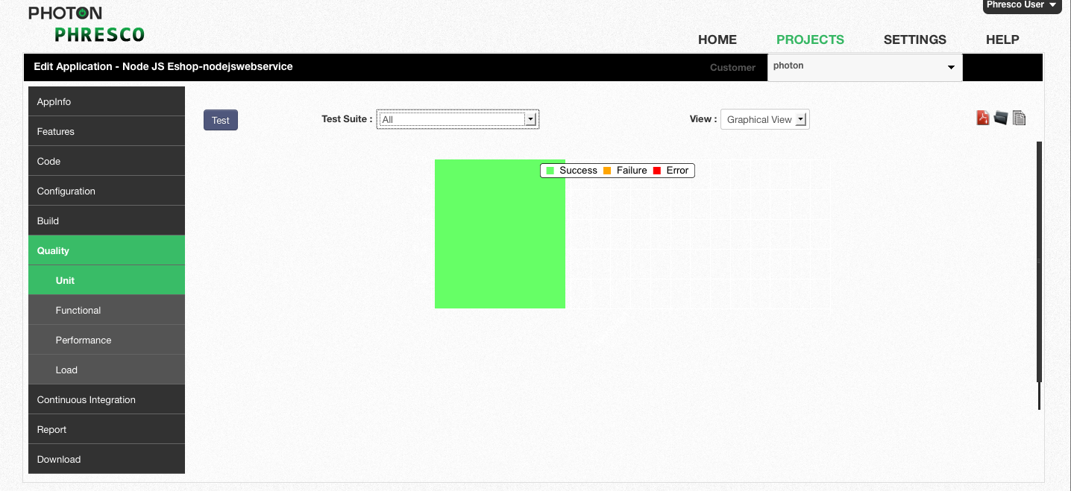

*Figure 8‑23: NodeJS unit test report for all test cases in graphical view*

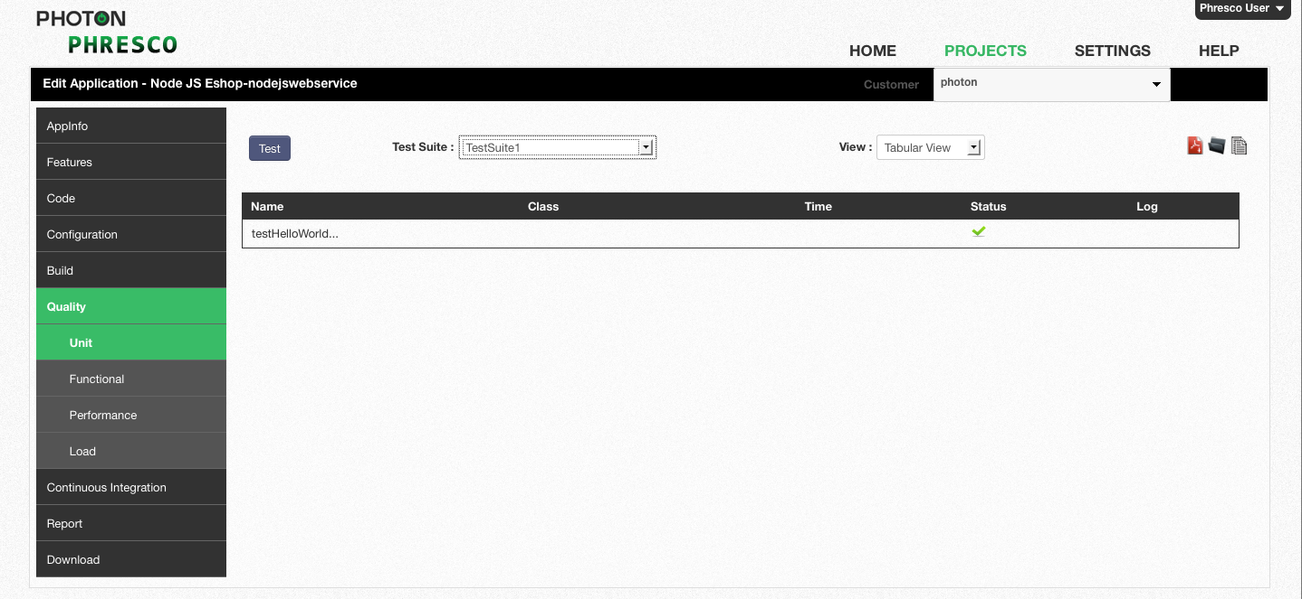

Figure 8‑24: *NodeJS unit test report for single test case in tabular view*

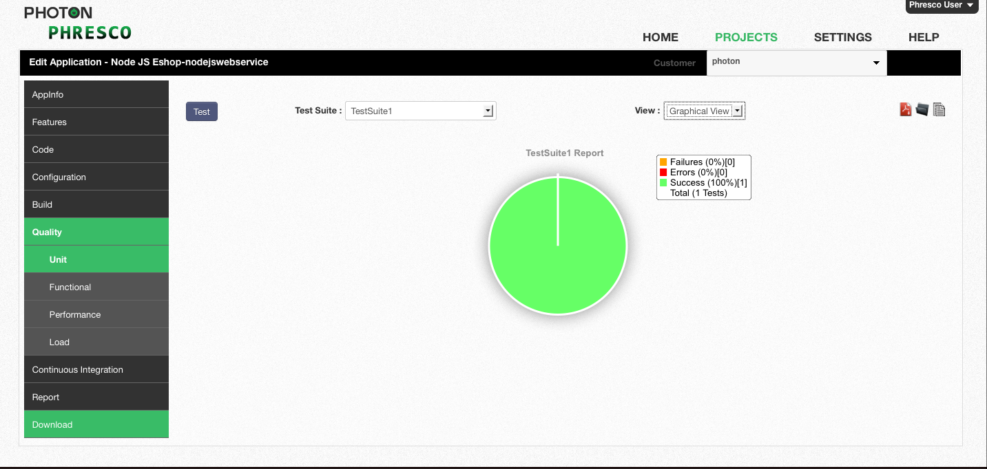

Figure 8‑25: *NodeJS unit test report for single test case in graphical view*

|  |
| --- |
| * **Note** * Refer section 8.1.2 for the Functional Test case structure which is similar to Selenium Grid Functional Test structure. |

## JQuery Test Cases

### Unit Test Cases

#### Structure of Test Case

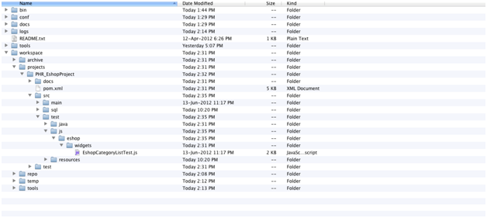

*Figure 8‑71: jQuery unit test case structure*

* 1. **Test cases:** Test cases can be added directly in the js folder.

/*global require */

require([ "jQuery", "./Category", "./EShopAPI", "qunit" ], function($, Category, EShopAPI, QUnit) {

var equal = QUnit.equal, expect = QUnit.expect, test = QUnit.test;

/**

* Test that the setMainContent method sets the text in the category-widget

*/

test("category-widget unite test case passed.", function() {

var category, initeObj, listener, api, Phresco, mainContent, currentName, currentID, navUL, output1, output2;

// Setup view and call method under test

category = new Category();

api = new EShopAPI();

//api.wsURL = "http://172.16.25.75:2020/eshop";

api.getWsConfig();

category.api = api;

category.listener = undefined;

category.Phrescoapi = undefined;

output1 = category.renderUI();

mainContent = $('<section id="submenu">');

currentName = 'name';

currentID = 'id';

navUL = $('<ul></ul>');

api.getCategories(function(jsonObject){

var productList = jsonObject,

totalCategories = productList.category.length,

i, category, categoryId, lis;

for (i = 0; i < totalCategories; i++) {

category = productList.category[i];

categoryId = category.id;

lis = $('<li><span><a href="javascript:void(0);">' + category[currentName]

+ '</a></span></li>');

navUL.append(lis);

}

});

output2 = mainContent.append(navUL);

// Expect that the text was set on the expected element

equal(output1.html(), output2.html(), "Expected text not set in category-widget");

});

});

#### Report generated after execution



*Figure 8‑26: jQuery unit test report for all test cases in tabular view*

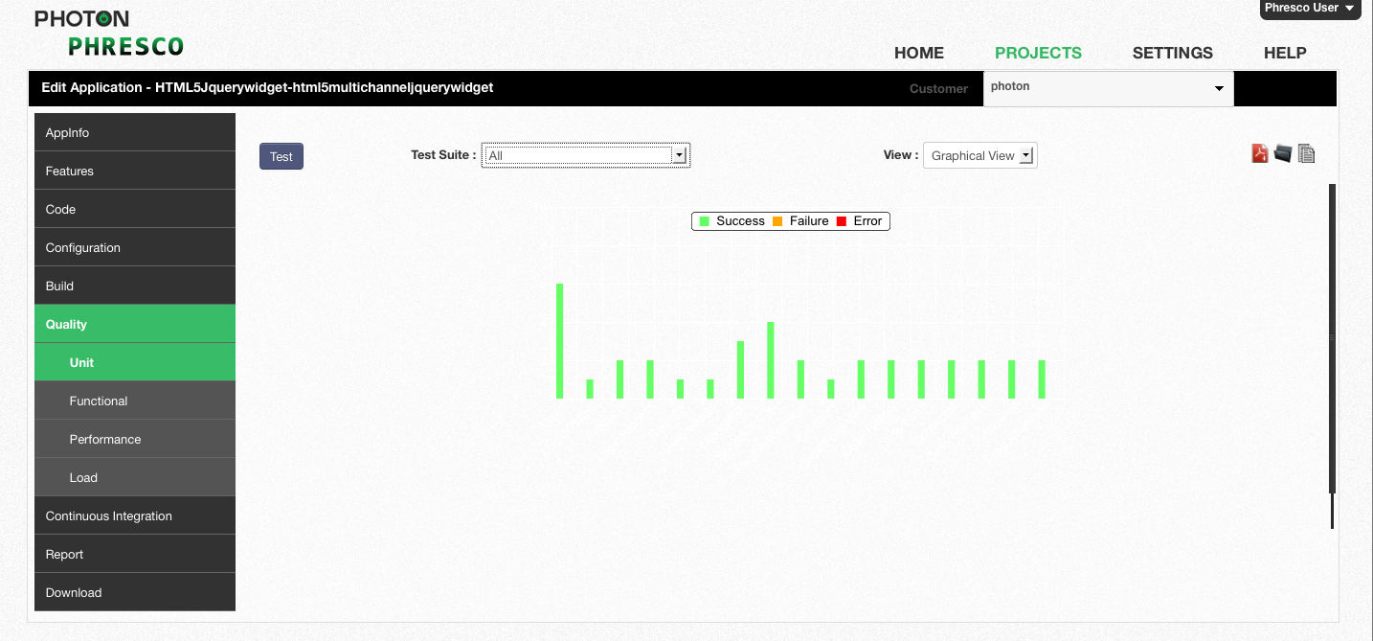

*Figure 8‑27: jQuery unit test report for all test cases in Graphical view*



Figure 8‑28: *jQuery unit test report for single test case in tabular view*



Figure 8‑29: *jQuery unit test report for single test case in graphical view*

**Prerequisites for jQuery Unit Test Cases**

A prior installation of Phantomjs software is essential to run Test cases for jQuery project. This software is available in the **Phresco framework->Downloads**.

* Set environment variable for the phantomjs software.
* Extract the zip file and set the path {installation path}\phantomjs-1.5.0-win32-static in the system variables field.

### Functional Test Cases

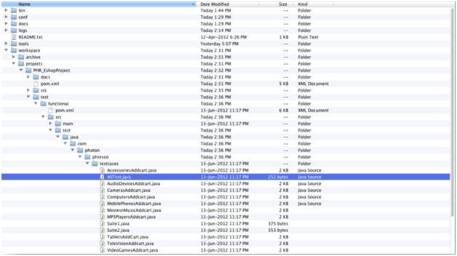

*Figure 8‑76: jQuery functional test case structure*

1. AllTest: This is a root JUnit suite class that can either call a suite of classes or individual test cases.
2. Suite Class: This is also a JUnit suite class which calls the individual test cases.
3. Test Cases: These are individual java classes which perform unique testing scenarios against the application.

#### Existing Test Cases and Suites Out Of the Box in Phresco

In Phresco testing Framework in Junit suite class is named as “AllTest”.

The testSuite contains a bunch of test cases, each of which performs a unique scenario on the application. Test developers can start writing new suite classes and test cases by following the syntax and structure of Phresco frameworks out of the box class structure. AllTest class calls all the suite classes and the test cases within it. Once suite classes and test cases are written developers can execute those from Phresco Framework and can see the report. Following is the AllTest file which shows up how to add / include the class inside it.

Package com.photon.Phresco.testcases  
  
import org.junit.runner.RunWith;  
import org.junit.runners.Suite;  
import org.junit.runners.Suite.SuiteClasses;  
  
@RunWith(Suite.class)  
@SuiteClasses({Suite1.class,Suite2.class})  
public class AllTest {

}

**Suite class**

Suite class is a collection of test cases that are intended to be used to test a project code to show that it has some specified set of behaviors. A suite class contains detailed instructions or goals for each collection of test cases. New test cases can also be added by using the same syntax.

package com.photon.Phresco.testcases;

import org.junit.runner.RunWith;

import org.junit.runners.Suite;

import org.junit.runners.Suite.SuiteClasses;

@RunWith(Suite.class)

@SuiteClasses({ WelcomePage.class,TeleVisionAddcart.class,

ComputersAddcart.class, MobilePhonesAddcart.class,AudioDevicesAddcart.class, CamerasAddcart.class

})

public class Suite1 {

}

**Test cases**

A test case is a set of conditions under which a tester will determine whether an [application](http://en.wikipedia.org/wiki/Software_application) is meeting the requirement. This helps the user to verify a particular functionality during the testing process. Elements can be identified and screen shots can be captured when the test fails.

package com.photon.Phresco.testcases;

import java.io.IOException;

import junit.framework.TestCase;

import org.junit.Test;

//import static org.testng.Assertjunit.*;

import org.openqa.selenium.server.SeleniumServer;

import com.photon.Phresco.Screens.MenuScreen;

import com.photon.Phresco.Screens.WelcomeScreen;

import com.photon.Phresco.selenium.report.Reporter;

import com.thoughtworks.selenium.Selenium;

import com.photon.Phresco.uiconstants.PhrescoUiConstants;

public class AWelcomePage extends TestCase {

private SeleniumServer serv;

protected Selenium selenium;

private PhrescoUiConstants phrsc;

private int SELENIUM_PORT;

private String browserAppends;

@Test

public void testWel() throws InterruptedException, IOException, Exception {

try {

phrsc = new PhrescoUiConstants();

String serverURL = phrsc.PROTOCOL + "://"

+ phrsc.HOST + ":"

+ phrsc.PORT + "/";

browserAppends = "*" + phrsc.BROWSER;

assertNotNull("Browser name should not be null",browserAppends);

SELENIUM_PORT = Integer.parseInt(phrsc.SERVER_PORT);

assertNotNull("selenium-port number should not be null",

SELENIUM_PORT);

WelcomeScreen wel=new WelcomeScreen(phrsc.SERVER_HOST, SELENIUM_PORT,

browserAppends, serverURL, phrsc.SPEED,

phrsc.CONTEXT );

assertNotNull(wel);

MenuScreen menu = wel.menuScreen();

assertNotNull(menu);

} catch (Exception t) {

t.printStackTrace();

System.out.println("ScreenCaptured");

selenium.captureEntirePageScreenshot("\\WelPageFails.png",

"background=#CCFFDD");

}

}

@Override

public void setUp() throws Exception {

serv = new SeleniumServer();

try {

serv.start();

} catch (Exception e) {

clean();

throw e;

}

}

@Override

public void tearDown() {

clean();

}

private void clean() {

if (serv != null) {

serv.stop();

}

if (selenium != null) {

selenium.stop();

}

}

}

#### To Add a New Test Suite in Alltest Class

You can add a new test suite to the AllTest class as follows.

**Example**

package com.photon.Phresco.testcases;

import org.junit.runner.RunWith;

import org.junit.runners.Suite;

import org.junit.runners.Suite.SuiteClasses;

@RunWith(Suite.class)

@SuiteClasses({Suite1.class,Suite2.class})

public class AllTest {

}

#### To Add New Test Case in Test Suite

You can add a new test case to the Test suite using the following method. Here is an example for creating a new test case in the name “CamerasAddcart”

package com.photon.Phresco.testcases;

import org.junit.runner.RunWith;

import org.junit.runners.Suite;

import org.junit.runners.Suite.SuiteClasses;

@RunWith(Suite.class)

@SuiteClasses({ WelcomePage.class,TeleVisionAddcart.class,ComputersAddcart.class,

MobilePhonesAddcart.class,AudioDevicesAddcart.class,

CamerasAddcart.class

})

public class Suite1 {

}

#### Report generated after execution

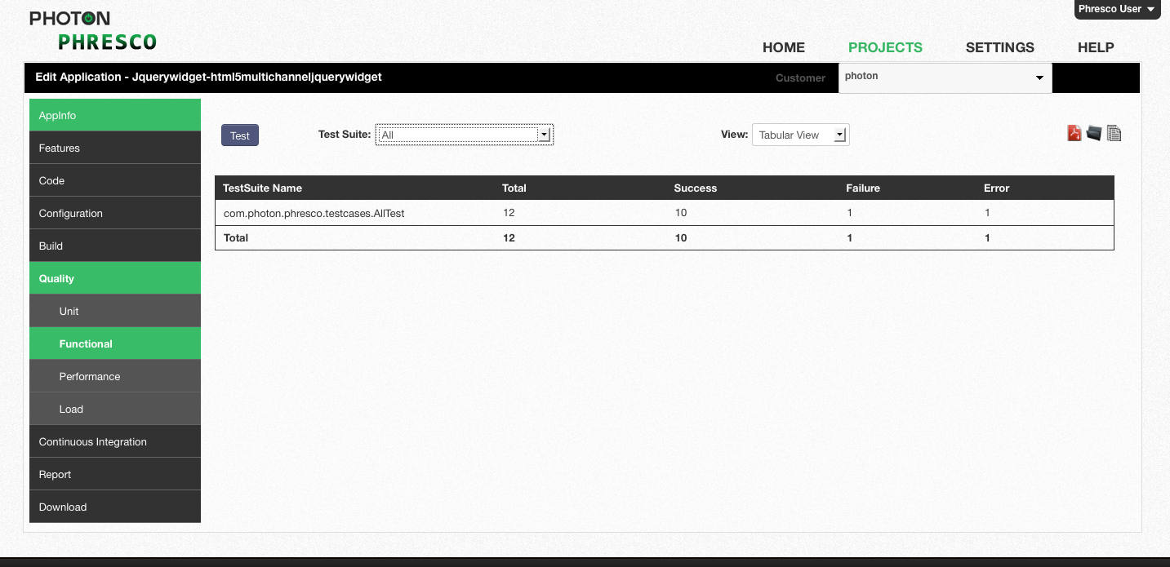

*Figure 8‑30: jQuery Functional test report for all test cases in tabular view*

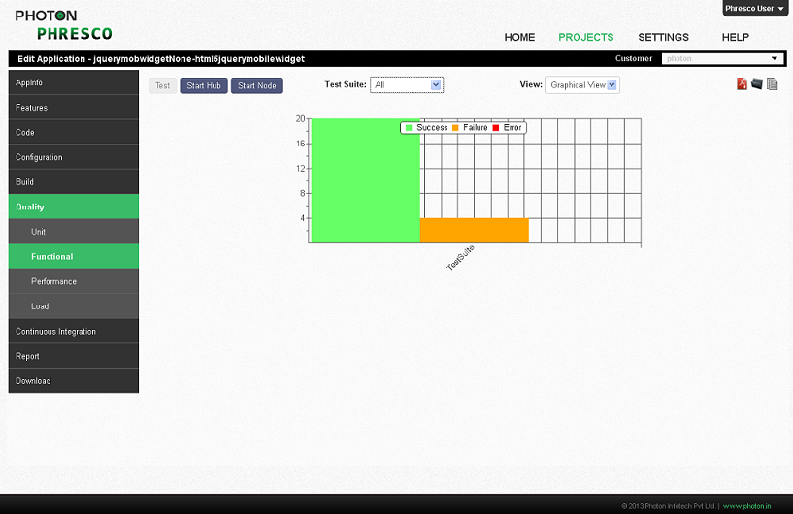

*Figure 8‑31: jQuery functional test report for all test cases in graphical view*

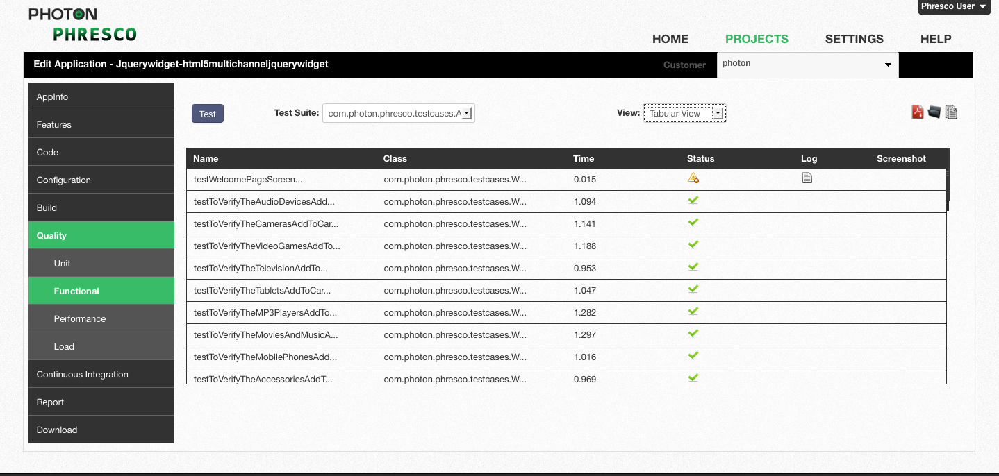

*Figure 8‑32: jQuery functional test case report for single test case in tabular view*

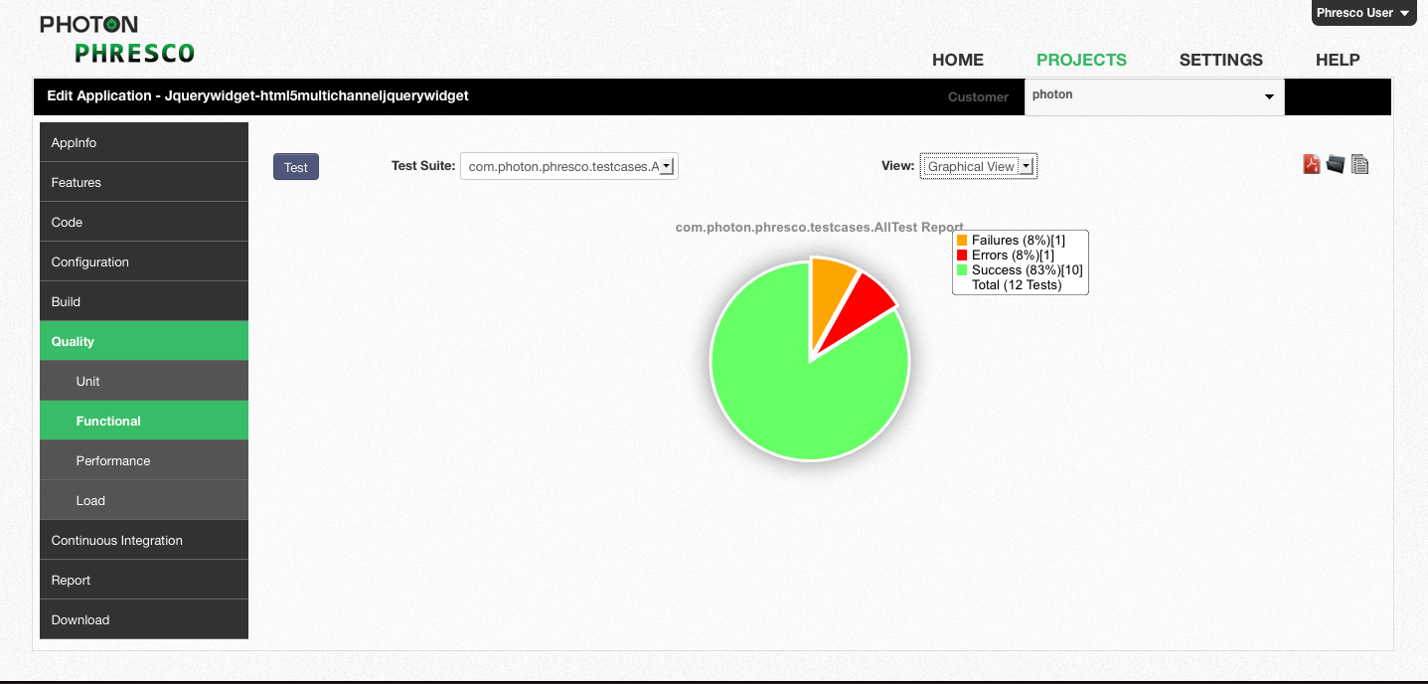

*Figure 8‑33: jQuery functional test case report for single test case in graphical view*

## Performance Testing

Phresco enables the users to test the performance of their project in an elementary way. It integrates JMeter as a tool and as a result generates a report that can be viewed by Phresco users. The Apache JMeter is a tool which is mainly used for testing both performance and load testing. It is fully comprised of java application and provides the result in tabular and graphical form. The inputs are entered in Phresco user interface which in turn is assigned as an input to the JMeter. The parameters for performance testing is calculated and given as a final report in Phresco framework.

Performance testing is testing the performance of a Server when certain number of users hits the URL at specific period of time. This helps in calculating the average response time, throughput, minimum responsive time and maximum responsive time.

**Average response time:**

Average response time is the Average time calculated when the server responds for any given input. This is calculated by using JMeter.

**Throughput:**

Throughput is the amount of capacity that a server can handle. In other words throughput is the amount of work that a server does in a specific time.

**Minimum and Maximum Response time:**

Minimum Response time is the minimum time calculated when the server responds for any given input.

Maximum Response time is the maximum time calculated when the server responds for any given input.

Performance testing can be done against server, web service and database.

**Performance test against server by using Phresco Framework:**

To run a performance test against a server, the server has to be selected along with the environment and the Test Result Name should be filled. To test the performance of any server, access to the server should be available. Add header tab is used to enter the header parameter which authenticates the server for testing. Few mandatory fields in Context URLs like Name, context, Type, Encoding and fields like No. of Users, Ramp-Up Period, and Loop count in Thread Group should be filled before Performance testing is done. GET or POST type can be selected in the type field. GET is the method used when user needs to get the content from the server. POST is the method used when input is fetched. One or more number of servers can be tested by clicking the add button while the minus button is used to deselect the URLs.

**Performance Test against Web Service using Phresco Framework:**

To run a performance test against a Web service, the Web services has to be selected along with the environment and the Test Result Name should be filled. To test the performance of any WebService, access to the WebService should be available. Add header tab is used to enter the header parameter which authenticates the WebService for testing. Few mandatory fields in Context URLs like Name, context, Type, Encoding and fields like No. of Users, Ramp-Up Period, and Loop count in Thread Group should be filled before Performance testing is done. GET or POST type can be selected in the type field. GET is the method used when user needs to get the content from the server. POST is the method used when input is fetched. One or more number of web services/servers can be tested by clicking the add button while the minus button is used to deselect the URLs.

**Performance Test against Database using Phresco Framework:**

To run a performance test against a database, the database has to be selected along with the environment and the Test Result Name should be filled. To test the performance of any database, access to the database should be available. Add header tab is used to enter the header parameter which authenticates the database for testing. Few mandatory fields in Database Query like Name, Query Type, Query and fields like No. of Users, Ramp-Up Period, and Loop count in Thread Group should be filled before Performance testing is done. One or more number of database can be tested by clicking the add button while the minus button is used to deselect the database.

**Report generated after performance testing**



*Figure 8‑81: Performance test Pop up*



*Figure 8‑34: Request header*

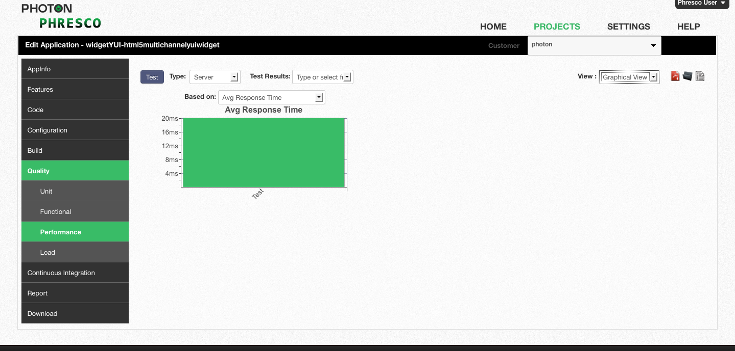

*Figure 8‑83: Performance test report graphical view*

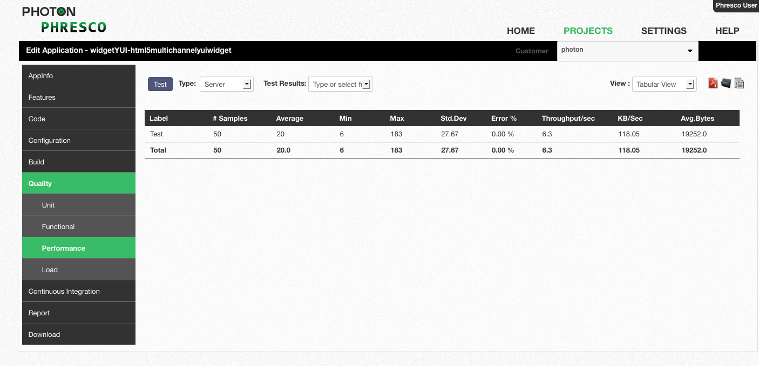

*Figure 8‑35: Performance test report tabular view*

## Load test

Load testing generally refers to the practice of modeling the expected usage of a server by simulating multiple users to access the same project concurrently. Project should be designed in such a way that when a maximum load is reached, a project should not crash and instead it should show a message saying the load has exceeded. Load and performance testing is usually conducted in a test environment identical to the production environment before a project is permitted for real time usage.

Phresco uses JMeter for Load testing. The result is given through static analysis and test cases. The test cases will point out the error and this will be very useful for the testing team.

**Elapsed Time**

The amount of time that has passed since a particular process started especially compared with the amount of time that was calculated for it in a plan.

**Load test against server using Phresco framework**

To run a load test against a server, the server has to be selected along with the environment and the Test Result Name should be filled. Few mandatory like No. of Users, Ramp-Up Period, and Loop count in Thread Group should be filled before load testing is done. By clicking the test button, JMeter carries the inputs and provides the end report in both tabular and graphical form. The elapsed time and the status can be viewed from Phresco user interface.

**Load test against Web service using Phresco framework**

To run a load test against a Web service, the Web service has to be selected along with the environment and the Test Result Name should be filled. Few mandatory like No. of Users, Ramp-Up Period, and Loop count in Thread Group should be filled before load testing is done. By clicking the test button, JMeter carries the inputs and provides the end report in both tabular and graphical form. The elapsed time and the status can be viewed from Phresco user interface.

### Report Generated After Load Testing

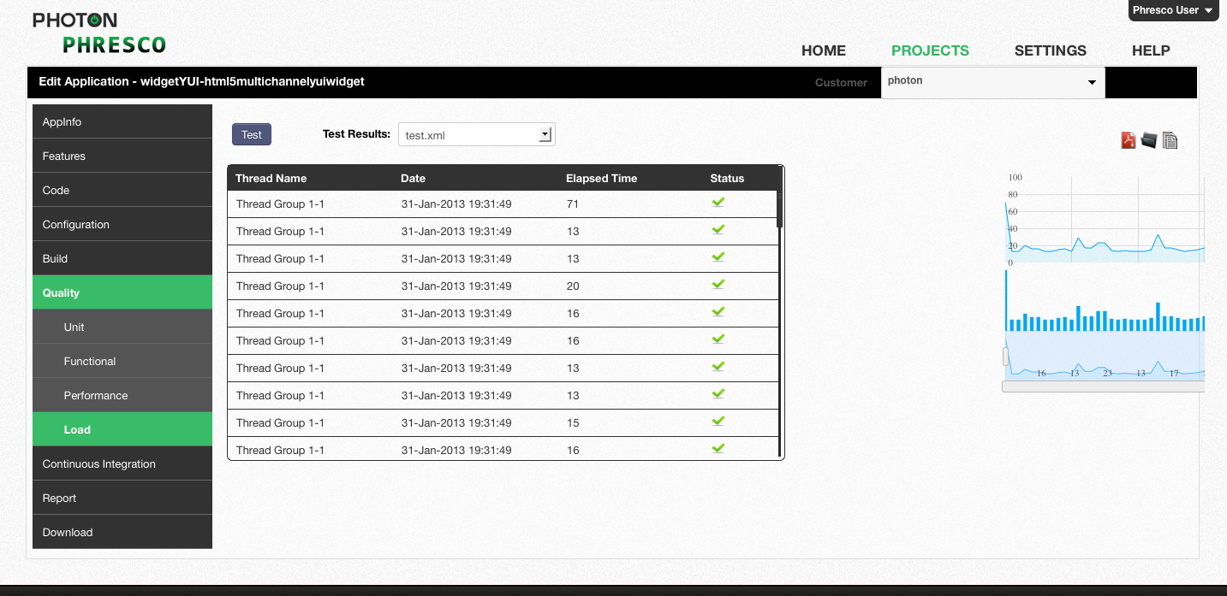

*Figure 8‑36: Load test report*

# Continuous Integration

Phresco offers Continuous Integration support to generate builds automatically and deploy them by scheduling it to a particular time. Testing processes can also be automated. This process reduces the integration problems and help produce a full quality project. It deducts errors that may occur during build, deployment and testing. Detailed reports are automatically generated and are mailed to those in the mailing list specified during the CI configuration process.

**Features**

**Job Templates**

Phresco allows the developer to create and configure the jobs in Continuous Integration. Called Job Templates, these jobs can be assigned to multiple applications within a project. To create a job template, go to **Edit Projects -> Continuous Integration -> Job Templates -> Create a Job Template**.

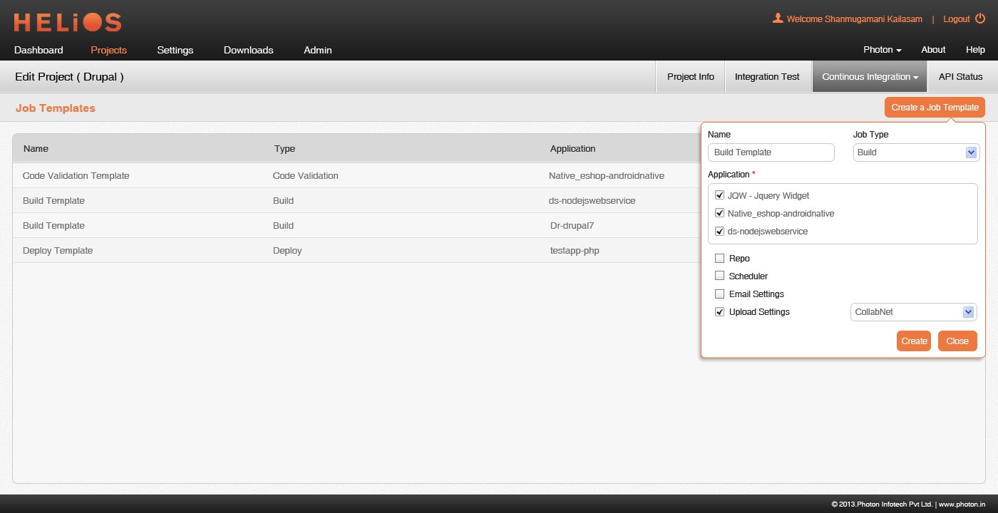

**Name**

Name of the job template created

**Job Type**

Select the type of job being created

**Application**

Select the applications to which the job is to be assigned

**Repo**

Select the Repo from which the project can be retrieved for the CI process

**Scheduler**

Use this option to schedule the Continuous Integration process. Scheduler configuration will be a part of the Job settings for which the Scheduler is selected

**E-Mail Settings**

Use this option to email the results of Continuous Integration to stakeholders.

E-Mail configuration will be a part of the Job settings for which the Email is selected

**Upload Settings**

Select the upload option to which the successfully built project should be uploaded after the CI process

**Continuous Integration**

Once the job templates have been created, go to **Continuous Integration -> Create** to configure and start the CI process.

The jobs are listed application wise. They can be drag & dropped in any desired order. Phresco offers multi module support and the Continuous Integration process will be performed in the order specified.

Configure the individual job using the settings icon that appears once the job is drag & dropped. The selected jobs should be configured before clicking Add to save the CI arrangement made.

|  |
| --- |
| * **Note:**   Continuous Integration tab under each application lists the application specific jobs. Only Edit action can be performed here. |